PROFILES IN OBSCURITY

Albert Smith

One of the earliest adult burials in the Farnhurst Potter’s Field holds Albert G. Smith, white, who died on January 12, 1892. His broken and mutilated body was found under a culvert along the Philadelphia, Wilmington, & Baltimore railroad, with sparse identification. His story was recorded in many newspaper articles as the coroner’s office tried to identify him and contact family members to come and claim the body. After two weeks on ice at the coroner’s office, with no response to the inquiries, it was decided to bury him in the relatively new Potter’s Field at Farnhurst. Just a few days after his burial, a letter from his wife confirmed his identity, but she was not able to afford to have his body sent home, so he remains at Farnhurst.
His Coroner’s Certificate of death estimated him to have been about 40 years of age, and states that he was accidently killed on the railroad, presumably hit by a train. Under complications we find the enigmatic statement: “Four fingers and thumb of his left hand.”
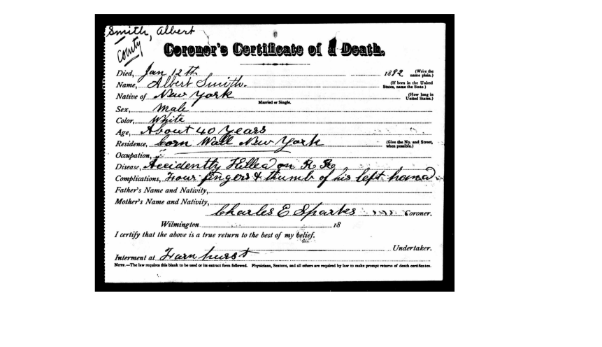
Summarizing from early newspaper reports, Mr. Smith was discovered lying beneath a bridge between Shellpot Creek and the Edge Moor railroad station. The body was discovered by Benjamin Garrett (“a colored man living in this city”) and another man, lying face down on the ice, frozen to the ground. The left side of his head and face were crushed in and his jaw was broken in several places. Both of his legs were broken, his face was badly cut and bruised, and there were numerous bruises on his body.
He was described as being dressed in a fairly nice, but badly torn suit, with no identification on him other than a letter in his coat pocket addressed to Albert Smith, Red Bank, New Jersey, from the Bristol Manufacturing Company of Waterbury, Connecticut. The letter indicated that he was a traveling salesman, selling steel belt fasteners, of which several samples were found in his pockets. A nickel key ring was also found in one of his pockets containing six keys and a small medal inscribed “Albert Smith, Cornwall, New York.” He also had several memorandum books with addresses in them indicating that they belonged to Albert Smith. His left hand was missing several fingers from an old injury. Mr. Smith was described as having a “full florid face, dark brown hair and a dark brown moustache” and being 5’6” tall.
The coroner’s jury heard from several witnesses and examined the remains and the personal effects found on the body, and concluded that the man was most likely Albert Smith of Cornwall, NY, who “met his death in a manner unknown to the jury.” He was buried on January 23rd in the New Castle County Hospital Cemetery in its role as the New Castle County Potter’s Field at the time.
Mrs. Hannah Smith of Mott Haven, NY sent a letter from New Haven, Connecticut, dated January 29th, inquiring if “Albert Smith” had already been buried. An exchange of letters confirmed that the dead man was Albert Smith of New York, and Hannah was his widow. On February 5th she sent another letter explaining that the family could not afford to have his remains returned to New York. She mentioned that he had lost several fingers in a planing mill accident near Tarrytown, New York, almost two years previously, that he was only 33 years of age, and described him as “being of a wandering disposition.” The letter stated that his hobby was belts and belt lacing.
His family had last heard from him in November of 1891, when he wrote to tell them he was leaving Red Bank, New Jersey to travel south. He had been in Red Bank since April of 1891. His family was used to him travelling for extended periods, so had not worried when they didn’t hear from him. His wife was working as a housekeeper in New Haven, Connecticut to support herself and their seven-year-old daughter. According to one newspaper account, his widow “states that her husband has long been a wanderer on the face of the earth and that she has not seen him in many years.” She also reported that he had two sisters and a brother living in Cornwall-on-the-Hudson, New York.
According to census records and www.ancestry.com trees, Albert G. Smith was descended from a long line of Smiths living in New York since the 1600s (see below). He was born around 1859 to Clark Smith and Mary Smith of Cornwall, Orange County, New York. In the 1865 New York state census, he was 6 years of age, living with his parents and his siblings Henry, Alonzo E., James S., Emeline, and Mary Smith. His father, who went by Clarke, was a mason. In the 1870 US Federal Census, he was 12, living with his parents and some of his siblings, including a younger brother named Willie. In the 1875 New York state census, he was 16, and living in Newburgh, Orange County, New York with Harrison Seley, age 60, working as a hired hand. In the 1880 US Federal Census, Albert was 21, living on his own and working as a plumber. In this census, his parents are described as having both been born in Prussia. Albert G. Smith and Hannah Weeks were married in either November or December of 1883, and their daughter was born around 1885. I could not discern his daughter’s name or place of birth, nor what happened to her. The www.findagrave.com memorial for Albert’s father Clark Smith can be found here: https://www.findagrave.com/memorial/223242252/clark-smith
Two descendants of ancestors of Albert Smith have traced the family back to the early 1600s or 1700s in Orange County, New York and in England, and provide this lineage via www.ancestry.com:
- John Smith and Isabel Smith (no dates, no location) were the parents of
- John “Rock” Lawrence Smith who was born in 1633 in St. Saviour, Denmark Park, Surrey, England, and who died ~1726 in Herricks, Hempstead, Queens County, New York; he was married to Anne Gildersleeve (1638-1728) and they were the parents of
- Jeremiah Smith (1656-1725), who married Anne Cornell (1657-1729), they were the parents of
- James Jacobus Smith (1688-?), who married Mary Wiltsee, they were the parents of
- John Samuel Smith (1710-1784); he died in Orange County, New York; he married Mary Hopkins (1694-1738); they were the parents of
- Joseph Smith (1730-1813), who lived in Orange County, New York; he married Lucretia Clark; they were the parents of
- Clark Smith (1760-1842), who married Susanna Davenport (1763-1848); they lived in Cornwall-on-Hudson, Orange County, NY, and were the parents of
- Joseph Smith (1790-1857), who married Clarissa Lounsbury (1791-1843), they lived in Orange County, NY and were the parents of
- Clark Smith (1817-1887), who was born in New York (no city specified) and died in Washingtonville, NY; he married Mary McCullough (1817-?) and they were the parents of
- Albert G. Smith (the decedent) buried in the NCCH Cemetery at Farnhurst

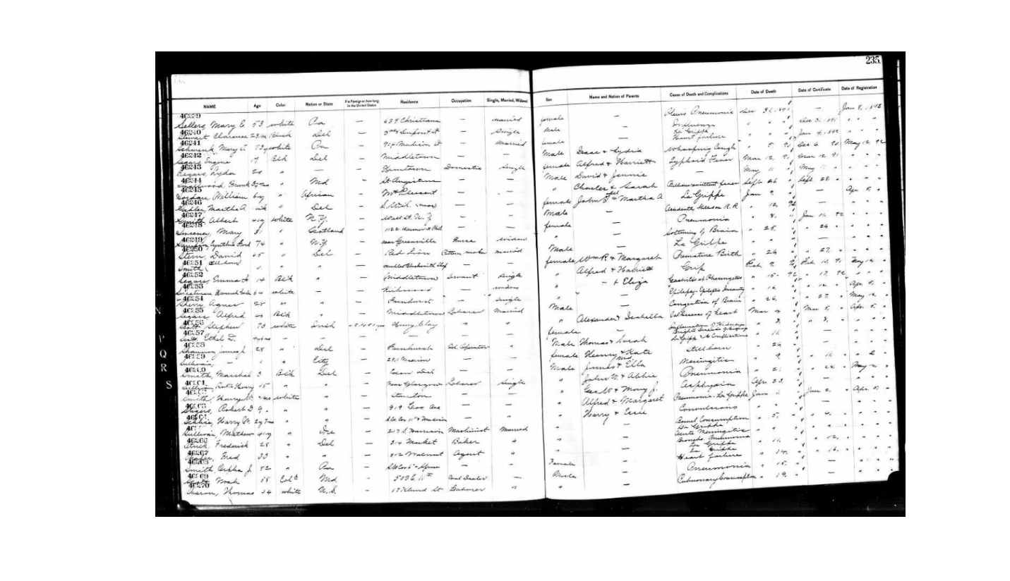

Morning News, Jan 13, 1892

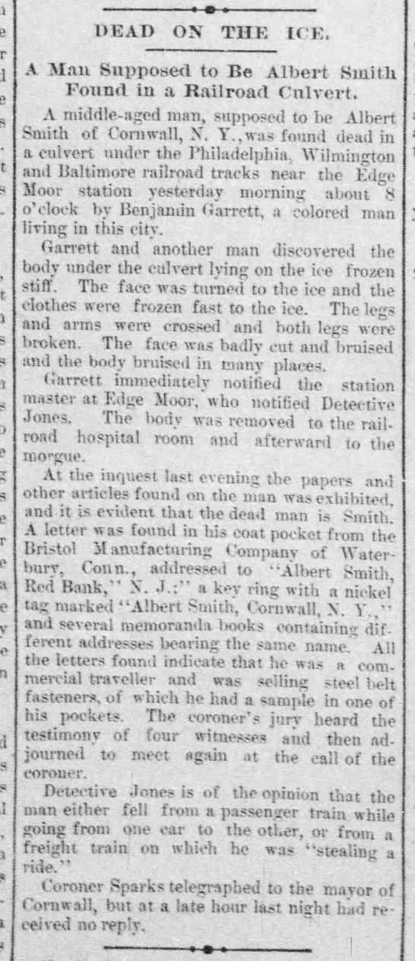
Delaware Gazette and State Journal, Jan 14, 1892

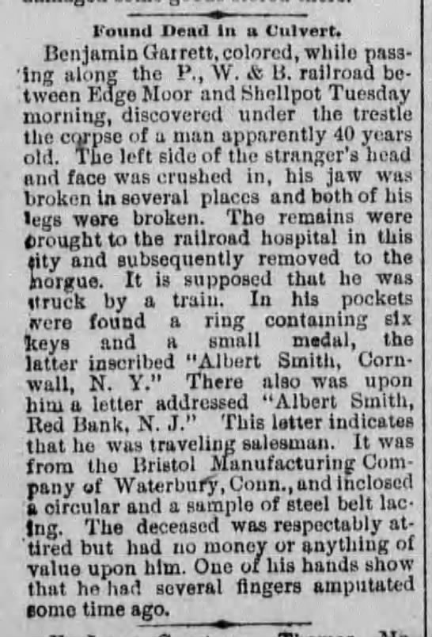
News Journal, Jan 16, 1892

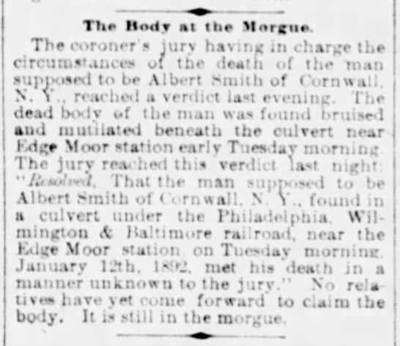

Daily Republican, Jan 18, 1892

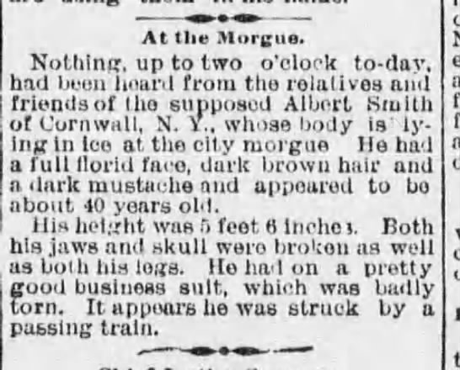

News Journal, Jan 23, 1892

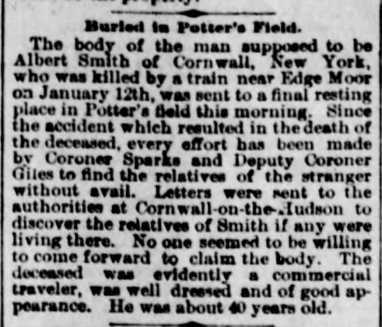

Daily Republican, January 30, 1892

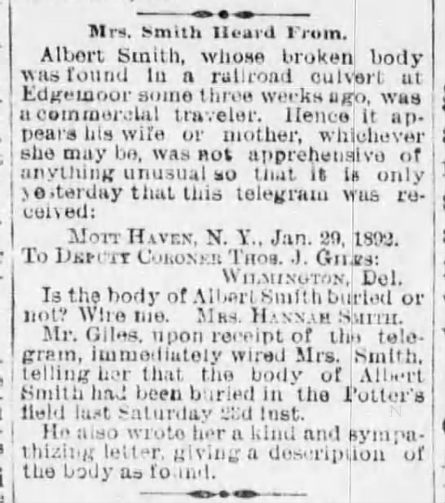

Delaware Gazette and State Journal, Feb 4, 1892

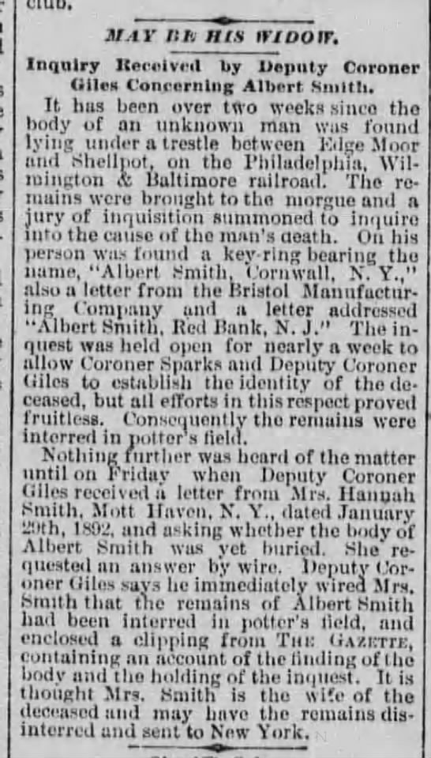

Evening Journal, Feb 8, 1892

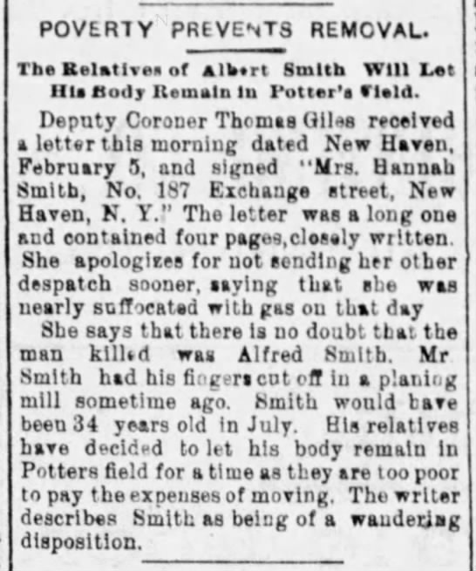

Daily Republican, February 8, 1892

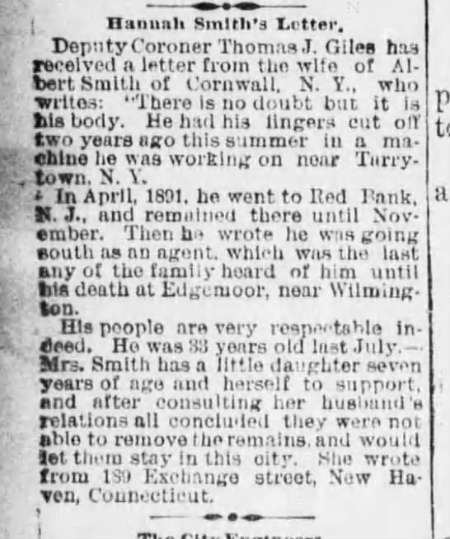

Morning News, February 9, 1892

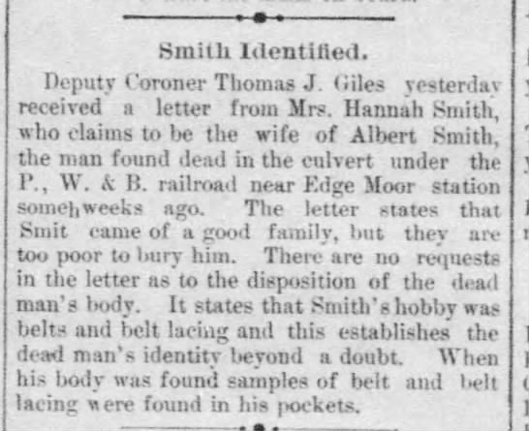

Delaware Gazette and State Journal, February 11, 1892

