Like Harriett Chadwick, we know almost nothing about the actual life and experiences of Amanda Row Hammond. She was born in 1855 in Wilmington, and died in 1933 at the New Castle County Hospital after a several-month’s stay (Feb 23-May 7), of cancer of the bowels (and gangrene of both feet). She was white, 78 years old at death, and a widow. She lived most of her life in Wilmington, but spent about 6 years (perhaps more) in the town of Port Hammond, British Columbia, Canada, from when she was married in 1903 to sometime after her husband’s death in 1909. She then moved back to Wilmington. She never had any children, as she didn’t marry for the first time until she 48 years old.
However, like Harriett Chadwick, she came from an interesting, well-known, and well-to-do family in Wilmington, and she married a very prominent Canadian man who helped found the community of Port Hammond in British Columbia. In addition, her siblings led interesting/unusual lives, and we can add some context to her life by exploring her relatives. It is not clear why she ended up at the NCCH Cemetery, given her upper class origins.
Amanda was the daughter of Bernard Row and Sophia Richenberger Row. Both the Rows and the Richenberger were prominent families who came from Bavaria, in Germany, immigrating first to Baltimore, and later, some members of the family moved to Wilmington. The story of both families is told in a book about the history of the Jewish community in Wilmington, Delaware. Sophia Richenberger had emigrated to the United States in 1848.
Bernard Row was born on October 20, 1818 in Bavaria. He emigrated to the United States in 1832 at the age of 14, staying first with relatives in Baltimore, Maryland. His brother Joseph was also living in Baltimore with his wife Sarah Richenberger Row and several children. In 1999, a book by Toni Young was published that provides information about the Row and Richenberger families in Baltimore and Wilmington. The book is titled Becoming American, Remaining Jewish: The Story of Wilmington, Delaware’s First Jewish Community, 1879-1924. Chapter One, “By Way of Background,” says of Wilmington’s Jews in the mid-nineteenth century:

In the 1850s, Jewish merchants from the neighboring cities of Baltimore and later Philadelphia began to open stores in Wilmington. Often the stores were branches of businesses that other family members continued to operate in the original cities.
Joseph Row, a native of Bavaria who had emigrated to Baltimore, arrived in Wilmington in 1853 to open a clothing store with his nephew Sol Brenner. Row, a master mason, also remained in business in Baltimore, where he was a member of the Baltimore Hebrew Synagogue. Other relatives – including his brother Bernard Row and brothers-in-law Moritz Landower, Louis Richenberger, and Emanuel [Manual] Richenberger – came to Wilmington in the late 1850s and early 1860s. They engaged in the clothing business in Wilmington together or separately for more than twenty years. During much of the period, Joseph Row, Landower, and the Richenbergers retained residencies in Baltimore and most likely returned home for religious observances. . . .
In 1872, about twenty Jews who lived or worked in Wilmington attempted to form a synagogue. Jacob DeWolf was elected president, Nathan Lieberman vice-president, and Joseph Row corresponding secretary. Although Row was not a permanent resident, he had been in business longer than any other Jew in Wilmington and had family here. Nathan Lieberman, Henry Buxbaum, and a newcomer from Philadelphia, Frederick L. Frank, sold subscriptions to the proposed synagogue at their clothing stores. The reaction from the general community was favorable: “Nearly every faith has here its house of worship, and it is quite time that the most ancient of them all had its tabernacle.” One of the major needs of the Jews was a burial ground. Jewish customs forbid burying the dead in a Christian cemetery, so when an observant Jew died in Wilmington his remains were always taken to Philadelphia for internment.
Unfortunately, subscriptions did not sell well, and the synagogue was not formed. However, services for High Holidays were held in different stores for several years. The failure of the synagogue might have caused some Jews to leave Wilmington. Within a few years of the synagogue’s failure, Joseph Row and Landower returned to Baltimore and Frederick L. Frank returned to Philadelphia.
The Row-Landower-Richenberger family seems to have split after Joseph’s return to Baltimore. In earlier days, family members had traveled back and forth between the two cities. However, Joseph’s daughter Carrie, born in 1869, only remembered her father in Baltimore. She did not remember her uncle Bernard or any Wilmington cousins. . . . [Joseph remained a devout Jew in Baltimore and was the chaplain of his Masonic lodge].
Brother Bernard, who remained in Wilmington, never formally renounced his Judaism; however, Bernard was not an active member of the Jewish community. Bernard’s son Isaac married a non-Jewish woman. Another son renounced his Judaism in order to become chaplain of one of the Masonic orders, requiring allegiance to Jesus Christ. Bernard, his wife Sophia, and their children Isaac, Clara, Joseph, and Harry were all buried in an unmarked plot in Riverview Cemetery.” [Young, 1999, pp. 29-31]

Brothers Joseph and Bernard Row were married to sisters of Manual Richenberger, Sarah and Sophia, while Manual married a non-Jewish woman. In Bernard’s obituary (1906), it says he had moved to Wilmington in 1850 and operated his clothing store for more than 40 years on Market Street. He was a member of the Central Presbyterian Church for 47 years, and a Mason. It also states that “[h]is habits were most exemplary, he having never used tobacco nor liquor in any form and in his daily walks of life was courteous and kind to all.”
Bernard and Sophia married in 1853 and had seven children, of which only six are known:
- Joseph – born in 1851, died in 1916 [never married, no children]
- Helen Paulina – born in 1853, died in 1877 at the age of 24 [2 children]
- Amanda – born in 1855, died in 1933 [no children]
- Isaac Lewis – born in 1857 or 1858, died in 1936 [no children]
- Henrietta – born ~ December 1859, died in 1944 [never married, no children]
- Henry B. “Harry” – born in 1863, died in 1925 [never married, no children]

In the 1860 census for Wilmington, the “Rowe” family includes father Bernard, 40, wife Sophia, 32, children Joseph, 9, Paulina, 7, Amanda, 5, Isaac 3, and Henrietta, 7 months. The family also employed three domestic servants, all females, two age 16, and one age 10. Bernard is running his clothing store.
In the 1870 census for Wilmington, the “Bowe” family includes Bernard, 51, Sophia, 43, and children Joseph 19, Hellen P., 17, Amanda, 15, Isaac L. 12, Henrietta, 9, and Henry B., 7. There are no domestic servants listed. Bernard is still working in his clothing store, along with Joseph. Oddly, Hellen and Henrietta are “at home,” while Amanda, Isaac, and Henry are attending school.
In the 1880 census for Wilmington, we have the “Bernart Row” family, with Bernard, 61, Sophia, 54, and children Isaac L., 22, Amanda Row, 23 (she was actually 25), Henrietta, 19, and Henry, 17. The two daughters are “at home,” and the two sons are working in the store. All four children at home are single.
In the 1900 census for Delaware, we have the family living at 606 French St., their home of many years, with Bernard, 81, Sophia, 74, Joseph, 45, Harry B. 38, and Amanda Row, 35. Note that the ages for the children are incorrect. Joseph would have been 49, Harry 37, and Amanda, 45. In this census, Bernard is working as a tailor, and Joseph and Harry are operating a china and fine household goods store. The three children still at home are all still single. In this census, women were asked how many children they had given birth to, and how many were still alive. Sophia responded 7, and 5. We know that Paulina had died in 1877, but we don’t have any record of who the other deceased child would have been.
In 1903, Amanda somehow met a man from Port Hammond, British Columbia. His name was John Hammond, and he and his brother had founded the community of Port Hammond (more about the Hammonds, below). It isn’t clear how or where they met, but Amanda and John were married in Agassiz, British Columbia, on October 23, 1903. There were two announcements in the local papers about the marriage. The first, from November 4, 1903, the Wilmington Morning News:
“Hammond-Row, at Agassiz, B.C., Canada, on October 23, 1903, by the Rev. James Lairig, John Hammond of Port Hammond, B.C., and Amanda Row, of Wilmington, Del.”
Another report comes from November 12, 1903, the Morning News:
“Married in Canada. Miss Amanda Row of this city, and John Hammond of Canada, were married at Agassiz, British Columbia, on the evening of October 23, the Rev. J.A. Laing officiating. The bride is a well-known young woman here, being a sister of Lewis, Joseph, and Harry Row, of this city. Mr. Hammond, her husband, is a prominent business man of Port Hammond. At present they are enjoying an extended wedding tour, and when that is ended they will make their permanent home at Port Hammond, British Columbia.
John Hammond was born on June 22, 1836, in Huntingdon, Huntingdonshire, England, to William Hammond and Elizabeth Loudonsack Hammond. He would have been 67 years of age, and Amanda was 48, and it was the first marriage for both. They had no children together. We know that he was living in Westminster, Canada by 1881, and with his brother founded the city that bore their name, Port Hammond. We have details about his life and marriage from an article about the brothers written in 2000 and published in the British Columbia Historical News, a journal of the BC Historical Federation [Vol. 33, No. 4, ISBN 1195-8294]. The article was written by H.B. (Barry) Cotton, and is titled “The Hammond Brothers and Port Hammond, and takes up pages 6-8 of the online newsletter [https://www.library.ubc.ca/archives/pdfs/bchf/bchn_2000_fall.pdf]. Mr. Cotton writes:

“John Hammond continued living on the townsite. Tired of being single, he eventually married a mail-order bride from Boston, Mass., and they lived in a house at the corner of Lorne Avenue and Waresley Street in Hammond. It is said that he played the violin, liked gardening and duck hunting, and, when he became a member of council for Maple Ridge, that he was wont to fall asleep at meetings. After he died in 1909, his wife sold his property and moved back to the United States.”

Amazingly, we have a photograph of John Hammond taken in 1884, two decades before he and Amanda married. It was published with the above-mentioned article, and a copy-able version was found online:
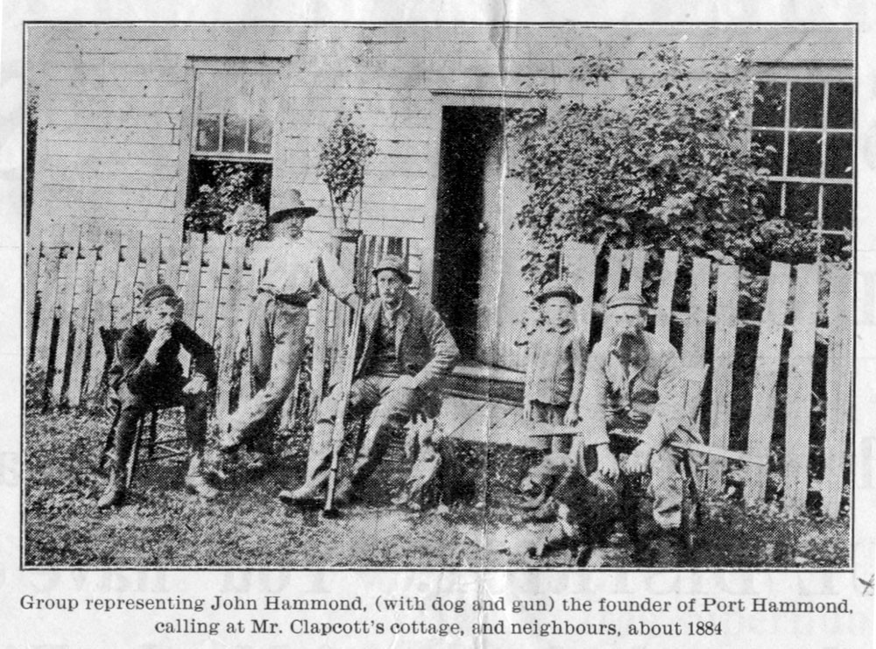

Yes, unfortunately, Amanda was only married for 6 years before her much older husband died. John Hammond died on December 9, 1909 in British Columbia, and was buried in Maple Ridge Cemetery, Greater Vancouver Regional District, British Columbia, Canada. According to information on Amanda’s findagrave.com memorial, she had moved back to Wilmington by 1912. Her father had died in 1906, and her brothers Joseph, Isaac Lewis, and Harry were operating I. Lewis Row & Co. at 413 King Street in Wilmington, a china, glassware, and home furnishings store [in 2022, the site of a burger bar, “The Farmer and the Cow”].
In the 1920 census for Wilmington, we find Amanda Hammond, widowed, age 55 (actually 65) as head of household, living with her brother Henry B. Row, 47 (actually 57). Neither are listed as having any occupation. Brother Joseph had died in 1916. The two siblings lived at 320 Seventh Ave., Wilmington, which is a vacant lot today (2022).
Amanda’s brother Henry B. died in 1925. In the 1930 census, she is still living by herself in the house at 320 Seventh Ave., claiming to be 65 (actually 75) and reporting that she was 38, rather than 48, at the time of her marriage. She is indexed for this census under the misspelling “Emenda Hamond.”
By the 1910 census, Amanda’s brother Isaac Lewis Hammond had married (1899) to Clara V. and moved to Ridley Park, Delaware County, Pennsylvania, where he ran a retail establishment. In 1910, Isaac was 49, and Clara was 35. They apparently had no children.
Amanda developed cancer, and died at the age of 78. Her certificate of death says that she was admitted to the NCCH on February 23, 1933, and died after 2.5 months of residence, on May 7, 1933. Her cause of death is listed as “cancer of bowels” with it also being noted that both of her feet were gangrenous. She had two surviving siblings at the time of her death, but her brother Isaac was already living in Ridley Park, Pennsylvania (and would have been 75 years of age). Her sister Henrietta, age 74, was a long-term patient at the Delaware State (Mental) Hospital, next door to NCCH, but would have been in no condition to help with funeral planning or expenses (more about Henrietta, below). Thus, Amanda, who came from a relatively wealthy family, and married into a wealthy and prominent family, none-the-less ended up in the NCCH Cemetery. Before we leave Amanda’s story to explore the stories of her two sisters, I feel obliged to comment on Mr. Cotton’s assertion in 2000 that Amanda had been a mail-order bride from Boston, Massachusetts. I’ve asked him the source of this tidbit of information, but have not heard back from him. We will likely never know why Amanda did not marry before the age of 48, nor when, where, and how she met John Hammond. Mysteries abound, as always.

Amanda’s Certificate of Death

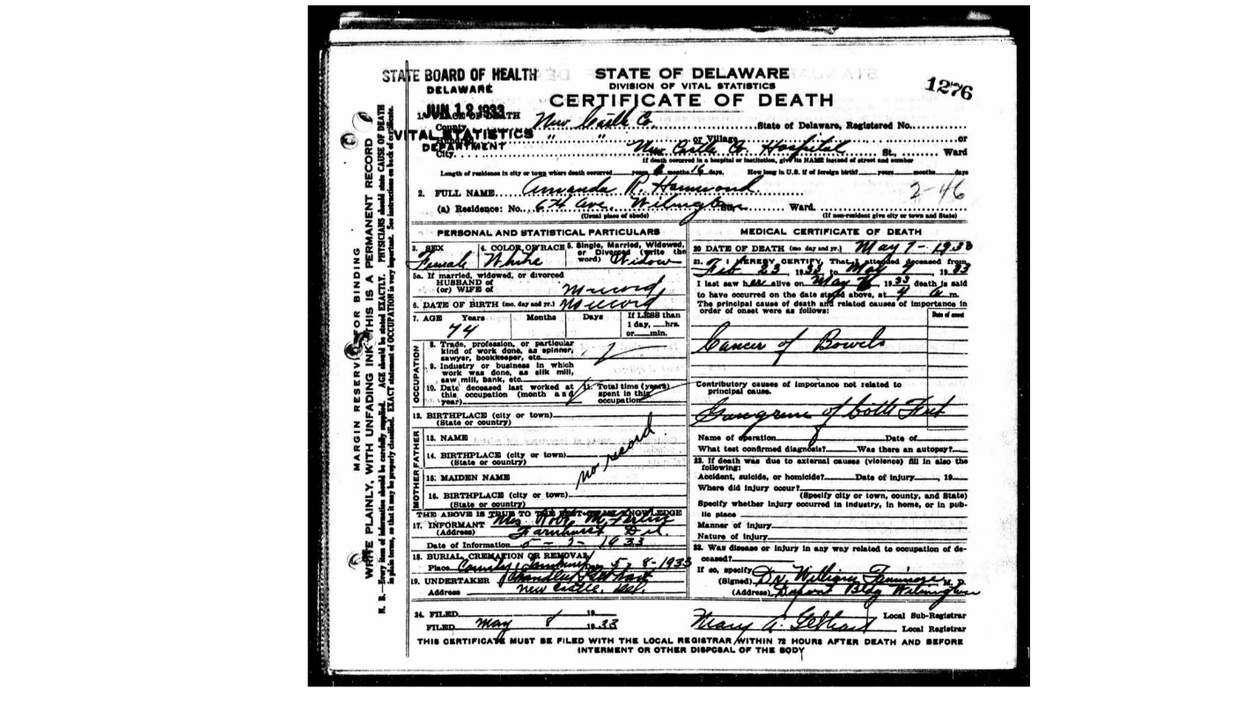

Amanda’s father Bernard Row’s obituary from 1906

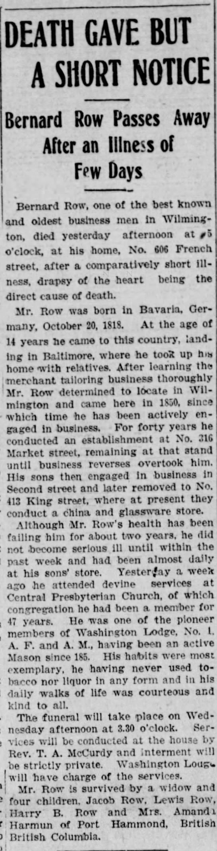 Evening Journal, 11/12/1906

Certificate of Death for Isaac Lewis Row, one of Amanda’s brothers:
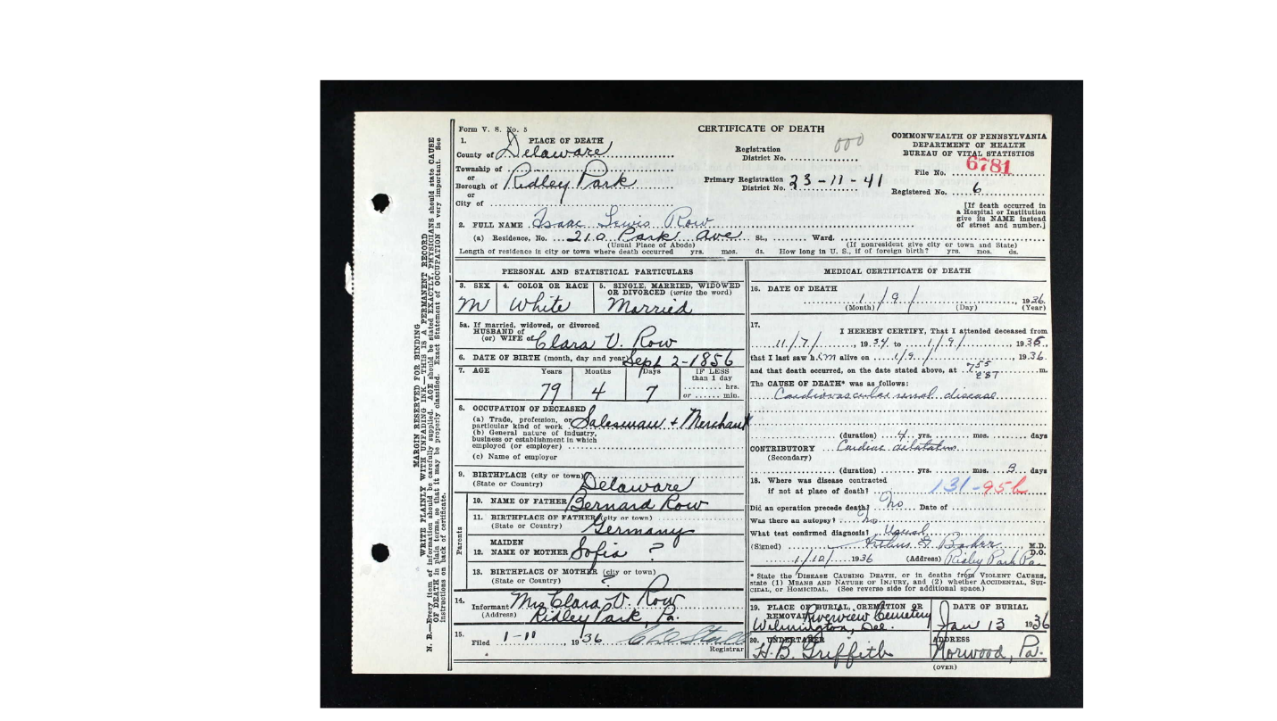

So what about Amanda’s sisters Helen Pauline Row and Henrietta Row? Both ended up having difficult lives.

Amanda’s older sister was named Helen/Hellen Paulina/Pauline Row, but she apparently went by “Nell” and/or Pauline. She was born in 1853 in Wilmington, Delaware. At the age of 20, on January 1, 1873, she married Samuel D. Strasburger of Pittsburgh, Pennsylvania. Once again, it isn’t clear how someone from Wilmington met someone from so far away, but both parties to the marriage were from financially well-to-do Jewish families. The marriage was reported both as having taken place in Delaware (with the bride’s named misspelled as Helen Carlina Row) and in Pittsburgh, Pennsylvania. The marriage was reported in the Delaware State Journal on January 25, 1873.

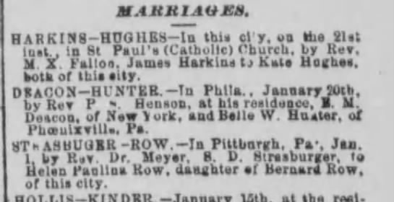

The Strasburger brothers included Samuel D., Abraham (d.1905, as Treasurer and Manager of National Glass Company in Pittsburgh), Isaac, and Nathan O. (Secretary of Vulcan Foundry and Machine Company in Pittsburgh). They were the children of David Strasburger and Louisa Katzenstein, and also had several sisters.
Samuel D. Strasburger was a glassware dealer and President of the Atlantic Glass Company, in Pittsburgh. Pittsburgh was well-known for both its steel foundries and its glass companies. Samuel D. Strasburger was born on August 13,1845. He married Helen Pauline Row in 1873. Together, they had two children, “Nell” and Daniel (see more about the children and grandchildren below).
After her marriage in 1873 and her children’s births in 1873 and 1875, Helen Pauline Row Strasburger died in 1877. She has no certificate of death, and no obituary. She was buried, for unknown reasons, under her maiden name, as H. Pauline H., in Troy Hill Jewish Cemetery (a different cemetery than the one used by her husband’s family and her children’s families). There is no documentation that I could find that would explain how she died, why she was buried under her maiden name, or in a different cemetery, and why in later years her children’s public records would say that their mother was “unknown.” There are no news stories about her death or any breakup of her marriage. One is very tempted to speculate that she died in childbirth, along with the child, and that the child was not her husband’s, but that is 100% speculation on my part. She is listed both as Pauline H. and H. Pauline on www.findagrave.com https://www.ancestry.com/discoveryui-content/view/135318509:60525?tid=&pid=&queryId=6b9077fb6a9731a3f5aa3a60f2584fc1&_phsrc=bZl7605&_phstart=successSource

After the death of his wife in 1877, Samuel D. Strasburger raised his two children alone. In the 1880 census he was living with his parents and his two children in Allegheny City (annexed into Pittsburgh in 1907). He reports that he is widowed. His occupation is “glass merchant” while his father is a “gent” and his mother is a housekeeper. The household is listed under “S. Strausberger.”
He ran his glass company in Pittsburgh for many years until his death in 1915. He never remarried or had any more children. He made the newspapers twice for very different reasons:

Pittsburgh Daily Post, 9/14/1885

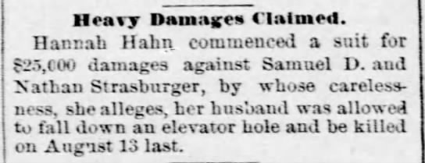

Pittsburgh Dispatch, 4/8/1892

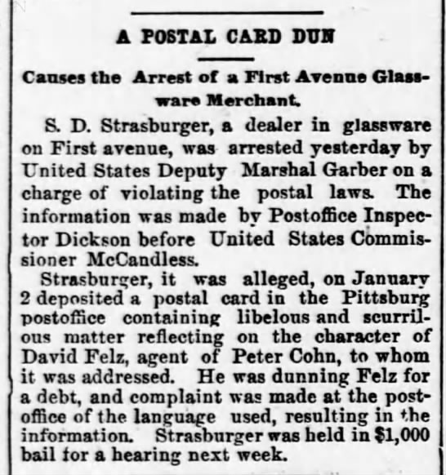

Samuel D. Strassburger died on January 2, 1915 at the age of 69, when he was living at 1222 Franklin St., Northside Pittsburgh. His obituary was published in the local papers, the Pittsburgh Daily Post, on January 3, 1915, as well as San Francisco, and Cincinnati and Cleveland, Ohio. He was buried in Westview Cemetery in Pittsburgh, where many other members of his family were buried. We know that in 1900, he was in Paris, France. Samuel was a member of the Tree of Life Congregation in Pittsburgh

Obituary for Samuel D. Strasburger of Pittsburgh, 1915

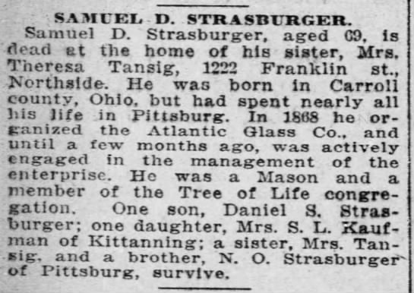

Pittsburgh Press, 1/4/1915

Children and grandchildren of Ellen Pauline “Nell” Row Strasburger and Samuel D. Strasburger

NELL: Daughter Ellen Pauline “Nell” or “Nellie” Strasburger was born on October 7, 1873, 10 months after her parents were married. She lost her mother when she was 4 years of age.
Nell spoke at her high school graduation exercises in 1891:

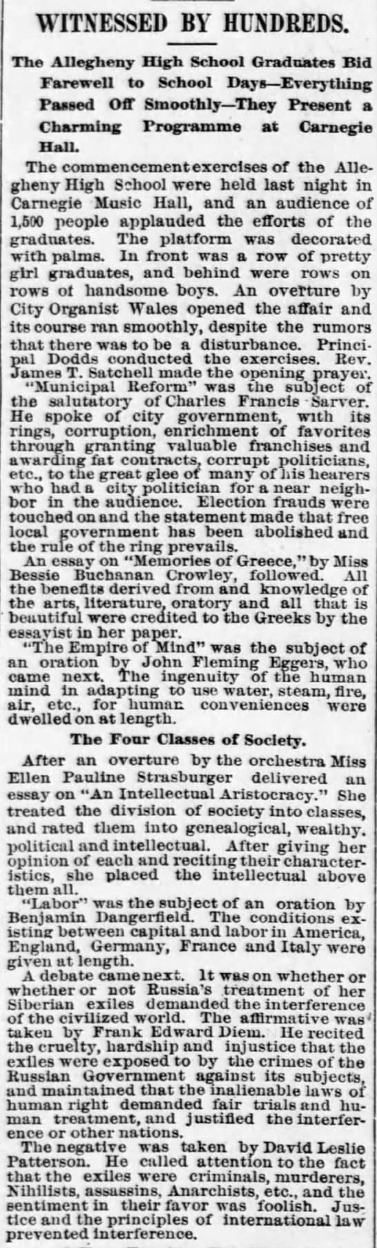 Pittsburgh Dispatch, 6/24/1891
Nell made her “debut” into society in 1892, at the age of 19. “Society” column of the Pittsburgh Press, 10/11/1892:

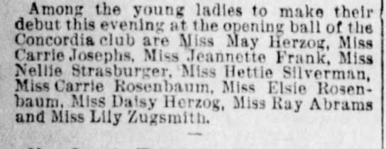

On April 14, 1897 Nell was married to Sydney Louis Kaufman (2/26/1869-11/14/1922) and they had two children together, Sydney Jr. in 1898 and Pauline in 1899 – but they had no grandchildren.

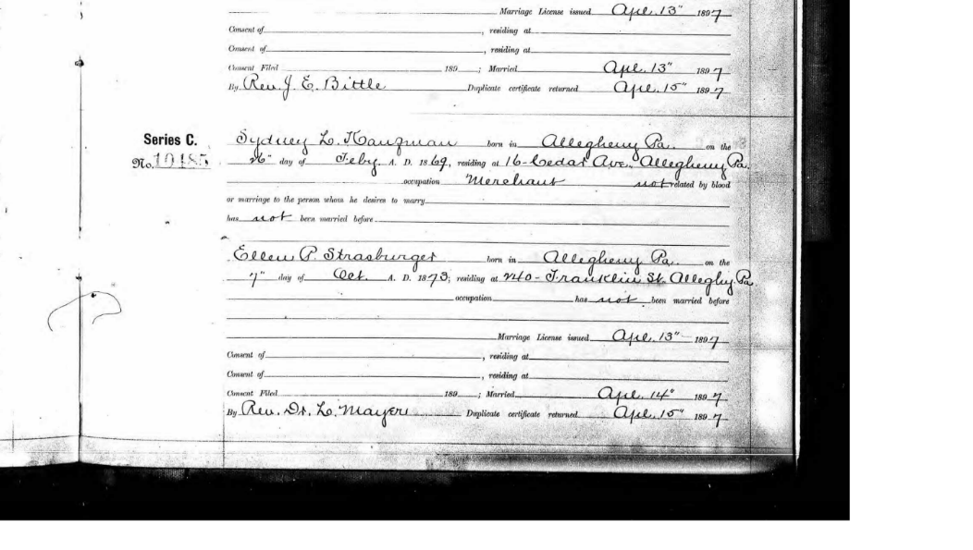
Sydney Kaufman Senior was the son of Simon and Sibilla Kaufman [no relation to the Edgar Kaufmann family of Fallingwater and department store fame; Simon ran a pantaloon company and was president of the Pittsburgh Writing Machine Company]. Nell and Sydney lived in Kittanning, Pennsylvania for many years, as evidenced by the 1900, 1910, and 1920 census records. Sydney Kaufman Senior died suddenly, and his obituary was published in the Pittsburgh Jewish Criterion 11/17/1922. After his death, the family moved back to Pittsburgh, to 5878 Darlington Rd., a large row house in the Squirrel Hill neighborhood. In the 1930 census, both children were still living there with their mother, as single adults.
After Sydney Kaufman’s death in 1922, Nell went to France at some point, and travelled back New York in 1934 at the age of 54. Nell died in 1934 at the age of 61 of breast cancer which had metastasized to her abdomen. She was buried in the West View Cemetery.
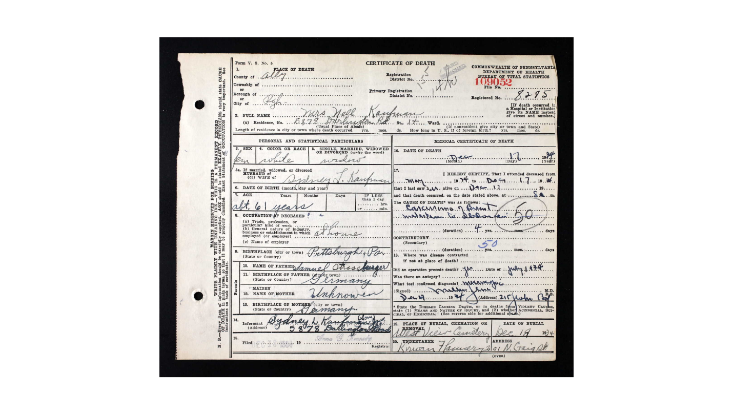
Pittsburgh Post-Gazette, 12/18/1934

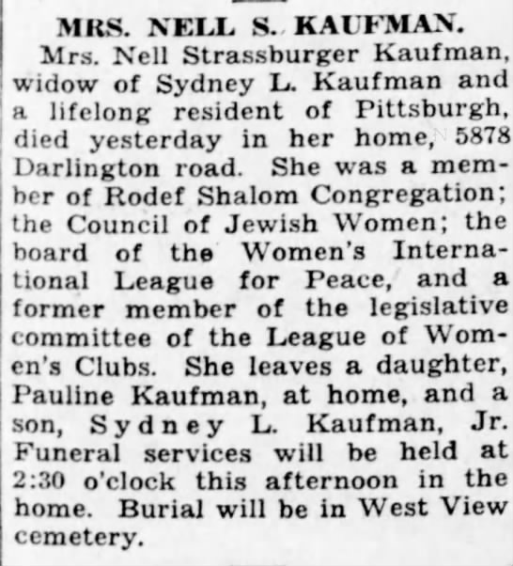

Sydney Kaufman, Sr. and “Nell” Kaufman had two children, Sydney Jr. and Pauline.
- Sydney L. Kaufman, Jr. was born in 1898, and married Lucille Arnold in Pittsburgh. Sydney Kaufman, Jr. and Lucille Kaufman apparently had no children.

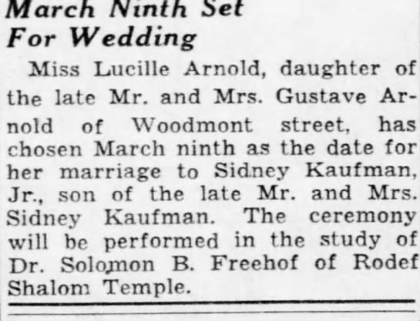 Pittsburgh Post-Gazette, 2/22/1939

Sydney Kaufman, Jr. died on 12/28/1975, his obit from the Pittsburgh Press, 12/29/1975:

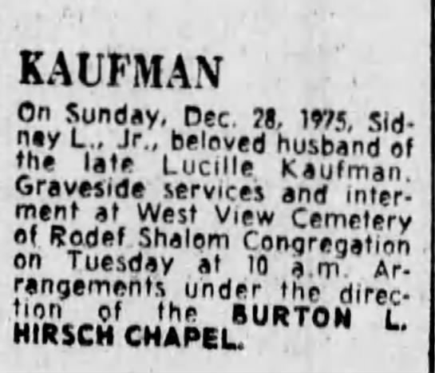

- Pauline Sibilla Kaufman was born in October 1899 in Pittsburgh, and moved to New York City at some point. She was married to Sidney Schoen on April 14, 1938 and died on May 15, 1967. She is buried at West View Cemetery in Pittsburgh. She was a social worker. Pauline and Sidney Schoen apparently had no children.

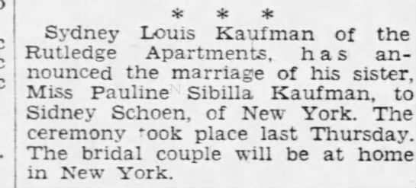 Pittsburgh Press 4/18/1938
5/18/1967 Obituary of Pauline Sibilla Kaufman Schoen
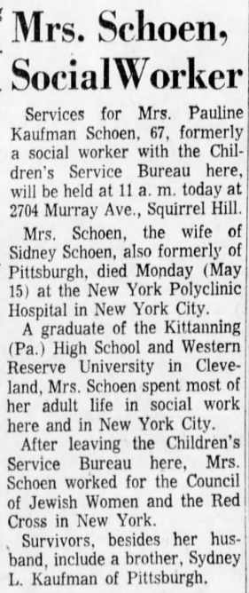

DANIEL: Son Daniel S. Strasburger was born October 9, 1875, so he was only two when his mother died. In the 1880 census he was living with his father, sister, and paternal grandparents. In the 1900 census, he was living with his Uncle Isaac Strasburger and his wife Amanda. I can’t seem to find Samuel in the 1900 census (he may have been in France when the census taker came by), but by 1910, Daniel is back living with his father and his father’s sister Teresa Tausig and her son David Tausig. In these census records, the last name is “Strassburger.” In 1911, Daniel married M. Augusta “Gussie” Rosenthal. In the 1920 census, Daniel and Gussie were living with her parents, an aunt, and two servants in a house is Swissvale, just east of Pittsburgh. Their son Raymond was 3 years of age. Daniel and Gussie had three sons, but only Raymond survived to adulthood.
  - Daniel Samuel Strasburger, Jr. was born on April 14, 1912 and died on July 6, 1918 of gastroenteritis. He is buried in West View.
  - Raymond Edward Strasburger was born on December 31, 1916, and died on March 20, 2008. By 1984, he had moved to Hollywood, Florida. He and his wife Elaine Moses Strasburger had two daughters, and they also have descendants. [See photo below].
  - Edward Strasburger was born in 1922 and died in 1935 of a “thymus gland attack” that led to “strangulation of the heart” while in the act of jumping into a swimming pool. He is also buried at West View Cemetery, Pittsburgh.

Daniel eventually retired as the owner of Atlantic Glass Company, taking over from his father, the founder.
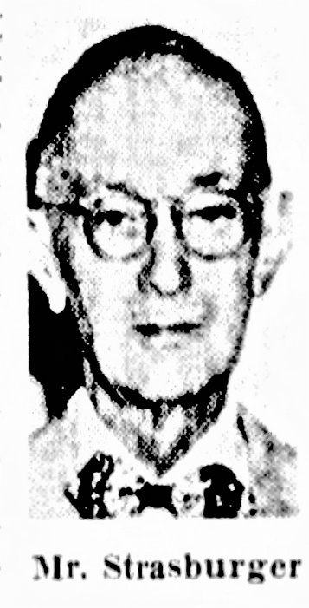 Daniel died on July 10, 1954 of pneumonia and heart disease at the age of 78. He is buried at West View Cemetery. Gussie died on July 31, 1980, and is also buried in West View.

Raymond Strasburger, Taylor Alderdice High School, 1934, Helen Paulina Row Strasburger’s grandson, Daniel Strassburger, Sr. and Gussie Rosenthal Strasburger’s son.
