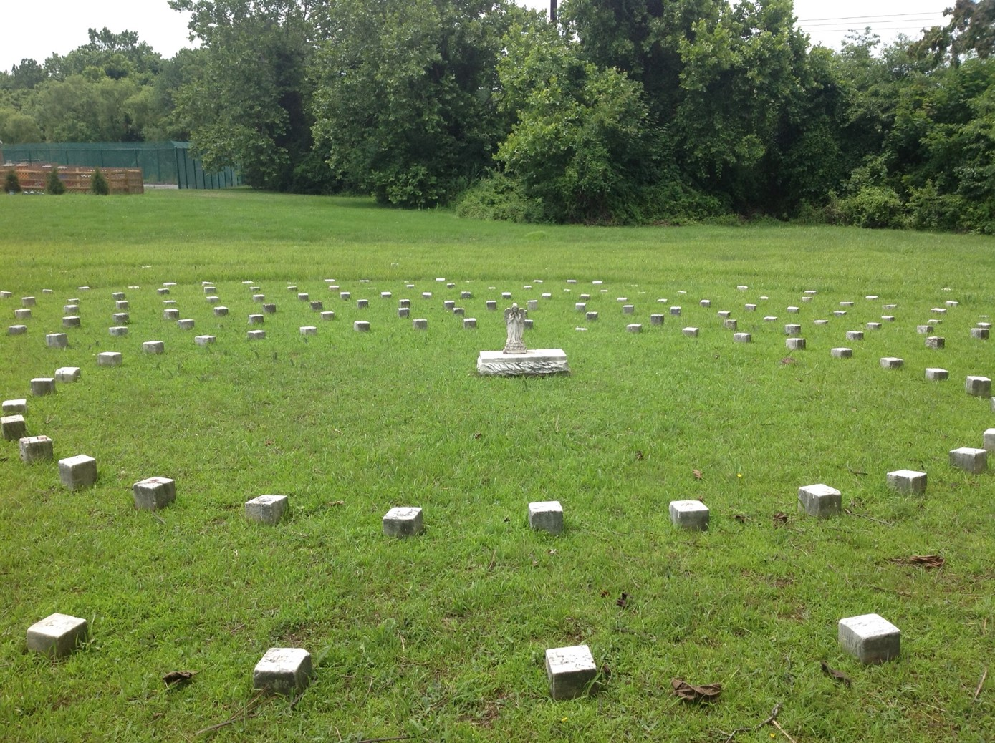

A BRIEF HISTORY OF THE DELAWARE STATE HOSPITAL
& THE SPIRAL CEMETERY

Written by Katherine A. Dettwyler with assistance from Faith Kuehn & members of
the Friends of the Spiral Cemetery Committee & the Creative Vision Factory
May 2016
©Katherine A. Dettwyler (text)

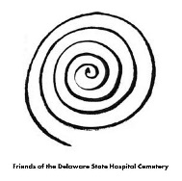

INTRODUCTION

Beginning in the late 1700s, the State of Delaware took steps to provide care for any of its citizens who could not care for themselves, including those diagnosed with mental illness. In 1889, the state purchased a building and land from New Castle County and created the Delaware State Hospital for the Insane at Farnhurst – consolidating the insane from all three county almshouses in one location. The hospital opened its doors on August 1, 1889 with 99 patients. In its early decades, the hospital cared for people with mental illness, developmental disabilities, traumatic and acquired brain injuries, seizure disorders, dementia, substance use disorders, and other conditions.

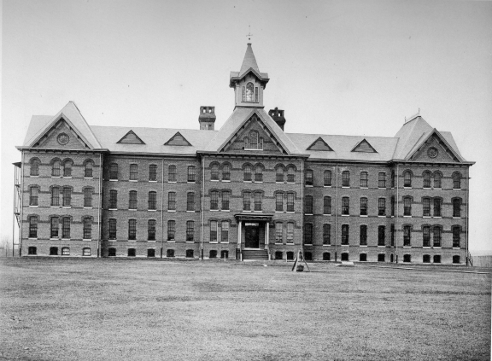

Delaware State Hospital shortly after it opened in the 1890s

Early on, it was decided that the hospital needed a dedicated cemetery for patients who died at the hospital and had no family or friends to claim the body, or whose family and friends could not afford to provide for their burial elsewhere. The cemetery was originally located northwest of the hospital (today’s “Main Administration Building”), where the Carpenter Shop stands today. It was designed in a circular pattern, similar to a number of post-Civil War national cemeteries. Graves were marked with numbered granite markers placed in concentric circles, with garden pathways in between. Burials in the hospital’s cemetery began in 1891 and

continued until 1983. The names were recorded in a hand-written “Cemetery Book,” which now resides in Dover at the Delaware Public Archives. This information is now available online through www.findagrave.com (search on the cemetery name, Delaware State Hospital), and also through the cemetery app developed by Jimmy Kroon.

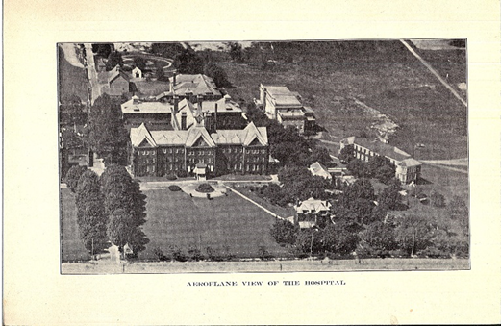

Aerial view of the DSH with the original cemetery visible at the upper left corner of the image (see blue arrow), prior to the mid-1920s

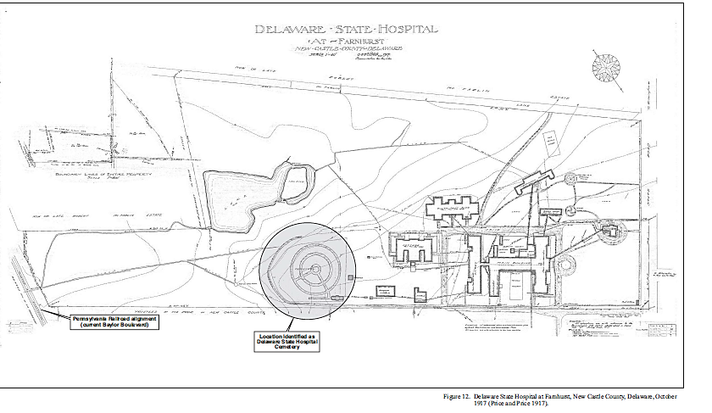

Diagram of the DSH site showing the location and layout of the original cemetery

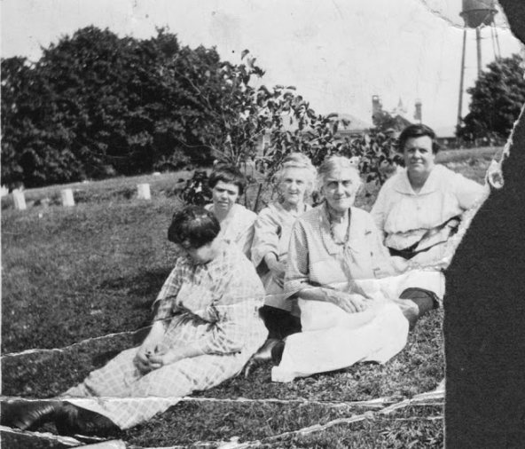

DSH patients with a caregiver at the site of the original cemetery

In 1926, the cemetery (with approximately 350 burials) was moved to its current location across from the Springer Building (which had not yet been built).

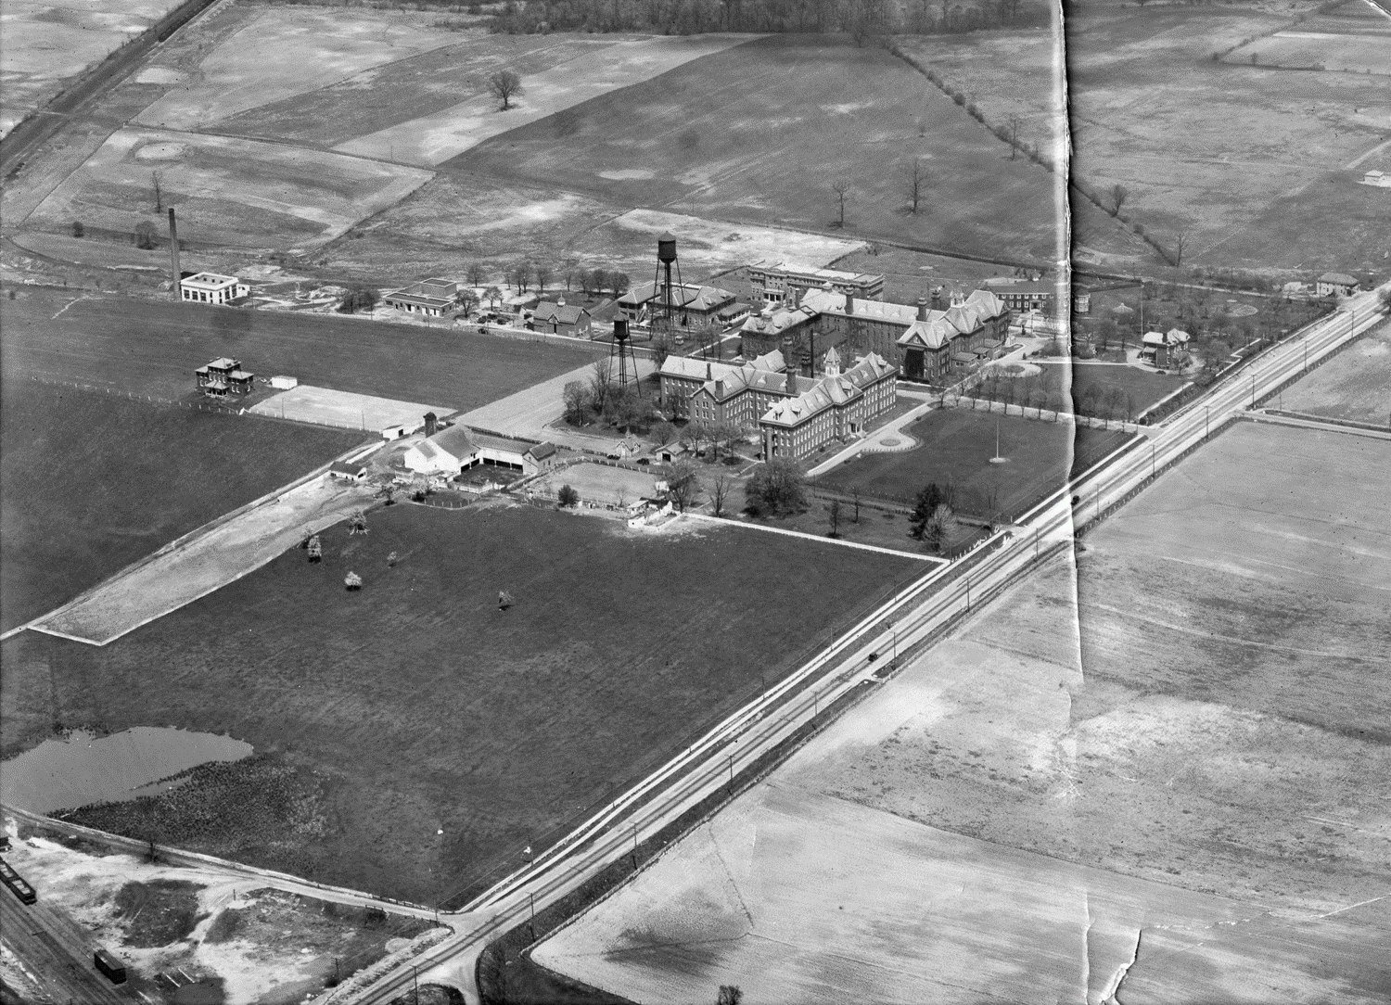

Aerial view of the Delaware State Hospital shortly after the Spiral Cemetery was relocated from its original location (see orange arrow) to its current location (see blue arrow)

The cemetery was closed in 1983 when the current New Castle County Potter’s Field was opened adjacent to the Baylor Women’s Correctional Institution. There is little documentation about the cemetery, although it is known that some individuals had wooden coffins and were provided funeral services in the chapel or at the graveside, attended by family, friends, and staff members. The Reverend Charles Bratten Dubell of Wilmington presided at a number of the funerals at the Spiral Cemetery around the turn of the century. Rev. Dubell was an Episcopal priest, and was the son of Charles Ellis Dubell, who owned a hat store in Wilmington for many years.

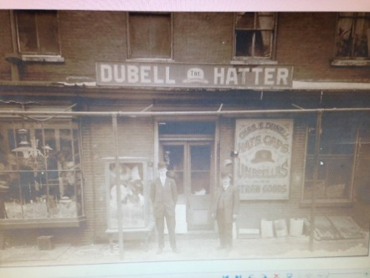 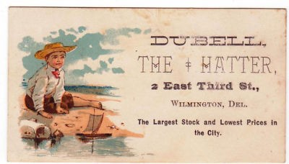 Dubell’s hat store

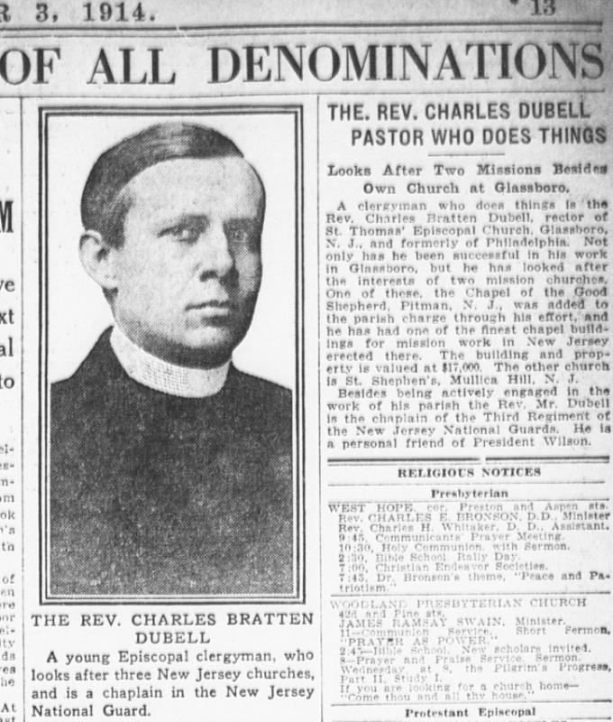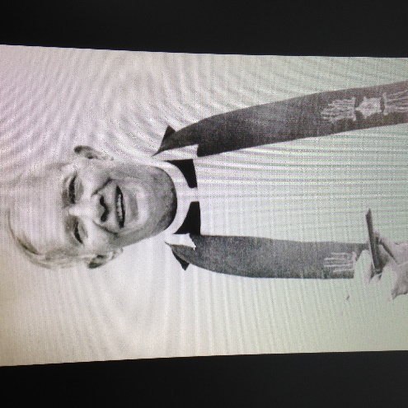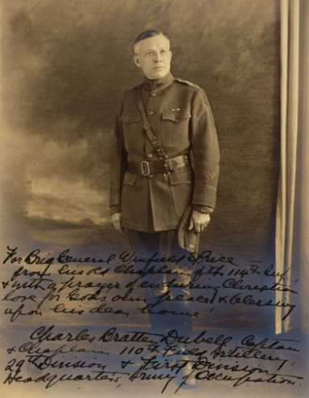

Images of Rev. Charles B. Dubell, courtesy of Art Dubell of New Jersey and the
New Jersey National Guard Photo Collection

At some point prior to 1954, a row of trees and shrubs was planted enclosing the cemetery. It was probably originally meant to demarcate and beautify the cemetery, but the growth of the vegetation over the years blocked the cemetery from view so effectively that it was essentially forgotten over time (see images below). By 2000, many long-time employees on the campus were not even aware that the cemetery existed. In 2013, under the leadership of Dr. Kevin A. Huckshorn, interest was rekindled in restoring the cemetery and honoring those buried within. Since that time, the Friends of the Spiral Cemetery Committee has been working to clean up the site, clarify exactly who is buried here, build the monument listing the namesand marker numbers, and install a Historical Marker to recognize the significance of the site.

The following series of aerial photographs shows the growth of the trees and shrubs around the cemetery from 1954 to 2010.

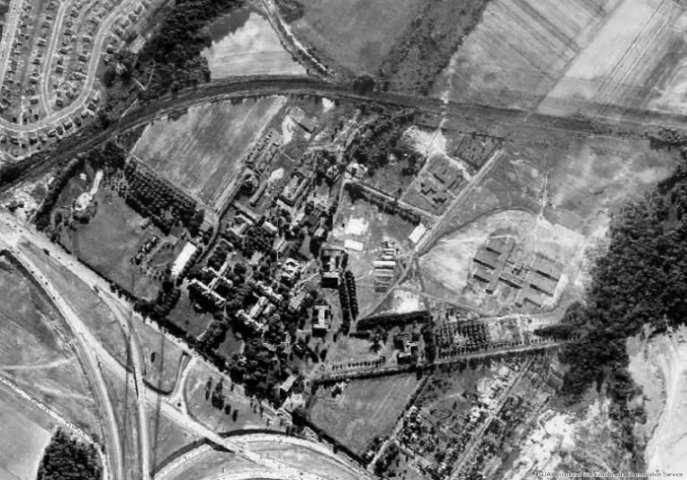 1954

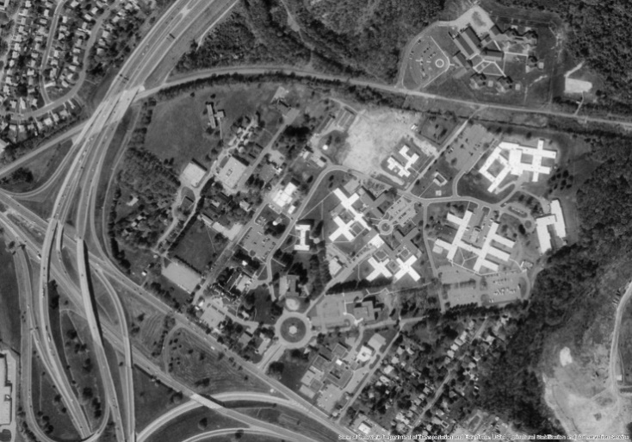 1997

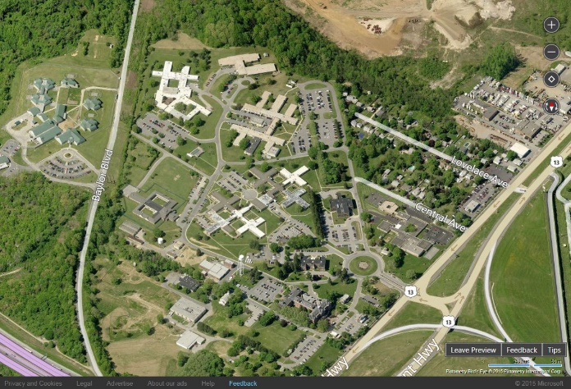 2010

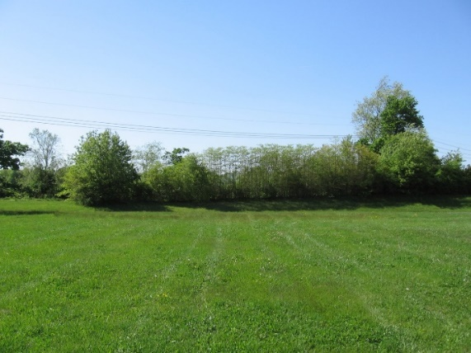 2010 street view before bulldozer

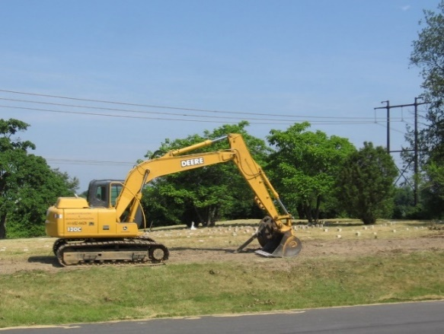 2010 street view after bulldozer

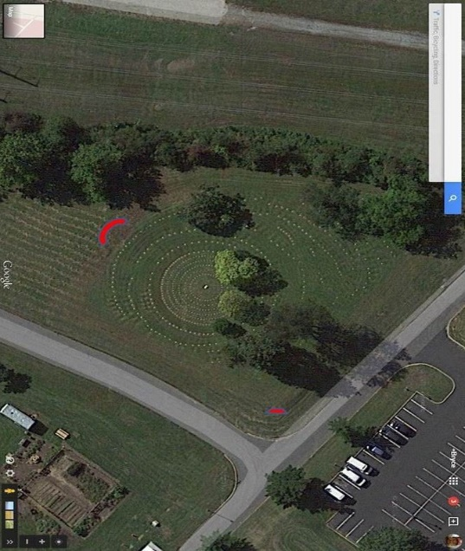

Aerial view of the cemetery in 2016 with the location of the monument and historical marker marked in red
DESIGN AND BUILDING OF THE MONUMENT

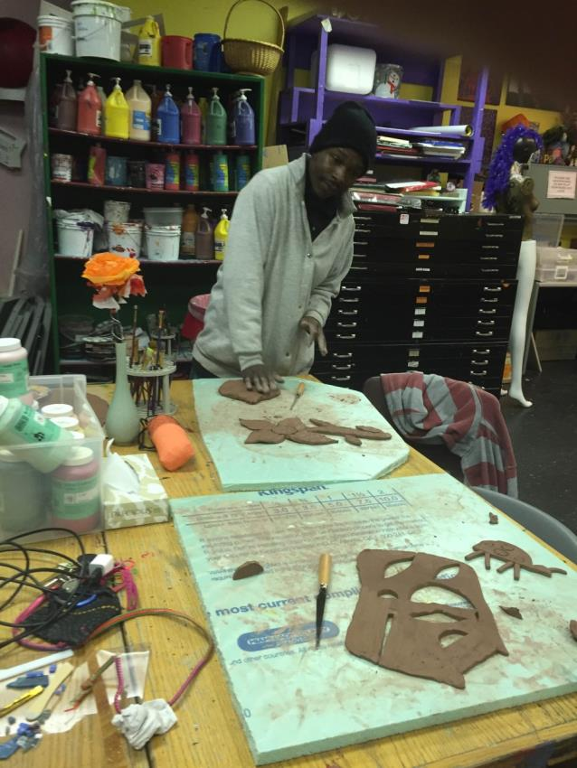
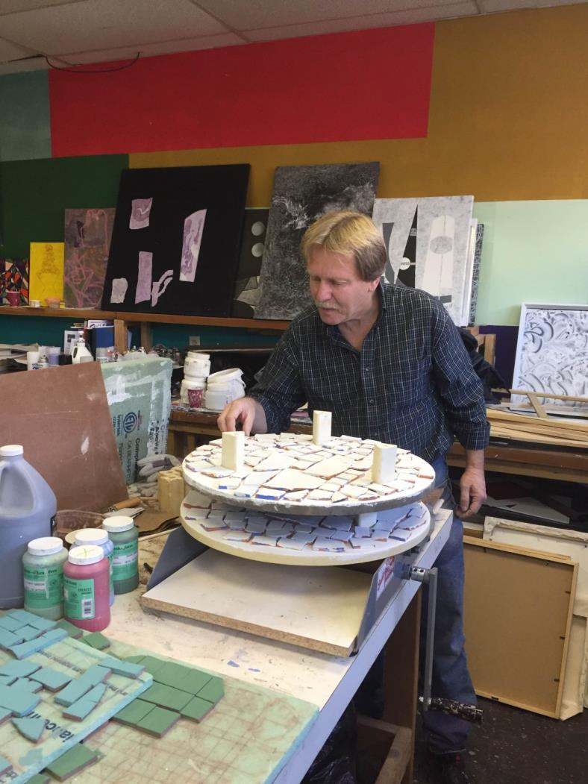
Peer artists working on tiles for the monument at the Creative Vision Factory

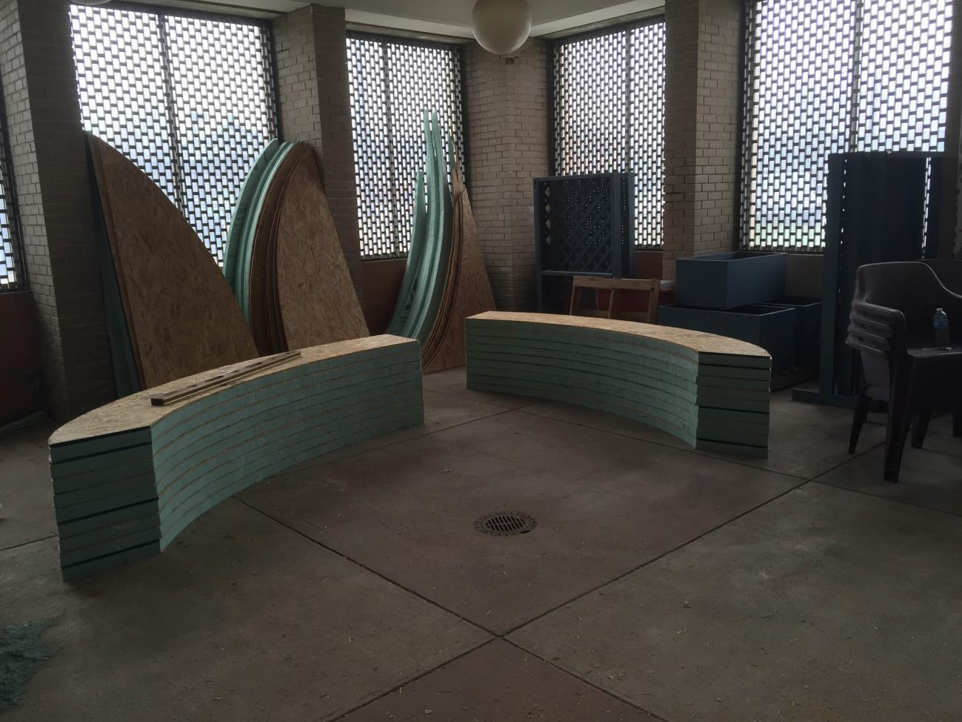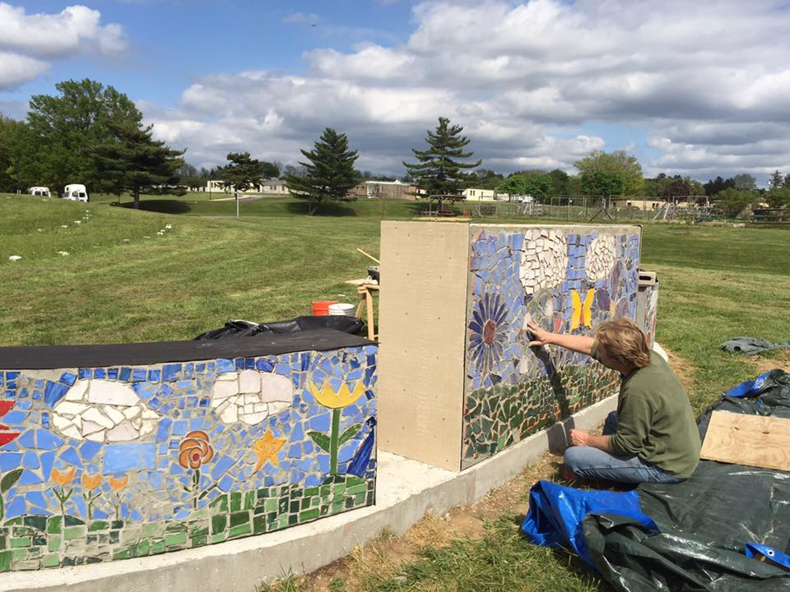
Monument under construction at DPC

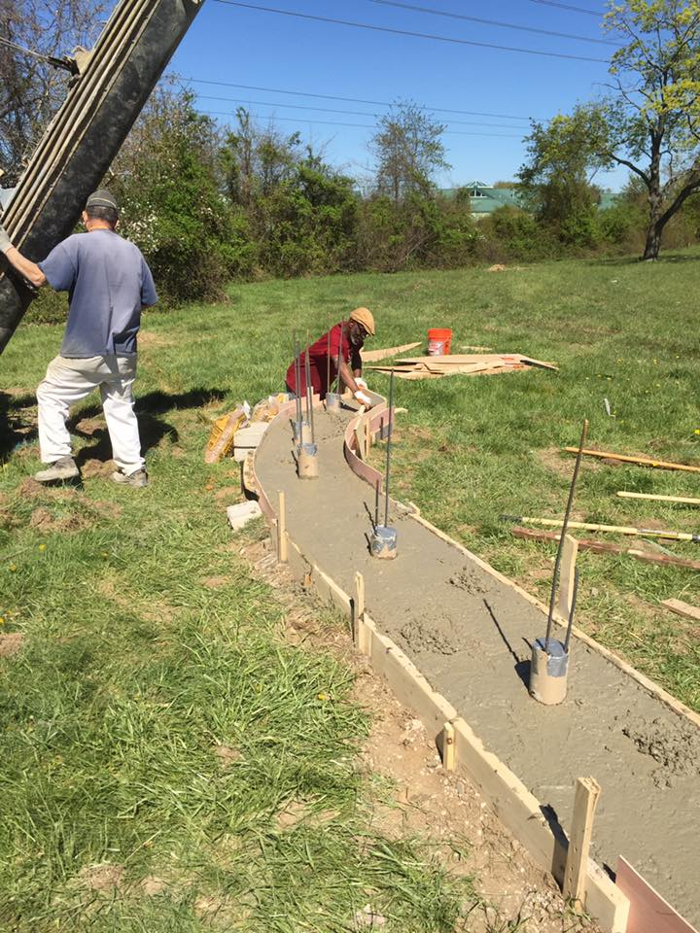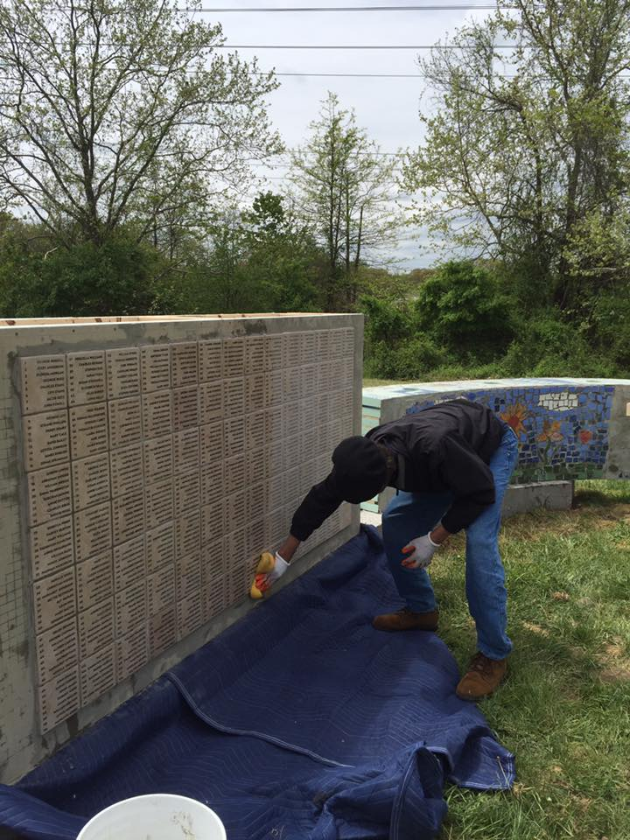

More images of the monument under construction in May 2016 at the site

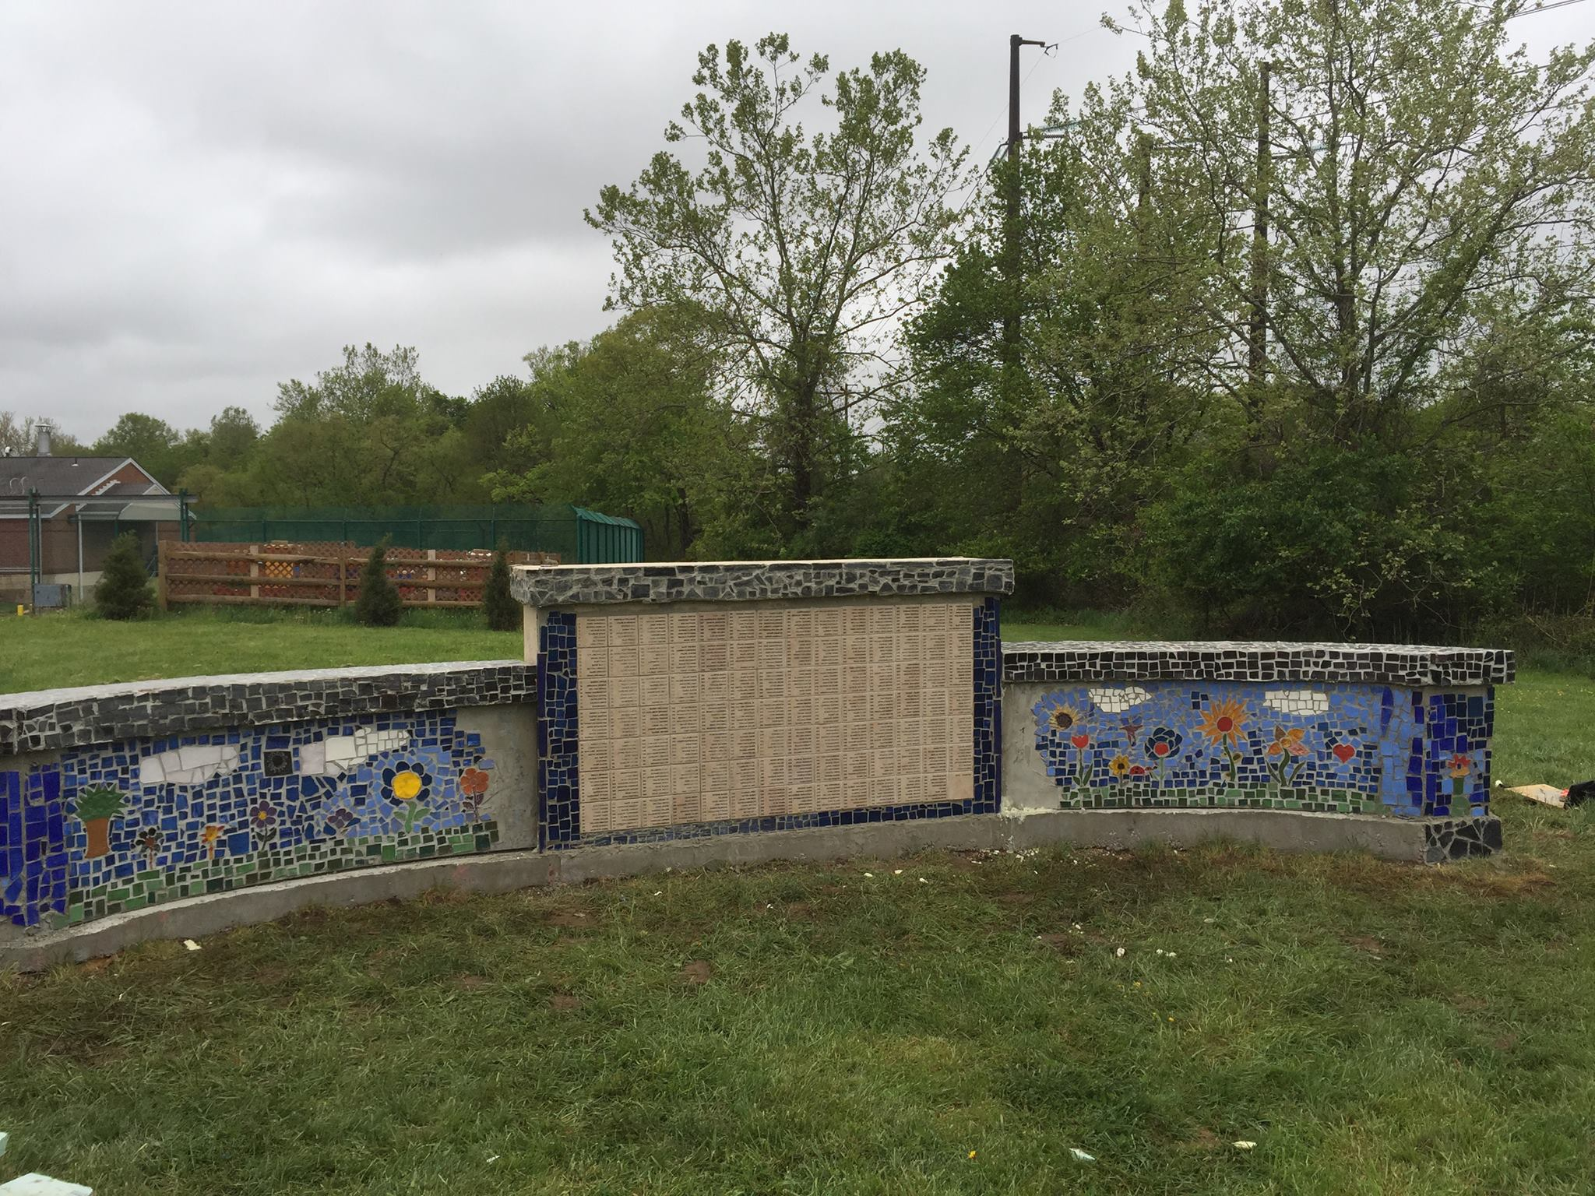

DEDICATION CEREMONY MAY 9, 2016

Friends of the Spiral Cemetery Committee: Dana Chant, DHSS, DSS—Indigent Burial Program; Katherine A. Dettwyler, Ph.D.—Department of Anthropology, University of Delaware; Holly Dixon—DSAMH, Peer Services Director; Clare Garrison—DSSC, Delaware State Office of Volunteerism; Bryce Hewlett—Delaware Consumer Recovery Coalition; Michael Kalmbach—Creative Vision Factory Director; Faith Kuehn, Ph.D.—DDA, Environmental Program Administrator and Chair of the Committee; Ashley McCabe—DSAMH, Peer Services Program Coordinator; Pat McDowell—NAMI Delaware; John McDermott—DHSS, DMS, Facilities; and Alexia Wolf—DSAMH, Quality Outcomes Review Manager.

Dedication Ceremony Program:
Welcome DHSS Cabinet Secretary Rita Landgraf
Comments Governor Jack Markell
The Project Faith Kuehn, Friends of the Spiral Cemetery
A Peer Perspective Karen DiNardo, Director of Inpatient Peer Support and Community Services, Mental Health Association/DPC
Honoring those Buried Katherine A. Dettwyler, Department of Anthropology, UD, Profiles of a few of the people buried in the Spiral Cemetery; Larence Kirby, Executive Director, DCVA, Profiles of the military veterans
Poem Delaware Poets Laureate Nnamdi Chukwuocha and Albert Mills
Music “A Change is Gonna Come” DPC Music Therapists Petie DelPizzo and Audrey Haussig [reprinted below]
Monument Dedication William G. Slowik, Jr., Creative Vision Factory
Marker Dedication Senator D. McBride and Representative J. Johnson
Laying of the Tributes DPC peers with Art Therapist Chris Byma
Closing Words Faith Kuehn, Friends of the Spiral Cemetery [reprinted below]
Prayer/Benediction Reverend William Boatwright, DPC Chaplain
Ringing of the Bell Invitation to all guests
Refreshments The Hospitality School & Pineapple Catering
Music Delaware State Police Pipes & Drums

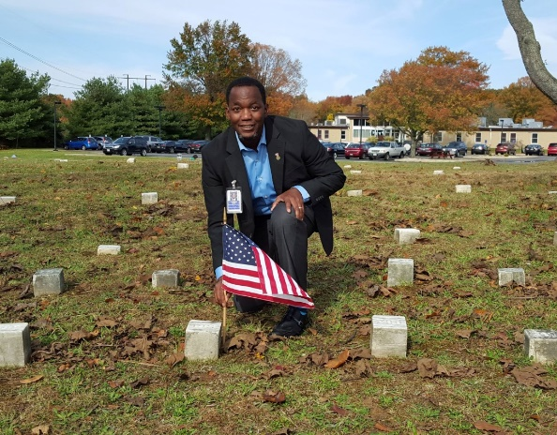

Larence Kirby, Executive Director, Delaware Commission on Veterans Affairs honoring Arnold Morris (#199), an African American veteran of the Civil War (Union)

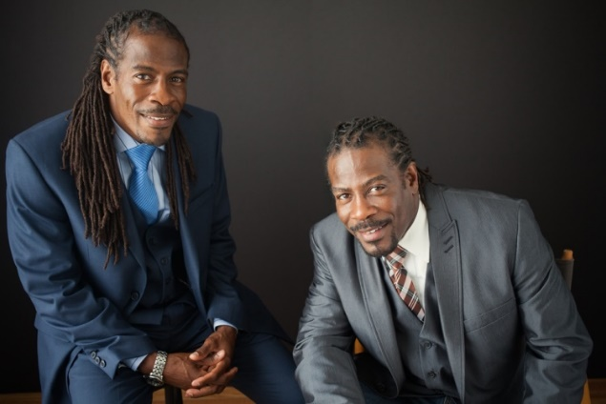
Nnamdi Chukwuocha and Albert Mills, Delaware’s Poets Laureate

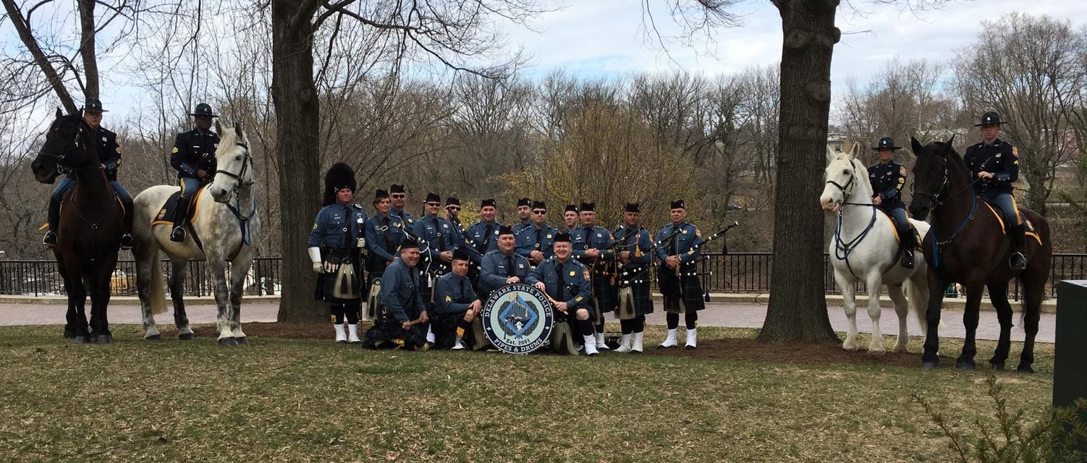
Delaware State Police Pipes and Drums

"A Change Is Gonna Come" I was born by the river in a little tent Oh, and just like the river I've been running ever since. It's been a long, a long time coming But I know a change gon' come, oh yes it will. It's been too hard living, but I'm afraid to die,'Cause I don't know what's up there beyond the sky. It's been a long, a long time coming But I know a change gon' come, oh yes it will. I go to the movie and I go down town Somebody keep telling me don't hang around. It's been a long, a long time coming But I know a change gon' come, oh yes it will. Then I go to my brother And I say, "Brother, help me please." But he winds up knockin' me Back down on my knees. There been times that I thought I couldn't last for long But now I think I'm able to carry on. It's been a long, a long time coming But I know a change gon' come, oh yes it will. Lyrics and music by Sam Cooke.

REMARKS BY FAITH B. KUEHN
Spiral Cemetery Dedication, May 9, 2016

INTRODUCTION – THE PROJECT

Good afternoon. On behalf of the Friends of the Spiral Cemetery, thank you for being here today to help us mark this important occasion.
The Friends have been working toward this day for several years. Friends’ members have brought different perspectives to this project, and were drawn to it for individual reasons. Yet we all believe in the importance of restoring the dignity of those buried here. We believe that the Spiral Cemetery in its former state, largely forgotten and hidden from view by a tangle of trees, helped to perpetuate a negative stigma about people who lived and died in Delaware’s State Hospital. The Friends feel strongly that a measure of our humanity is how we treat others – both the living, and the memory of those who have lived.
The Friends have coordinated the building of a monument, the installation of a Historical Marker, and the development of a history document about the Delaware State Hospital and its people. Today’s Dedication Ceremony will unveil the monument, the marker and the history document. Today’s Dedication Ceremony is a celebration of restored dignity.

CLOSING WORDS

One way that we mark our reverence for life is to bury the dead in a place we call sacred. Everyone is entitled to a proper burial in such a place, set aside as sacred, such as a cemetery. But a cemetery is much more than a place for the remains of the dead. It also a place for the living. A cemetery is a place for us to honor life. When we visit a cemetery, we often leave a remembrance: perhaps a stone or flowers on a tombstone, a wreath or flag for someone who has served our country, a prayer for a departed friend or loved one.
Some cemeteries have grand monuments of carved marble, and manicured lawns landscaped with beautiful trees, flowers and shrubs. But honor and dignity don’t need to be grand and formal.
The Cemetery Project has restored dignity to those buried in the long-obscured graves in the Spiral Cemetery. We may not know any of the dead, but the people buried there and the lives they lived are part of our shared history. The cemetery is no longer hidden behind overgrown shrubs. It is open to the world, to our lives and these times. Those buried in the Spiral Cemetery are not simply a marker number, now they are also a name, a person.
Last week, there was no sign by this cemetery. You had to know it was there, figure it out, or ask someone. But today, there is a marker at the entrance of the Spiral Cemetery, naming the cemetery and noting its historical significance. Plants selected for installation around the marker are primarily old-fashioned varieties, to mirror the cemetery’s place in time. These plants will provide interest and color in each of the four seasons, acknowledging the seasons of life.

The monument listing the names has been built by many hands and hearts of our peer Artists, Builders and Volunteers. Their work shows the power of art, how this beautiful monument can push back against the negative stigma associated with mental illness.
On behalf of the Friends of the Spiral Cemetery, I am very grateful for the dedication and support of all who have helped to bring this cemetery from a neglected corner of the Holloway Campus to a proud statement of the inherent worth and dignity of every human being.

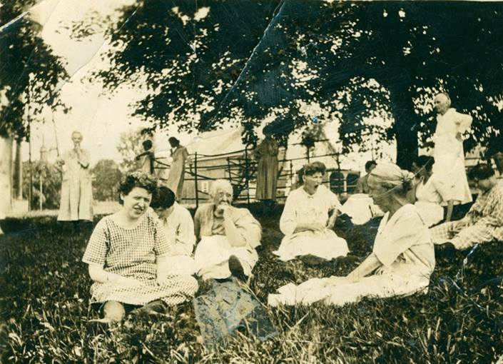

Patients enjoying the outdoors, early 1900s

WHO’S BURIED IN THE SPIRAL CEMETERY

Of the 776 people buried here, most were patients who died at the hospital. Some were immigrants from Europe while others were from surrounding states and other parts of the country. In addition to patients, three hospital employees were buried in the cemetery during times when the hospital was under quarantine due to epidemics of contagious disease. Several individuals were brought to the hospital after death for autopsies, and one arrived after a nearby car accident, and they were also buried in the hospital cemetery. Two babies – Baby Crumlish and Baby Boy Magee – were stillborn to hospital patients, and are also buried here. Graves #295 and #604 are empty, because the bodies originally buried there were disinterred and no one else replaced them. In addition, some 41 markers are missing. Many are probably just sunken beneath the surface of the soil or have been covered up by tree roots. The Friends Committee decided not to alter the arrangement or placement of the markers, leaving them as they have settled into the earth.
Demographic information: nativity. The cemetery holds mostly US-born citizens (651), but there are almost 100 people from other countries, including Germany (21), Ireland (16), Italy (15), and England (11). For some individuals there is no nativity information available.

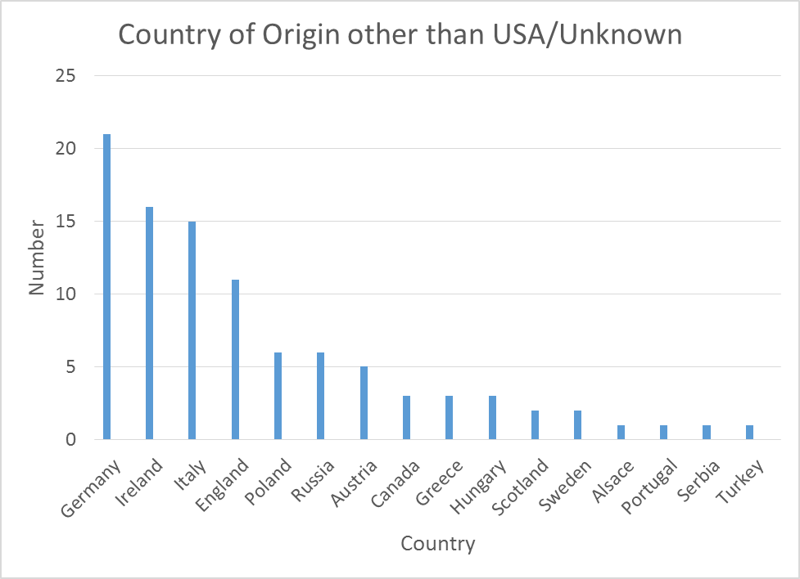

Most of the US natives are people who were born in Delaware (364), with Maryland (95), Pennsylvania (48), Virginia (42), and North Carolina (18) among the other states who contributed. Richard Heyl travelled the farthest, from his home state of Arizona, to be buried in grave #526. Again, some individuals have no specific information available about state of birth.

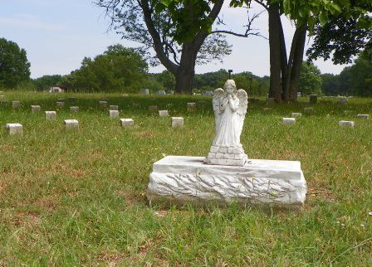

The Angel in the center of the cemetery

Demographic information: ethnicity & sex. For those of known sex, approximately 2/3 are males, and 1/3 female. For those of known ethnicity, 397 are African American, 373 are White, and 2 are Native American (Jane Soccum, #141, was a Delaware Native American; Richard Heyl, #526, was a Tonto Apache from Arizona).

Demographic information: age. With the exception of the two stillborn babies (Baby Crumlish, who has no marker, and Baby Boy Magee, #735) the youngest person buried in the Spiral Cemetery is two-year-old William C. Moore (#417), who was born with hydrocephaly and spina bifida, and who lived at the Delaware State Training School. He died at the age of two and was brought to DSH for an autopsy, then buried in the DSH cemetery. Other individuals ranged in age from 12 to 96 years, with most dying between the ages of 50 and 80 years (see graph). Patients usually died of conditions unrelated to their reasons for admission, including, most commonly, heart disease, stroke, and tuberculosis. The patient who lived the longest at DSH was Matilda Atwell (#703), who was visually impaired and cognitively disabled. She entered the hospital on April 8, 1903, and died there on July 5, 1963, at the age of 81, a stay of just over 60 years. Thomas Fields, of Virginia, is the oldest person buried in the cemetery. He died in 1967 at the age of 96 years after a brief stay in the hospital.

Military veterans buried in the Spiral Cemetery. There are at least three military veterans in the cemetery including Arnold Morris (#199) and John Cheffins (#104) who were Civil War veterans, and William Adkins (#427), who was a veteran of the Spanish-American War. Both Mr. Morris and Mr. Cheffins are featured in the Profiles section of this document (below).
DSH Employees buried in the Spiral Cemetery. There are three DSH employees buried in the cemetery, including Samuel McMullen, a supervisor (#102), and John Cheffins, a painter (#104), both of whom died during the 1902 smallpox epidemic, and Harland P. Williams, an attendant (#121) who died of diphtheria in 1904 at the age of 22 years. Because the hospital grounds were under quarantine for a serious contagious disease at the time of their deaths, they were buried in the hospital cemetery. John Cheffins also was a Civil War veteran.
Non-patients/non-employees buried in the Spiral Cemetery. Over the years, a number of individuals who had died elsewhere, and were never patients at DSH, were brought to the hospital to be autopsied in the morgue and were then buried in the Spiral Cemetery. These include the people buried in Graves #417 (the 2 year old, William C. Moore), 423 (William W. Jones), 428 (Irene Clark), and 747 (Willard L. Austin).
Other notable burials, in grave number order.
- Leon Pisa – Grave #38; a patient who was beaten to death by two attendants, who were later tried and convicted for Mr. Pisa’s murder.
- Maria Gaieta – Grave #189; she died of acute mania secondary to grief after the death of her daughter. She was in the hospital for only a few months before she died.

- John Hollis – Grave #213; he was an African American patient who is described in the ledger thusly: “. . . works on the wards and takes care of the little colored boys." Mr. Hollis died of TB at the age of 59.
- Joseph Segrella – Grave #245; Mr. Segrella was committed to DSH after becoming insane while incarcerated at the Workhouse for criminal assault upon a minor child. Originally he was sentenced to be hanged, but his sentence was commuted. He had tried to kill guard at the workhouse. He was brought to DSH in 1910 and died in 1915 of chronic parenchymatous nephritis (kidney disease).
- Robert Pyles – Grave #296; Mr. Pyles was cognitively impaired and was brought to DSH in 1912 under a court order after being arrested for stealing a horse and wagon. He died in the great influenza epidemic of 1918.
- Bertha Williamson – Grave #301; Miss Williamson is described as a white woman, age 37, and as being ‘mentally deficient.’ When she came to DSH in 1912 she was covered with bruises and welts as though she had been beaten with a belt. She was from Lincoln City, Sussex County. She died in 1919.
- Levi Johnson – Grave #422; “Flying Whispers” patient; admitted Feb 15, 1897 at age 44, died Sept 25, 1933; he had hereditary dementia, and used to hear voices, with onset at age 30. [Dr. Dettwyler’s book on patients from the hospital – whenever she finishes it – will be titled Flying Whispers, Broken Dreams: Long-Forgotten Stories from the Delaware State Hospital at Farnhurst, 1894-1920.]
- William Dyatt – Grave #486; Mr. Dyatt is a classic example of a patient who ended up at DSH due to an acquired brain injury. As a child, he was fine until he contracted scarlet fever at the age of four years; he was never the same (cognitively) after that. He was cared for at home until he was 27, when his mother brought him to DSH (1914). He was at DSH until his death in 1938, some 24 years later. According to his death certificate, he died of parenchymatous nephritis and softening of the brain.
- William Lovering – Grave #530; like Mr. Dyatt, Mr. Lovering was cognitively impaired, although he is described as being a ‘congenital idiot’ meaning that his condition was apparent at birth. He was cared for at home until he was 42 years old, then he was brought to the hospital, where he lived for 32 more years, dying in 1942 at the age of 74.
- Augustus Eisman – Grave #622; Mr. Eisman was admitted in 1910 and stayed until his death in 1953. In the ledger, his clinical notes end in 1918. His diagnosis was paranoia and delusions. Apparently he was constantly writing letters to the President of the United States, the Emperor of Germany, and others.
- Willard L. Austin – Grave #747; Mr. Austin, from West Virginia, was involved in what was described as an auto-pedestrian accident on I-95 in 1969 at the age of 48 years. After the accident, he was brought to the closest medical facility, DSH, but was dead on arrival and was buried in the hospital cemetery.
- Paul W. Wolynetz – Grave #756; Mr. Wolynetz is the only person in the Spiral Cemetery whose family erected a standard tombstone with his names and dates of birth and death. He was from Russia and he died in 1972 at DSH after a brief stay.
- Evelyn Jolly – Grave #770; Evelyn, an African American woman, was admitted in 1920 and stayed until her death in 1979.

Final note about HIPAA: “Place of burial” is public information, not covered by HIPAA. In addition, medical records are only subject to HIPAA restrictions for fifty years after a person’s death.

LONGER PROFILES OF SELECTED INDIVIDUALS BURIED IN THE DSH SPIRAL CEMETERY

Caswell Boyles, Jr. 1853-1919. Mr. Boyles’ father, Caswell Boyles, Sr. was born in North Carolina between 1825 and 1830. Caswell Sr. seems to have spent most of his life living in and around Mobile, Alabama. In the 1870 census, he was living on the property of Anderson Clements, presumably as a slave. He was married to a woman named Mary, along with their children Caswell Jr. (b. 1853), Rachel (b. 1858), Albert (b. 1860), and Lucy (b. 1861). There was a fifth child, but I have not been able to find any information out about him/her. In the 1880 census, Caswell Sr., age 50, and Mary, age 48, were still living with Anderson Clements in Mobile, Alabama, along with their two daughters, Rachel, age 20, and Lucy, age 18.
By this time, Caswell Jr. was living elsewhere. In 1879, when he was 26, he married a widow, Emily Woodley, at Beaver Meadow, Alabama. It isn’t clear if they had any children together. In 1890, he married for the second time, to a woman named Susie (b. 1870), from Virginia. They had three children, Albert (b. 1892), Lorenzo (b. 1894), and Mary (b. 1895). In the 1900 census, Caswell Jr. and Susie and the three children were all living together. By 1906, at the age of 56, Caswell Jr. had married for the third time to a woman named Annie, and they had a daughter named Stella, born in 1908. There is no record of what happened to Annie or Stella. In the 1910 census, Caswell Jr. was living with Annie, and several of his children, including 2 year old Stella.
At some point, Caswell Jr.'s son Lorenzo moved to Wilmington, Delaware and was working as a helper in a steel mill. This was where Lorenzo registered for the military in World War I. By 1919, Caswell Jr., now married to Effie Boyles (his 4th wife?), was also living in Delaware. Caswell Jr. was admitted to DSH on April 17, 1919 with senile dementia, and died 12 days later, on April 29, 1919, primarily of diabetes mellitus. He was buried in the Spiral Cemetery, Grave #305. Land records show that he bequeathed to his wife Effie a plot of land that he owned in the Marshallton area. In the 1920 census, Lorenzo had moved in with his younger sister Mary and her husband Arthur Cade and their infant son William, in Harrisburg, Pennsylvania. Lorenzo was again working in a steel mill. Lorenzo died of tuberculosis on December 18, 1921 at the Dauphin County Home in Harrisburg, Pennsylvania.

John H. Carmean. John Carmean arrived at the Delaware State Hospital and was admitted on December 18, 1903, at the age of 30. He was from Georgetown in Sussex County. John was described as being a white man, about age 30, single, and a farmer. His record indicates a 3 month history of chronic mania, but no other history was available. He was reported to be in good physical condition. On April 1st of 1904, he struck an attendant on Ward C and was moved to a different ward and placed in restraints. A few days later, it became apparent that he was coming down with smallpox, and he was taken to the Emergency Hospital [on the grounds of DSH, for contagious individuals]. He was returned to the general wards on

May 7th, recovered, but with a lot of facial scarring. It should be noted that a number of patients and some attendants died during the smallpox epidemic of 1904. His record in the ledgers is very sparse, saying only that his condition remained unchanged through the years and that he was sometimes violent and required restraint. There are no further case notes after 1908. He did register for the military draft for World War I, but was never called for service because of his illness. The U.S. Federal census shows him as a patient at the hospital in the census records for 1910, 1920, 1930, and 1940. His death was noted in the ledger on July 3, 1954, when he was 81 years old. He is buried under marker #627, and his death certificate says that he died of cancer of the bladder (1 year) and secondary anemia (10 months). Since he was single and had lived at the hospital for 51 years, it is perhaps not surprising that no one came to claim his body for burial.

John L. Cheffins. Union Civil War Veteran John L. Cheffins was an employee of the hospital, working as a painter, and died during the smallpox epidemic of May 1902. He is buried under marker #104. As far as can be determined from historical records and various on-line resources, John Cheffins was born in southern Delaware in January 1825. His last name is variously listed as Cheffins, Chaffins, Chiffens, and Chiffins. In the 1850 census, at the age of 24, John was living in Duck Creek Hundred in Kent County, near Smyrna. At that time, he was already working as a painter, and was living with the family of Campbell C. Walls, also a painter, along with Mrs. Walls and several children of the family. In 1852, he married Rebecca J. Mountain, who was born in 1827, the daughter of James Mountain (various spellings) and Eliza Mull.
During the Civil War, John served the Union under two different enlistments. He joined the 2nd Pennsylvania Heavy Artillery, Battery 2, and served as a Private from December 27, 1861 through February 11, 1864. Just a year later, he joined the 13th Pennsylvania Volunteer Reserve Corps 6, Company F, and served as a Private from February 14, 1865 through his discharge on November 14, 1865. While in this unit he was part of the defense forces in and around Washington, D.C. He filed for an “invalid’s pension” on March 3, 1879, and was still receiving this pension at the time of his death.
In the 1870 census, we find John living in Philadelphia, along with his wife Rebecca J., and their four children (William C., Alonzo, Eliza, and Leonora). They had had another daughter, Margaret, who was born in 1867 and died in 1869 at the age of 22 months. At the 1900 census, the family is still living in Philadelphia. John is now 75, Rebecca is 69 (she seems to have been fudging her age). Their unmarried daughter Lislie (Eliza, Leslie, Lidie), age 41, is living with them, with her occupation listed as dressmaker. In 1900, Rebecca is listed as being the mother of 6 children, of whom only two are still living. John’s occupation is listed as a “house painter.”
It appears that John moved to Delaware in June of 1900, to work and live at DSH as a painter, leaving his wife and daughter in Philadelphia. On April 14, 1902, the first case of smallpox was reported at the hospital, and the disease quickly spread through the wards. By the time the quarantine was raised on May 23, 1902, there had been 22 cases and 7 deaths. All of the deaths were in people more than 73 years of age, including John Cheffins, who died on May 14th or 15th. He was buried at the DSH Cemetery because of the quarantine. His widow

Rebecca filed for a widow’s pension on May 19, 1902, just a few days after his death. Rebecca lived until 1911, and is buried in the cemetery at Barratt’s Chapel in southern Delaware. Their daughter Lislie never married; she died in 1936 and is buried in Northwood Cemetery in Philadelphia. The fate of their other children is unclear.
In the 7th Biennial Report of the hospital to the legislature, dated December, 1902 (page 10), John Cheffins is honored, along with another employee who died in the same smallpox epidemic and is also buried in the Spiral cemetery: “Two employees of the institution sacrificed their lives for their patients in their honest efforts to help them and the Trustees will always gratefully remember them, Samuel McMullen, supervisor, and John L. Cheffins, painter.”

Arnold Morris. Arnold Morris was a “Buffalo Soldier,” fighting for the United States in the Civil War. He is buried under grave marker #199. Acknowledgement is offered here to Tedd Cocker and Russ Pickett, who have provided generous assistance with tracking down the military records of a number of hospital patients, including the three veterans buried in the Spiral Cemetery.
Arnold Morris first came to the Delaware State Hospital in 1905 for a six week stay due to overindulgence in alcohol, commencing with the festivities of the 4th of July. He was admitted on July 14, 1905, and is described as being from Dover, in Kent County, a “Colored” male, born in Sussex County, Delaware, age 60, married, a laborer, with poor circumstances, illiterate in terms of education, and a Protestant. His habits are “intemperate” (he was known to drink alcohol). He is listed as having no children, no insane relatives, not suicidal, and not homicidal. He was brought to the hospital by friends after 10 days of excessive drinking that began on the 4th of July. His wife Mary Morris of Dover is listed as the correspondent. His diagnosis is alcoholism.
A short newspaper article accompanies this first entry in the ledger, and is reproduced here in its entirety: “Thinks He Is Pursued. Special Correspondence of Every Evening. Dover, July 13. Arnold Morris, one of Dover’s oldest Negroes and also an old soldier, has become suddenly demented and imagines that he is being pursued by a big Negro with a gun. He is confined in jail here, awaiting further development, before he is declared insane.”
From DSH ledger V. History: “July 14, 1905. Patient brought by his employer who states that patient was drinking to excess on July 4th, and since that date (ill. word) has been unbalanced, imagines men are after him with a gun.” “August 8th, 1905. Is very much improved, works about farm and is a very good patient.” “Sept 2nd, 1905. Patient has improved sufficiently to be paroled, and sent to his home this 7:30 am (Dover, Del.).”
His second stay came a year and a half later, and lasted for five months. He was admitted on January 2, 1907. This time, his age is listed as 65 years, his habits as “good,” and the form says that he had attempted homicide and was brought to the hospital by officers. This time, his diagnosis is recurrent mania brought on by intemperance.
From DSH ledger V. History: “January 2nd, 1907. Was a former patient in this institution. For previous history see Book V, page 154. Patient occasionally imbibes freely and during a recent debauch he became violent and attempted to kill a friend. When admitted he was very calm and realizes he is in DSH.” “January 8th, 1907. Is delusional, a few days since, he imagined his brother had been killed and (he) became very violent, attempted to assault an attendant.”

“June 11th, 1907. Paroled.”
Mr. Morris’ third and final stay began when he was admitted on January 27, 1908. This stay lasted for just over 3 years, until his death from pneumonia in 1911. At this final admission, his age is listed as 66 and his habits as “intemperate.” This time he had not tried to assault anyone, but was brought by officers, and diagnosed again with recurrent mania brought on by intemperance.
From DSH ledger V. History: “January 27th, 1908. Has been a patient in this institution on two different occasions. For past ten days he has been acting strangely and was arrested. For previous history see Book V, page 317.” “March 15th, 1908. Condition remains unchanged.” “August 25th, 1908. Says he was committed without cause and also says that he cannot help what his shoes say, when they squeak.” “Feb 4th, 1910. Is usually very surly, says he does not belong here and we have no right to keep him.” “Jan 1st, 1911. Says he is sane and we have no right to detain him.” “April 8th, 1911. Had a pronounced chill today, temperature 104° F., tongue heavily coated, dry rales over both lungs.” “April 9th, 1911. Temp. still high, labored breathing and pulse very rapid, in a semi-conscious condition.” “April 11th, 1911. Died of lobar pneumonia.” Mr. Morris is buried in the Spiral Cemetery under grave marker #199.
Very little is known of Mr. Morris’ life other than his service during the Civil War. According to various on-line resources (www.ancestry.com, www.familysearch.org, and a number of military history web sites), he was born in Sussex County, Delaware in 1843. His wife Mary was born in 1840, the daughter of Charles and Rachel Ingram (Engram/England), who are listed in the 1830-1870 census records as being “free blacks.” Arnold and Mary apparently had no children.
Arnold Morris enlisted in the Union Army at the age of 19, as a private, on January 28, 1864 in Wilmington, Delaware, for a period of 3 years. He is described as having a black complexion, black hair, dark eyes, and standing 5 ft. 8 1/2 “ in height. He was mustered in the same day as enlistment, in Wilmington. At the time of enlistment, his last place of residence was Sussex County, Delaware, First District. He joined Company G, of the 25th Regiment of U.S. Colored Troops, shown below in formation at Camp William Penn, Chester County, Pennsylvania.

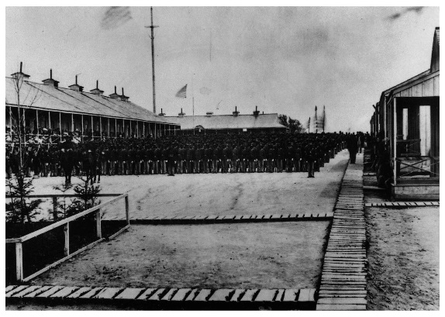 Photo courtesy of http://www.angelfire.com/pa5/8usct/25usct_history1.html

The history of the 25th Regiment is briefly described on many web sites as follows: “Organized at Philadelphia, Pa., January 3 to February 12, 1864. Sailed for New Orleans, La., on Steamer "Suwahnee" March 15, 1864 (Right Wing). Vessel sprung a leak off Hatteras and put into harbor at Beaufort, N. C. Duty there in the defenses, under Gen. Wessells, until April, then proceeded to New Orleans, arriving May 1. Left Wing in camp at Carrollton. Attached to Defenses of New Orleans, La., Dept. of the Gulf, May to July, 1864. District of Pensacola, Fla, Dept. of the Gulf, to October, 1864. 1st Brigade, 3rd Division, U.S. Colored Troops, Dept. Gulf, October, 1864. 1st Brigade, District of West Florida, to January, 1865. 3rd Brigade, 1st Division, U. S. Colored Troops, District of West Florida, to February, 1865. 1st Brigade, 1st Division, U.S. Colored Troops, District of West Florida, to April, 1865. Unattached, District of West Florida, to July, 1865. Dept. of Florida, to December, 1865.” A more detailed description of the regiment’s activities during the war can be found here: http://www.pa-roots.com/pacw/usct/25thusct/25thusctorg.html.
Mr. Morris was apparently not an ideal soldier. On the company muster roll for May and June of 1865, he is listed as “Absent.” Under remarks, it says: “Stop eight dollars per month sentence of G.C.M. [General Court Martial] for six months. In confinement at Fort Pickens, Fla. Per sentence G.C.M. since May 24, 1865.” On the regiment’s muster-out roll at Philadelphia on December 6, 1865, he is listed along with the other survivors. At muster-out, his last pay is recorded as Feb 28, 1865. For his clothing account, he is said to owe the U.S. $36.55. He also owed $6.00 for arms, equipment, & etc., and with a bounty due of $300.00. “Remarks: Stop ($8.) per month for six months per sentence G.C.M. G.C. No. 50, Hd. Qtrs. Dist. West, Fla. May 13, 1865. Stoppage for (ill. word) and G.E. $2. Fee. Book mark: 497.612.”
We have two pieces of correspondence dated January 11, 1879 and January 17, 1879 between members of the Adjutant General’s Office, Colored Troops Branch, with respect to Arnold Morris’ court martial and sentence (see below). “Charge – Disobedience of orders. Finding – Guilty. Sentence – To be confined at hard labor at Ft. Pickens, Fla. for six months, and forfeit $8.00 per mo. for same period. Approved.”
The last record related to Mr. Morris’ Civil War participation is the pension record, which lists his wife Mary Morris as his widow. At the bottom there are two entries:
Date of Filing Class Application No. Certificate No. State from which filed
1883 Oct 13 Invalid 497.612 665.720 Del
1911 May 12 Widow 964.764 723.914 Del

Apparently, even though he was court martialed, had his pay suspended, and served six months of hard labor before discharge, he was entitled to a pension once he became an invalid in 1883. After his death in 1911, his widow Mary continued to receive his Civil War pension until her death in 1914.

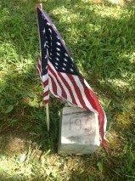 Arnold Morris’ grave at DSH with a US flag

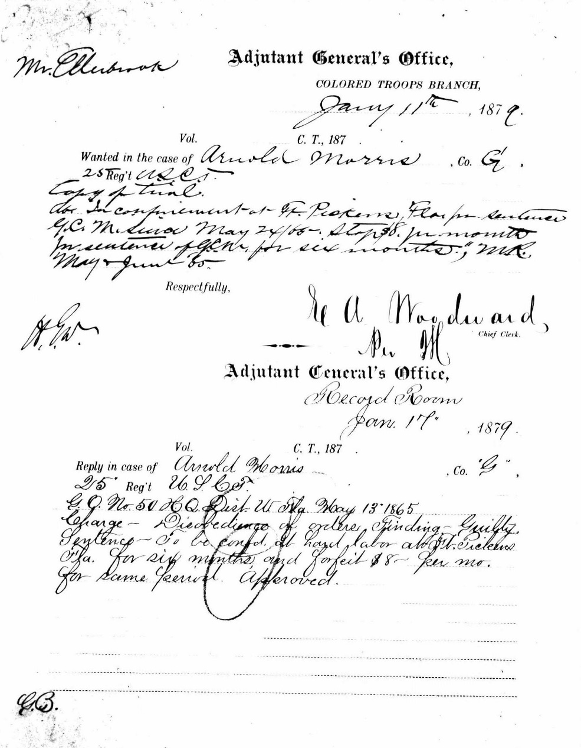
Letter from the Adjutant General’s Office, January 11, 1879

Margaret Reinike. Margaret Esther (Buken) Reinike (#150), was the wife of Gustave Reinike, who ran, unsuccessfully, for the position of Governor of Delaware on the Socialist Party ticket in 1900 and 1904. Mr. Reinike also had two admissions to DSH. The first was April 21, 1905, and he was discharged on May 7, 1906. After his first discharge, he was unable to find work, and the family ended up in the New Castle County Almshouse/New Castle County Hospital. In August of 1906, Margaret tried to escape from the Almhouse with one of her children, and was caught and sent to DSH. On December 7, 1906, Gustave was readmitted to DSH, where he died of “general paresis” (syphilis) on January 24, 1909. His burial site was not recorded.
Margaret’s admission and clinical notes record from the ledger are as follows:
“Admitted: August 11, 1906. From Wilmington, New Castle County, white, female, age 43, married, 4 children, youngest is 2.5 years of age, housewife, poor circumstances, limited education, Protestant, born in Germany; her husband was a former patient at DSH, complications of anemia, brought by Mr. Blackburn (Superintendent of the Almshouse); diagnosis of primary dementia due to grief.
History: Brought from New Castle Co. Almshouse by Supt. Blackburn, who states that patient attempted to escape with her baby. Her husband was a former patient in this hospital and after his discharge was unable to obtain employment as a result they had to go to the Almshouse.
Oct 15, 1906. Quiet and well behaved. Talks in sensible manner.
Apr 2, 1907. Eats and sleeps well. Works in dining room.
Sep 2. Has had an apoplectic stroke. Paralyzed below waist, sphincters involved. Heart weak. General condition very poor.
Oct 15, 1907. Died at 5:30 p.m. of cerebral hemorrhage.
Buried at DSH, #150.”

There was a newspaper clipping attached to Gustave Reinike’s first ledger entry. “Socialist Leader Insane. Gustav Reinike demanded $25,000 from Chief Justice Lore. Twice Candidate for Governor. Brooded Over Case Tried Before the Chief Justice Twelve Years Ago, Which He Lost – Mind Has Been Failing For Some Time. Gustav Reinike was committed to the Delaware State Hospital for the Insane at Farnhurst on Friday. For the past three weeks he had been writing letters to newspapers demanding $25,000 from Chief Justice Lore, and he declared that when he got the money he proposed spending $5,000 for the State Socialist organization, $5,000 for the national organization and the balance to further the interests of organized labor. Reinike’s reason for demanding $25,000 from Judge Lore was because of a case tried before the Chief Justice twelve years ago, in which [he] figured. Reinike demanded a transcript of the vend in this case or else demanded that the Chief Justice be sent to jail. Twelve years ago, Reinike had another German arrested on the charge of alienating his wife’s affections, and the man was committed to New Castle jail. Finally proceedings were instituted for his release and the case came before Judge Lore. At that time Reinike did not believe in God or the Bible and the man’s unbelief was reported to Chief Justice Lore. When about to take the oath on the witness stand he was asked concerning his belief and for over five minutes he stood thinking. Finally he announced he believed in God and in the Bible, and he was sworn. The

case was dismissed and Reinike has brooded over it ever since. Three weeks ago he left his employment to get the daily papers which contained reports of the case. He also wanted a transcript of the record and threatened to do damage should he be denied his request. He wrote several letters to newspapers in a legal form demanding $25,000 for Socialist work. Reinike had been the candidate for Governor on the Socialist ticket in 1900 and 1904. He was the leader of that party in Delaware. People in the neighborhood of his home, No. 119 North Jackson street, having noted that his mind was failing, and fearing that while under the spell of some of his hallucinations he might do damage to himself or others, requested the police to take him in charge. Dr. A.E. Frantz and Dr. Irvine M. Flinn examined him Friday morning and he was pronounced insane and afterwards taken to the Delaware State Hospital at Farnhurst. Reinike has been a resident of Wilmington for eighteen years, having come here from Germany after being married. He was considered one of the best machinists in Wilmington and always could find employment. He had a strong hold on the labor organizations in Wilmington.”

Mary Wells. Another sad story concerns Mary J. Wells, Grave #93. A note of caution: At the turn of the 19th-20th centuries, there were two families living in Wilmington, Delaware where the husband was named Benjamin Wells and the wife was named Mary Wells. Both families lived on King Street, and both men worked as butchers and grocers. Never-the-less, they seem to have been unrelated. One family was quite distinguished, and came from Blackbird Hundred. They lived at 1320 King St. in Wilmington for many decades. That Benjamin Wells was born in 1818 in Blackbird Hundred, where he grew up; he married Mary Seemans, and they had a number of children. That Benjamin Wells died on March 15, 1906, of paralysis, at the age of 88 years; his wife Mary died at the age of 86 years, a widow, also of paralysis, on May 5, 1911.
The other Wells family, the one where the wife is buried at DSH, left little trace. In the 1860 census, they were living in the 3rd ward of Wilmington and the household consisted of: Benjamin, 32, a butcher, who was born in Pennsylvania; his wife Mary Jane, 35, born in Delaware, and a daughter Maretta, listed as being 8 years of age. In the following census, 1870, we find: Benjamin, 42, butcher, his wife Mary J., age 41, a daughter Mary, age 16, and an unrelated female, age 18. No further trace of the daughter is to be found in the available records. It isn’t surprising to find that people did not necessarily age by 10 years between the different censuses, nor that their names should change slightly, or even a lot!
During the 1900 census, Mary J. Wells is listed as a patient at DSH. Her husband is listed as a 75 year old widower (even though Mary had not yet died), living in Wilmington as a boarder, and his occupation is listed as retired butcher. Benjamin died on December 18, 1900 at Farnhurst, presumably at the New Castle County Hospital (Almshouse) since he isn’t listed as being a patient at DSH. His death certificate describes him as a white male, married, and retired. He died of apoplexy (stroke), and was buried from 616 King St. to the Wilmington and Brandywine Cemetery. Mary died at DSH in October of 1901, and is buried in the Spiral Cemetery under marker #93. Hers is a sad story. She was admitted to DSH on July 5, 1899, age 70, married, poor, no info on children, deaf, no correspondent info.
From ledger:
“History: Patient has been a well-known character around Wilmington for years. When brought to Hospital was almost black with filth, hair matted. Officers know but little of her history.
Jul 6, 1899. Was very noisy last night, so much so that it was necessary for Dr. Wilson to get up at 1:30 a.m. this morning to give her a hypodermic to quiet her. At this time she was walking

around and pounding on the doors. This morning attendants found her lying on the floor unable to stand. Upon examination, a fracture of head of femur right side was found. A sand bag was placed along leg to keep it in position. As patient is very restless, good results cannot be expected. Patient will not eat, nor will she take water – says that it is all poisoned.
Aug 13. Is much better. Still in bed, eats and sleeps well, and does not now express any delusions.
Aug 29. Patient very quiet as a rule – sleeps well and has a fair appetite, but complains much of the pain in her leg, though she is able to use it to a limited extent. Is still in bed most of the time, but occasionally sits up in an easy chair.
Jan 19, 1900. Patient seems a good deal stronger; eats well and usually rests well at night. Sits up most of the day in a rolling chair; mental condition unchanged. Seems quite contented here now, as she imagines herself in her own house.
Oct, 1900. No improvement in mental condition, but in fair general health, although lately has had more or less trouble with diarrhea. Appetite fair and is usually quiet at night. Sits up all day as a rule.
Oct 26, 1901. For about a month has been in bed – gangrene of left foot (2 small toes). At first seemed fairly well, but lately has been failing gradually; up to last day or two was easily aroused. “Auntie Jane glad to see me.” “Mr. Dooley call again, call again.” “How nice you look Auntie.” “How nice you look Mr. Dooley.” Was able to distinguish figures, etc. but now seemed (not?) to recognize anyone. Ate [ill. words] yesterday. Last day or two circulation in extremities has been failing gradually and the end came peacefully at 7:30 p.m. this evening without a struggle or sound from patient.”

There was a newspaper article attached to Mary’s ledger entry:
“KEPT HIS WIFE A PRISONER. Mrs. Benjamin Wells locked in her residence, No.1308 King St. WAS FOUND BY CITY OFFICIALS. The Woman Demented and in Scant Attire. STRATEGEM EMPLOYED TO REACH HER. The police and health officials made a shocking discovery yesterday afternoon at the house No. 1308 King St., which has been occupied for some time by Benjamin Wells and his wife. [The husband] is about 74 years of age and his wife about 70, and the neighbors have been under the impression for some time that Mrs. Wells’ mind was affected.
Last Saturday [she] was found wandering aimlessly about the streets by the police, who took her to the police station and afterward sent her home. The appearance of the house aroused the suspicions of the health officials and Secretary Wigglesworth of the Board of Health decided to make an investigation.
On Monday Mr. Wigglesworth, accompanied by Health Officers McKinney and Hignutt, visited the house and made an effort to get in. They could hear a woman inside. She was making peculiar noises and screamed several times, evidently being frightened by the approach of the men. All of the doors and windows were found to be closed, locked and nailed, and there appeared to be no possible way of entering except by breaking in, as the woman inside could not be induced to open a door or window, even if it was within her power to do so. The health officers could not see the woman and she could not see them. The men were in a dilemma as to what should be done. After a consultation they left the place, to return when they could devise some means of gaining an entrance.

Mr. Wigglesworth sought advice from City Solicitor Conrad, and after the consultation with him it was decided not to forcibly enter the place if they could get in in any other way. Yesterday Mr. Wigglesworth and the health officers, accompanied by Policemen Todd and Peterson, made two visits to the house. On the first visit they were unable to get in, but while they were there took occasion to draw some of the nails from one of the doors which had been nailed up. Last evening they returned and the condition of the house appeared about the same. They heard [the woman] and going to the door from which the nails had been drawn succeeded in inducing her to open it after they told her the nails had been taken out.
She was evidently of the opinion that one of the men was her husband, as she was surprised and appeared angry when the men entered the building. She had no clothing on except an undergarment, which was in shreds. The men found an old dress about the place and endeavored to put it on her, but she resisted them and they were compelled to overpower her before she could be dressed. A cab was summoned and she was placed in it and sent to the State Hospital for the Insane, at Farnhurst, after she had been adjudged insane by Police Surgeon Harris and Dr. France.
After [she] had been sent away the officers made an examination of the house. They found no carpet and nearly all of the furniture was piled in heaps in the front room. The sanitary condition of the place was bad. Cobwebs and filth were found in several of the rooms, and in the kitchen, where the woman lived and slept, ashes to the depth of nearly six inches, had been piled against the door, the object evidently being to keep out the light. The entire lower part of the house was dark, the shutters, windows and doors, as stated above, being locked and nailed, while a bureau, table and other pieces of furniture were piled against the front door, presumably to keep the woman away from it. One bed was found upstairs, but the conditions there were not much better than on the first floor.
After the officers completed their investigation last night they left the house, first closing the doors, but returned this morning, when it was fumigated throughout. It will be cleaned and put in good shape either this afternoon or tomorrow.
Nothing was seen of the woman’s husband yesterday when the officers were at the house, but he was seen this morning. He did not appear to be much concerned about what had happened, but objected when Health Officer Hignutt ordered him out of the house and informed him that he would have to stay out until the fumigation had been completed. He told Secretary Wigglesworth that he had the windows and doors nailed to keep thieves out and said the ashes were placed against the back door last winter to keep the snow out.
Just how Mr. Wells and his wife lived has not been ascertained. There is no water about the place, so far as could be discovered. Mr. Wells told Wigglesworth that he and his wife were healthy all the time last winter when people were sick all around them. “It depends on the way you live,” he explained. Mr. Wells is a butcher by trade, but has not been doing anything lately, so far as is known. He has been spending most of the time walking about, and, according to the neighbors, when he left the house, he locked his wife inside to prevent her from making her escape. Some of the neighbors say last Saturday night is the only time they have seen her out of the house for nearly five years. She is in fairly good physical condition, barring her mental trouble.”

Wayman Wood. Wayman Wood came from the city of Camden in Kent County, Delaware. Mr. Wood was admitted to the Delaware State Hospital at Farnhurst on January 9, 1908 at the age of 26, with a diagnosis of epilepsy, complicated by tuberculosis. There were no treatments for epilepsy at the time, and a number of individuals with seizures disorders were admitted to the hospital. Mr. Wood was an African American male, 26 years of age, single, and his occupation is listed as “laborer.” He was brought to the hospital by his employer, Dr. L.S. Conwell of Camden, for whom he had worked for 10 years. His clinical notes indicate that he was well-behaved and tidy, not violent, and that he had several seizures each month, from which it took him several days to recover. After 5 ½ months, he died of pulmonary tuberculosis on June 21, 1908. Dr. Conwell was informed, and sent a letter in response, which is included in the ledger with Mr. Wood’s clinical notes. On letterhead of “Office of L.S. Conwell, M.D. of Camden, Delaware.” The letter is dated June 22, 1908, and is handwritten in ink, on unlined paper. “Dear Dr. Hancker, I received notice of Wayman Wood’s death. Thank you for your kindness. It marks the ending of a greatly afflicted life. As I told you he has no relatives except a sister and I do not know where she is and do not think likely she would claim the body, so I guess he will have to rest with other unfortunates. Yours truly, L.S. Conwell.” Mr. Wood is buried under grave marker #157. No other information about Mr. Wood has been found, which is, unfortunately, typical for African Americans during this time period. Dr. Luther S. Conwell was a well-known and highly-respected physician in Camden. He died in 1934. He is descended from one of Delaware’s oldest families (they arrived in Delaware in 1699). For more information on Dr. Conwell’s family line, see: http://freepages.genealogy.rootsweb.ancestry.com/ ~cfii/TheConwellFamilyByOliverConwell.pdf

BRIEF TIMELINE OF DELAWARE’S CARE FOR THE POOR, INCLUDING THE POOR “INSANE”

- 1775 An act was passed to provide care for the support of paupers and for the appointment of an overseer of the poor
- 1785 Overseers of the poor of Christiana Hundred bought land in Wilmington on Broome St. between Front and Fourth Sts. – erected 3 story stone building for the poor of Christiana Hundred only
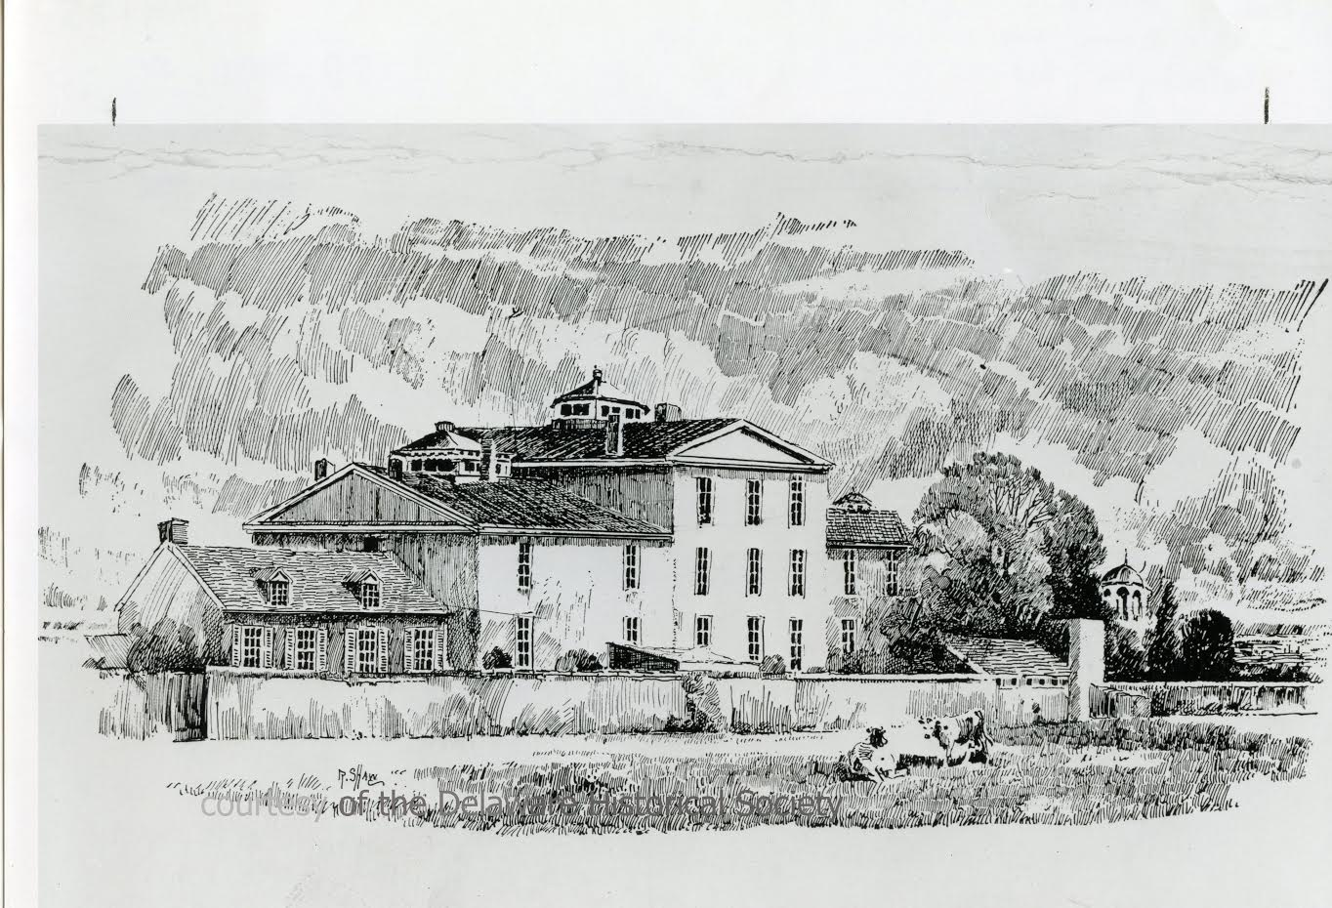

- 1791 General Assembly passed an act titled “An Act for the Better Relief of the Poor,” appointing a group of trustees from each county; authorizing the erection of a poor-house in each county (or purchase of buildings already existing) each with its own overseer; trustees appointed for each county, authorized to purchase up to 100 acres of land and to erect buildings; anticipated that NCC Trustees would purchase already existing “Christiana Hundred Poorhouse” for New Castle County’s use
- 1792 Building originally built by Christiana Hundred purchased by NCC Trustees of the Poor in 1792 – destroyed by fire 1804
- 1806 New building built
- 1815 “Legislation was passed authorizing the issuance of court orders mandating the removal of lunatic and insane persons from the public jails and requiring their placement in the poorhouses of the State.” [DE Archives, 2230, p. 3]
- 1851 NCC allowed for a new location to be sought for a new Almshouse outside the city of Wilmington; profits from a farm on the property were to be used to pay for the NCC Almshouse

Farnhurst site
- 1881 Legislature passed an act authorizing raising of money for new buildings for the insane and poor of NCC through the sale of bonds (“50 Year Report”); other sources say 1883
- 1882 Trustees of the Poor of NCC bought from Graham Blandy a farm of 100 acres at Farnhurst for $20,000. “Near Hare’s Corner Station in New Castle Hundred.” A committee was appointed to build a new Almshouse on the site, just south and east of the big bend in the Christiana River

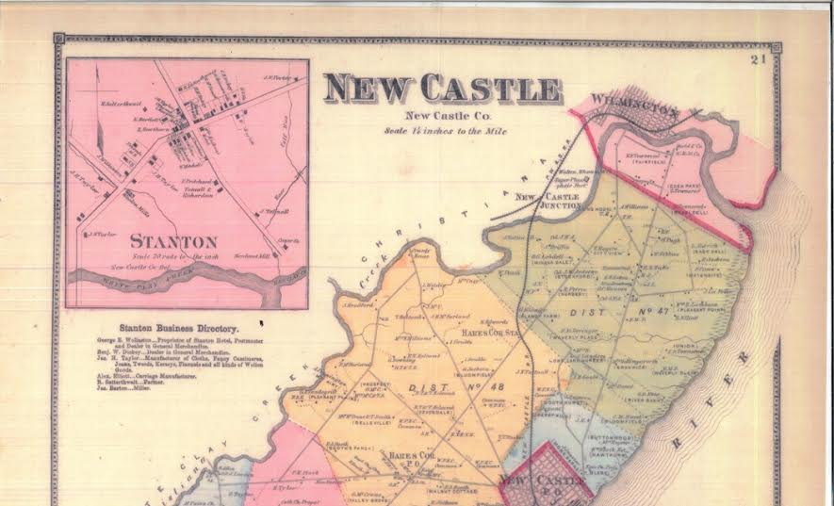

- 1884 New Almshouse Building (below, left) and almost-matching building for the “insane department” (below, right) were completed on May 1, 1884 at a cost of $163,000

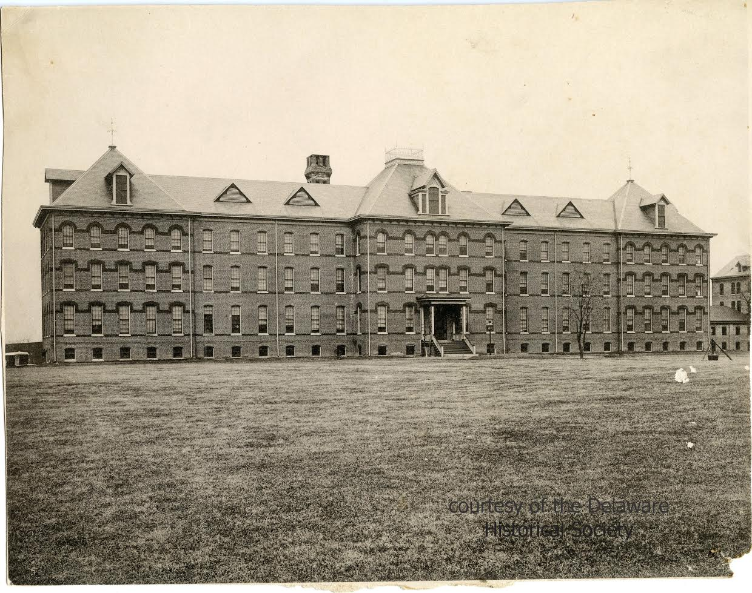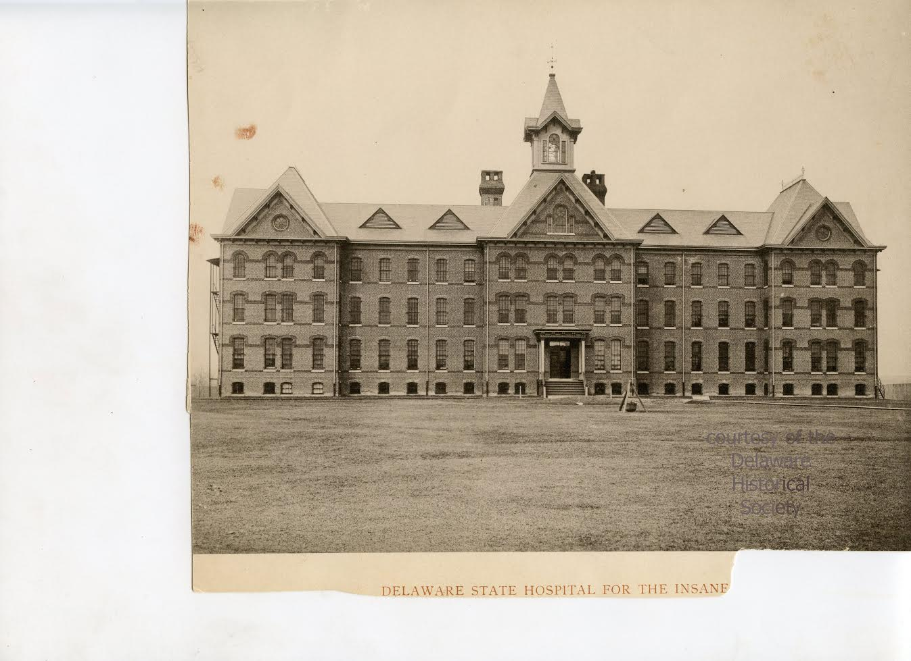

- 1885 May of 1885 is when the buildings were reported ready for occupancy. On May 20, 1885 some 75 “insane” were transferred from Wilmington to the new building (Main Admin. – NCC Almshouse “Insane Department and Hospital”), and on May 21, 1885, the Almshouse patients were moved to their new building (New Castle Bldg.)
- 1882-1885 Old Almshouse Buildings and land and some furnishings in Wilmington were sold in July 1885 +/-
- 1889 Name of the NCC Almshouse was changed to “New Castle County Hospital”
- 1889 “The state assumed responsibility for the care of the insane, leaving the NCCH to care for the aged, infirm, and the chronically ill.” [2230, p. 4]. The state paid New Castle County $75,000 to transfer the property to their control
- 1889 Delaware State Hospital for the Insane opened its doors on August 1, 1889 with 99 patients
- 1889 Dr. D.A. Harrison was appointed the 1st Supt., but he never served; Dr. D.D. Richardson was the first superintendent, left after a few years, in September 1893, to go to Norristown State Hospital in Pennsylvania
- 1891 “The State Hospital for the Insane officially became the Delaware State Hospital [at Farnhurst]”
- 1891-1893 A Superintendent’s Residence [“T” building], a laundry, and an amusement hall were built
- 1892 Dr. William H. Hancker appointed to succeed Dr. Richardson, served until ill-health necessitated his resignation in 1926
- 1919 Hospital started a “modern classification of mental diseases” (new record keeping system, phase out of old ledgers)

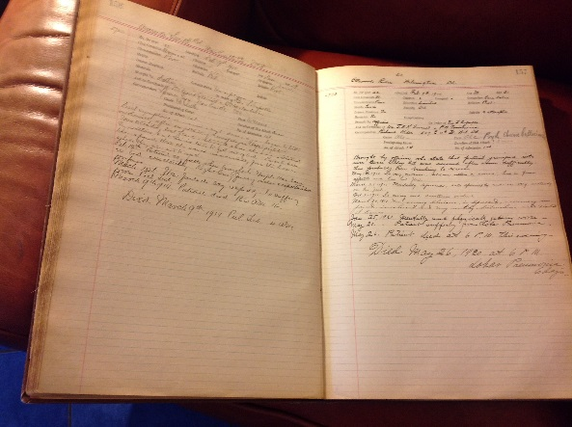
In 2012, 7 of these original ledgers were discovered in various places on campus; they document patient admission information and clinical notes from 1894 to 1920. Kathy Dettwyler is working on a project to type all of this handwritten information into a searchable Access database, which will be available for researchers on-line through the Delaware Public Archives.

- 1926 Dr. Mesrop Tarumianz became the 3rd Superintendent; he had joined the staff in 1918 (after fighting for Russia in WWI); remained until 1961 when he retired after 42 years of service
- 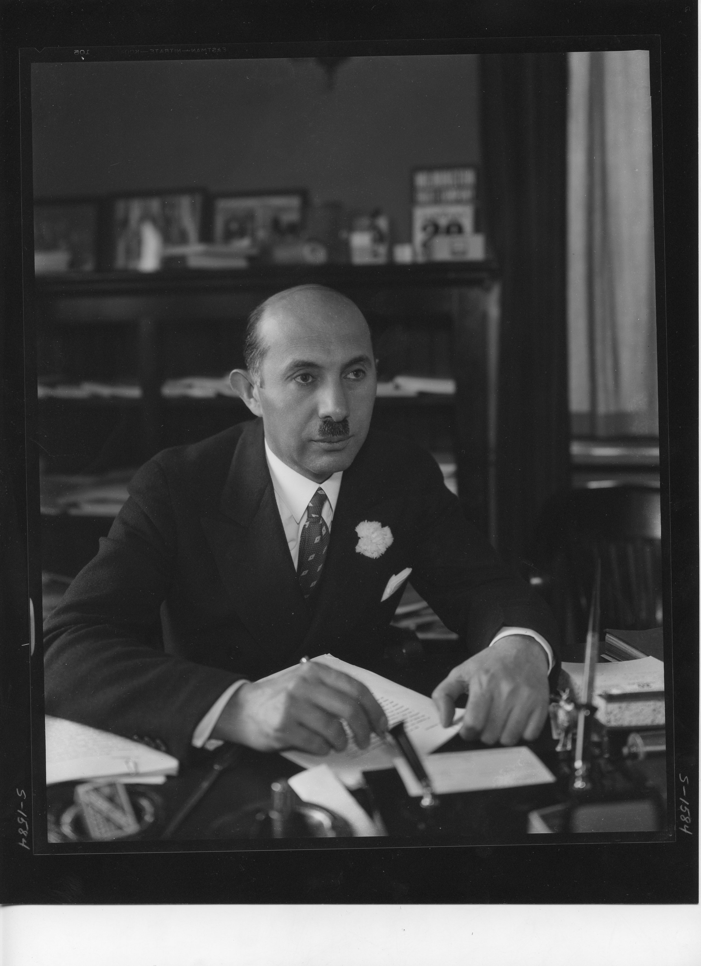 Dr. Tarumianz, with his trademark carnation boutonniere

- 1926-1928 A new utility building was built at the site of the original cemetery; the cemetery was moved to its current location
- 1933 The New Castle County Hospital (along with its own dedicated cemetery) was closed and the indigent aged people became wards of the state (and moved to the new state Welfare Home in Smyrna); old NCCH building sold to DSH for $20,000

- 1939 The Chapel was built as a WPA Project 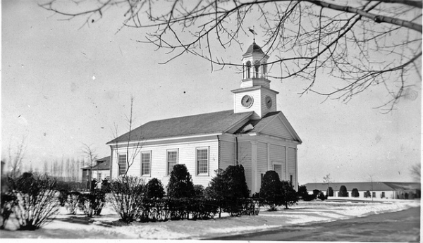
- 1940s DSH “among the first psychiatric facilities in the US to utilize the newest treatment techniques, including sterilizations, lobotomies, and electro shock therapies”

- [Centennial Celebration, Highlights]; typically ~1200 patients throughout 1940s
- During World War II – DSH served as the site for Civilian Public Service Camp No. 58; 30 CPS men assigned to DSH; camp closed on October 31, 1946
- 1947 A separate department for the Criminally Insane was established
- 1950s DSH had a “leadership role in psychopharmacological treatment and research” for new drugs; Dr. Tarumianz “gained national attention in his efforts to speak out against capital punishment”
- 1950 Comegys building built for mentally ill offenders (“criminally insane”)
- 1953 First mention of use of drugs to treat mental illness at DSH (Thorazine trials)
- 1954 Psychotherapy – both individual and group – was initiated at DSH; mainly aimed at alcoholic, geriatric, and schizophrenic patients
- Late 1950s No more lobotomies
- 1960 Willard Springer, Jr. building built and dedicated on April 23, 1960; originally to house acutely ill and convalescent patients with treatment rooms, officers for doctors, OT rooms, a gymnasium with a stage, and 3 enclosed patios for fresh air within the building
- 1961 Dr. Tarumianz resigned after 42 years of service; replaced by Dr. Charles K. Bush, Jr. and then by a series of short-term appointments and interim superintendents
- 1964 Board of Trustees of the Delaware State Hospital became the Board of Trustees for a new created Department of Mental Health (included Governor Bacon Health Center, Hospital for the Mentally Retarded at Stockley, Day Care Center at Dover, and the Mental Hygiene Clinic at Fernbrook, in addition to the DSH)
- 1960s Hospital population reached its peak at 1,600 patients; wards were integrated, beginning with the Biggs Building, which changed from a “Negro” unit to an integrated geriatric unit; creation of Day and Night Hospitals (national prototypes); Community Mental Health Center model adopted; Night Hospital allowed patients to live in the community during the day, but come back to the hospital for meals and to sleep
- 1965 Farm dismantled
- 1966 New Castle Building caught fire on August 16, 1966 – there were no serious injuries or deaths, but the building was destroyed and had to be torn down
- 1968 New Kent Building opened in 1968 and all patients were moved out of the Main Building
- 1968 Former farm area transformed into recreational facilities including tennis, basketball, shuffle board courts, football, softball, and handball fields
- 1968 Psychiatric Emergency Service established for crisis intervention with 24/7 phone and a walk-in clinic as well
- 1970 Department of Mental Health reorganized as Division of Mental Health and Mental Retardation, under Delaware Dept. of Health and Social Services
- 1970s Continued process of deinstitutionalization; Sheltered Workshop begun to employ mentally ill living in the community
- 1971 Division of Mental Health became a separate entity; swimming pool built

- 1980s Various parts of DHSS began to move their offices and client services to DSH grounds
- 1983 Last burial in the Spiral Cemetery; after that time, anyone who died at DSH/DPC without the means for a private funeral was buried in the New Castle County Potter’s Field adjacent to the Baylor Correctional Facility
- 2012 – first of seven DSH ledgers were discovered in a closet in the Springer Building and saved by a custodian
- 2013 – Dr. Kevin Huckshorn commissioned Kathy Dettwyler to write a report about what other states were doing to preserve state institution cemeteries and honor those buried in them; this report is available online: http://farnhurst.weebly.com/final-report-for-dr-kevin-huckshorn.html
- 2014 – Friends of the Delaware State Hospital Cemetery Committee established; chaired by Dr. Faith Kuehn
- 2016 – Dedication ceremony for the new monument was held on May 9, 2016

ACKNOWLEDGEMENTS

I would like to acknowledge the special contributions many individuals made to this publication, in no particular order (and, no doubt, forgetting somone):
- Dr. Kevin Ann Huckshorn, who started the whole thing in 2013 by commissioning me to write a report about what other states had done, or were in the middle of doing, to restore institutional cemeteries and honor the people buried in them. The report is available here: http://farnhurst.weebly.com/
- My husband, Dr. Steven P. Dettwyler, who has put up with me devoting untold hours to this project, most of them only for the glory and satisfaction of the task
- Dr. Faith Kuehn, who has been the chairperson of the Friends of the Spiral Cemetery Committee throughout its work, ably leading us and cajoling us, and keeping me in line.
- Jason Johnson, who works for the State of Delaware on the Holloway Campus (the third generation of his family to do so) and who has provided me with lots of background information about his grandfather Benjamin Danna’s days at DSH and more recent history of the campus, as well as old photographs. He also provided my connection to Lynn Bloom and Paula McHugh, who provided additional historic photographs.
- Tedd Cocker, genealogist, fellow taphophile (lover of cemeteries), and tireless data entry worker. It was Tedd who first visited the Delaware Public Archives, got ahold of the cemetery book, and entered all the names into www.findagrave.com (search on “Cemetery Name = Delaware State Hospital.” He has continued to work with me on updating and finalizing the spelling of everyone’s names. Any mistakes in spelling are all mine.
- Russ Pickett is another genealogist, taphophile, and keeper of all military record knowledge, and contributed information about the military service of the veterans buried in the cemetery.

- Jimmy Kroon, GIS specialist for the State of Delaware, who created the wonderful interactive map of the Spiral Cemetery, available here: http://delaware.maps.arcgis.com/apps/webappviewer/index.html?id=e99076eeadfb4c9c93c08d8e37e6187b
- Marian Coker, Information Resources Specialist for DHSS at the Delaware Public Archives, who has worked closely with me on this project, as well as the DSH Ledger project.
- Various staff members at the Delaware Public Archives, the Delaware Historical Society, the Hagley Museum Library, and the Morris Library at the University of Delaware, who have helped me with research and patiently answered all my questions.
- Michael Kalmbach and William G. Slowik, Jr. of the Creative Vision Factory, who organized the design and building of the monument, along with members of Delaware’s peer community.
- Everyone who worked to get the historical marker approved and installed.
- John McDermott and the grounds crew at the Holloway campus, who help maintain the appearance of the cemetery.
- Ashley McCabe (Welton), of DHSS, who has provided administrative support to this project.
- The members of the Friends of the Delaware State Hospital Cemetery Committee, who have contributed in a number ways to this project.
- Last, but not least, I want to thank all of the people buried in the Spiral Cemetery. I feel like I know many of you.

