Ferdinand Hunt is a quintessential example of many of the people buried in the NCCH/Farnhurst Potter’s Field. He died on February 18, 1895. There is almost no information about him, other than that he was either 60 or 70 years of age, African American, supposedly widowed, and worked as a laborer. He appears in no census records. He appears in newspapers articles only twice – once in 1881 being charged with being drunk and disorderly, and also for carrying a concealed weapon, and ten years later in 1891 for drunkenness again. His body was found frozen in the ice beneath the P.W.&B. railroad bridge at Ninth St. It was assumed he had been to the grocery store, as a loaf a bread and a bag of prunes were found scattered on the ice nearby. A broken “club” nearby was thought to have been used by Mr. Hunt as a cane. An inquest concluded that the death was accidental, and that Mr. Hunt was probably inebriated and fell off the bridge or jumped when he saw a train coming.
His entry is the index of deaths for Delaware says that he was born in Virginia, and was a widower, but neither fact could be confirmed by any official records.

Certificate of Death
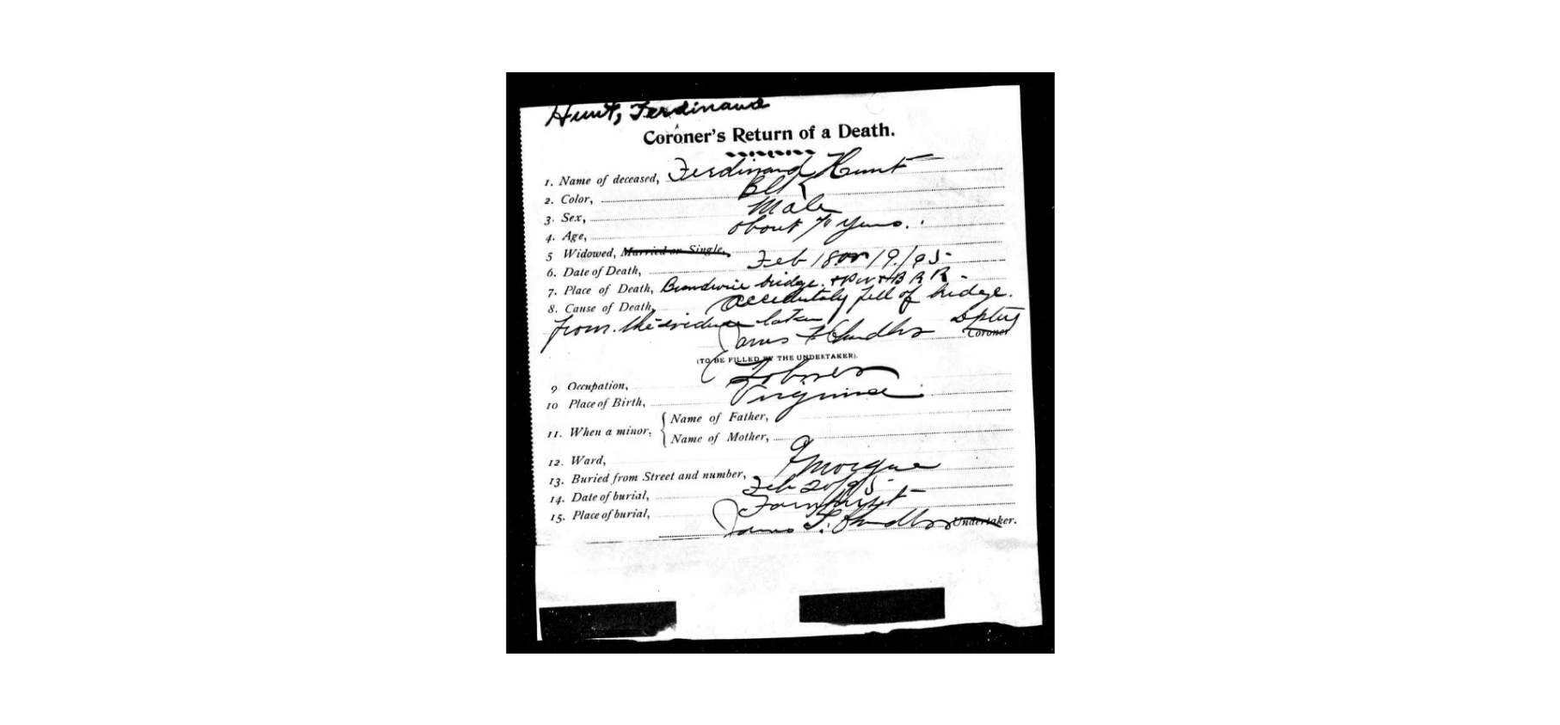

News Journal, 2/19/1895

