Jerry Ivory

Jerry Ivory was an African American man who was born around 1873 and died on June 30, 1930 at the Wilmington General Hospital of an intestinal blockage. He is buried under marker #2104 (under the I-295 ramp). He was a widower, and I could find no record of children. As with so many African Americans of the time, we know very little of his life. The 1920 census says he was born in Georgia, and his father was also from Georgia, but his mother was from Virginia. He did make the newspapers in 1919 in a series of stories detailing an injury he received while performing a good deed. [Note that there was a white man named Jerry J. Ivory, who lived in and around Altoona, Pennsylvania at the same time, but he is not the one buried in the Farnhurst Potter’s Field].
On July 14, 1919, Jerry was living alone on Miller Road in north Wilmington, across the street from George W. Rickards, an elderly African American man who was still working out as a farm laborer. Jerry Ivory, although only middle-aged, was badly crippled and did not work. One morning he heard the sound of glass breaking at Rickards’ house and went to investigate. He saw a man wandering around on the second floor. This would turn out to be John Wharton, a young African American man who Ivory was acquainted with. Ivory called out and told Wharton to leave, and Wharton asked if Ivory planned to shoot him, as both had guns. Ivory said no, and sat down on a tree stump in the yard. Wharton then proceeded to fire two shots from his shotgun at Ivory. The first grazed Ivory’s scalp and ricocheted off, leading to profuse bleeding (as well as breaking a window in a neighboring house). The second shot went wide. Ivory tried to return fire, but his shotgun jammed. Ivory took himself home, and thence to the local Oberly brick yard, and one of their drivers took him to the Delaware Hospital. He was not seriously injured. After treatment, he went to the police station to report both the burglary and being shot by Wharton. Although police searched the area, they could not find Wharton, who was also wanted on a charge of breaking and entering in West Chester, Pennsylvania.
Other than this rather colorful story, Jerry Ivory is not mentioned in the local newspapers. Some 11 years after this incident, he developed an intestinal obstruction and was taken to the Wilmington General Hospital, where he died. In the absence of family or friends, he was buried in the Farnhurst Potter’s Field.
We actually know a little more about George W. Rickards. George was born around 1838 in Maryland. We first find him in the 1850 census, when George is 12, listed as part of a family of free inhabitants of Subdivision 11, Sussex County, Delaware. The head of the household is Robert Rickards, 73, along with wife Flora, 65, and a number of other people. It isn’t clear how George is related to Robert and Flora, but perhaps he is a grandson. In the 1870 census, George is farming in Seaford, Sussex County, with his wife Jane and their four children, John, Joseph, Henry, and Anne. I couldn’t find George in the 1880, 1900, or 1910 census records online. In the 1920 census, we find George, age 87, living with a housekeeper and two boarders, one of whom was white (Pinkerton). George died on October 2, 1923 of senile gangrene and was buried in the Mt. Olive Cemetery.
Other information about George includes that in 1885 he was cited in an article about “moving day” in Wilmington, March 25, 1885. Moving day was an annual event in many cities in the northeast, where landlords would announce rent increases, and everyone who couldn’t afford to stay where they had been living would need to find a new place to live, and then everyone would move on the same day! https://vernonhistoricalsoc.org/wp-content/uploads/2017/06/Moving-Day-article.pdf
George was also cited a few times over the years for being drunk and disorderly.

I could only find one John Wharton, black, in Delaware at the right time. His WWI registration says he was from Kent, Delaware (confirmed by census records), was 19 years of age in 1918, and was blind in his left eye and crippled in his right hip. It isn’t certain that this is the same person who shot Jerry Ivory.
There was also a white man named John B. Wharton who was for many years a sheriff in Kent County, but he was clearly not the person who burgled George Rickards’ house and shot Jerry Ivory.

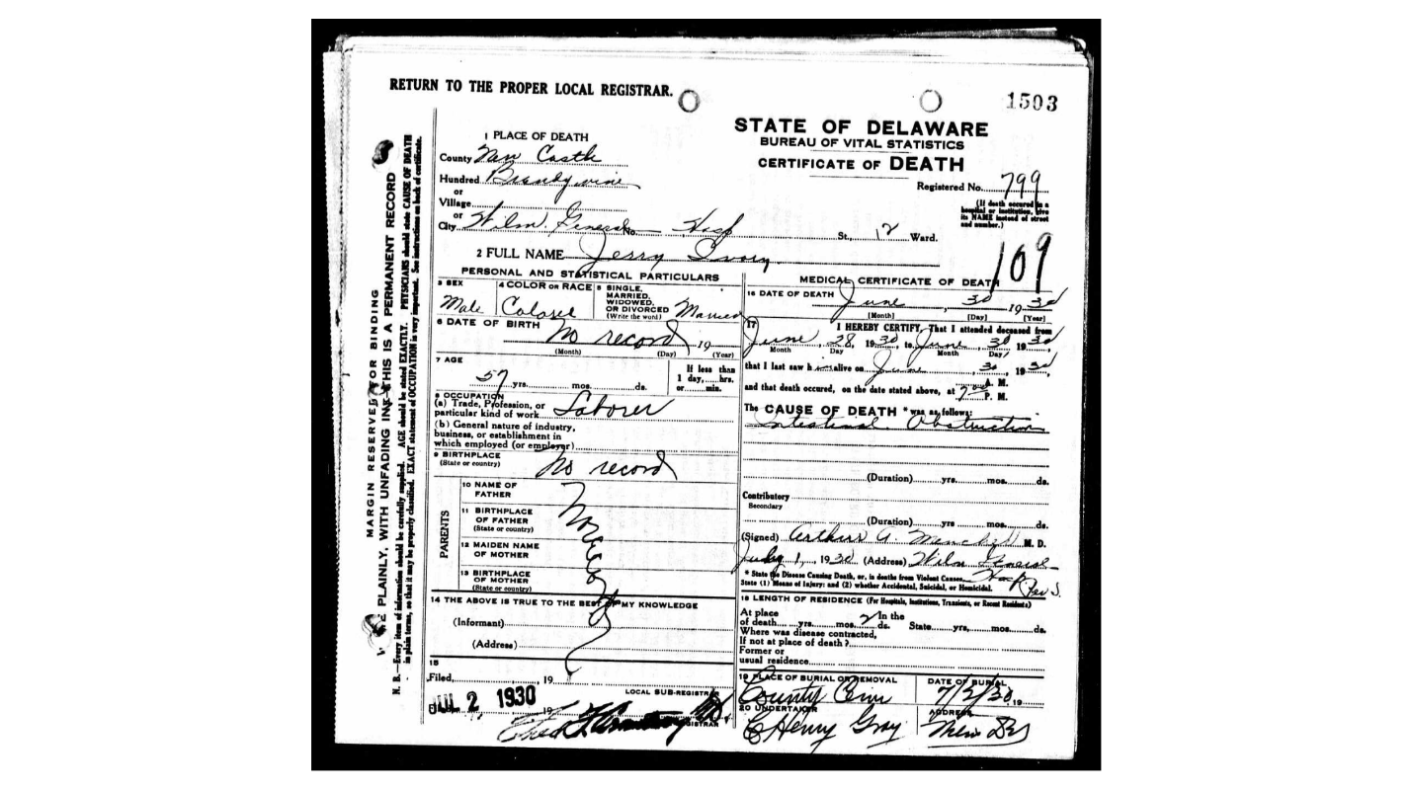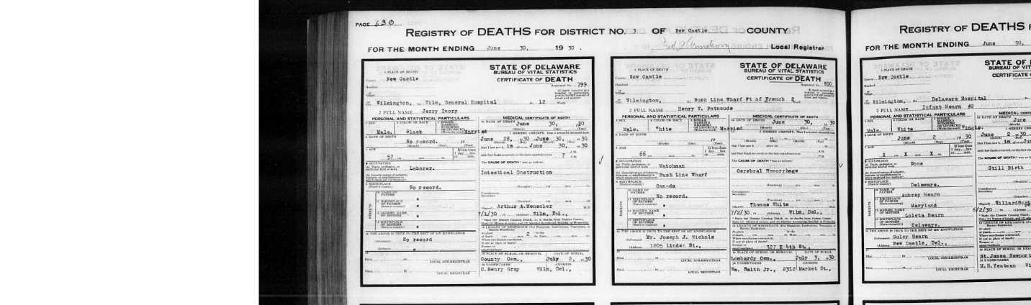
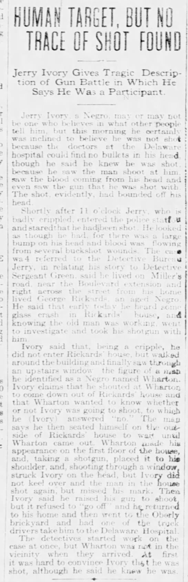 News Journal, 7/14/1919
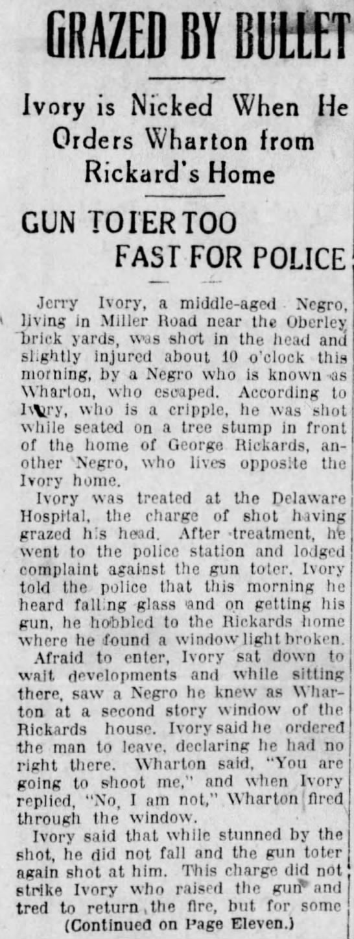 Evening Journal, 7/14/1919 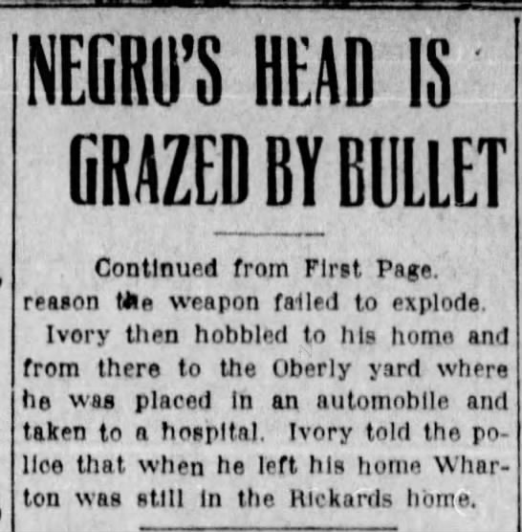 con’t.

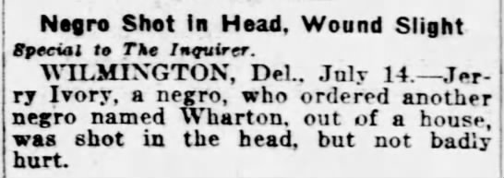
Philadelphia Inquirer, 7/15/1919

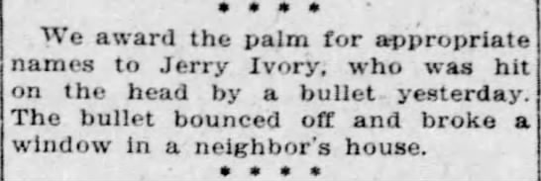
Morning News, 7/15/1919

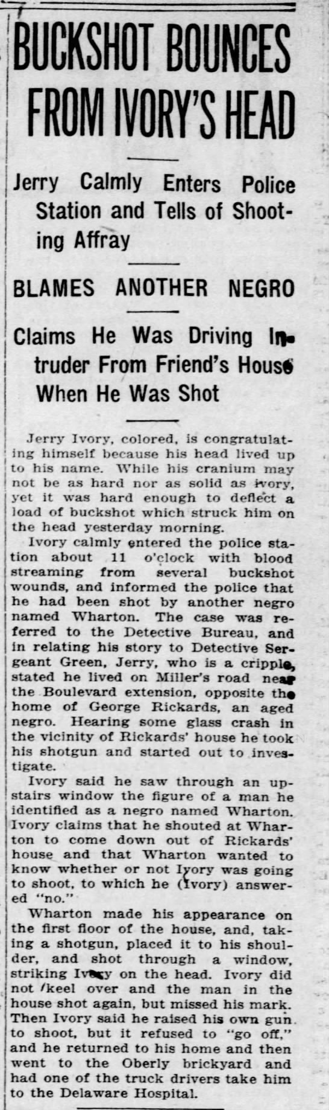 Morning News, 7/15/1919

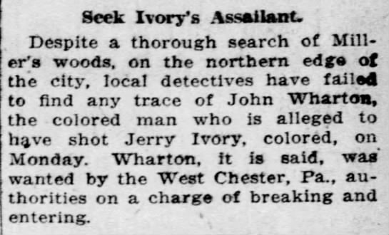
Morning News, 7/16/1919

1920 census

Name: | Jerry Ivory
Age: | 53
Birth Year: | abt 1867
Birthplace: | Georgia
Home in 1920: | Representative District 6, New Castle, Delaware
Street: | Miller Road
House Number: | X
Residence Date: | 1920
Race: | Black[White]
Gender: | Male
Relation to Head of House: | Head
Marital Status: | Widowed
Father's Birthplace: | Georgia
Mother's Birthplace: | Virginia
Able to Speak English: | Yes
Occupation: | None
Home Owned or Rented: | Rented
Home Free or Mortgaged: | Free
Able to Write: | No
Neighbors: | View others on page
Household Members | Age | Relationship
Jerry Ivory | 53 | Head

1870 census

Name: | George Rickards
Age in 1870: | 30
Birth Date: | abt 1840
Birthplace: | Delaware
Dwelling Number: | 9
Home in 1870: | Seaford, Sussex, Delaware
Race: | Black
Gender: | Male
Post Office: | Seaford
Occupation: | Farmer
Cannot Read: | Yes
Cannot Write: | Yes
Male Citizen Over 21: | Yes
Personal Estate Value: | 100
Real Estate Value: | 1000
Inferred Spouse: | Jane Rickards
Inferred Children: | John RickardsJoseph RickardsHenry RickardsAnn Rickards
Household Members | Age
George Rickards | 30
Jane Rickards | 27
John Rickards | 10
Joseph Rickards | 8
Henry Rickards | 6
Ann Rickards | 4

1920 census

Name: | George W Richards
Age: | 87
Birth Year: | abt 1833
Birthplace: | Delaware
Home in 1920: | Representative District 6, New Castle, Delaware
Street: | Miller Road
House Number: | X
Residence Date: | 1920
Race: | Black
Gender: | Male
Relation to Head of House: | Head
Marital Status: | Widowed
Father's Birthplace: | USA
Mother's Birthplace: | Delaware
Able to Speak English: | Yes
Occupation: | Laborer
Industry: | Farm
Employment Field: | Wage or Salary
Home Owned or Rented: | Rented
Home Free or Mortgaged: | Mortgaged
Able to Write: | No
Neighbors: | View others on page
Household Members | Age | Relationship
George W Richards | 87 | Head
Carrie Dreden | 38 | Housekeeper
Laura Langford | 37 | Boarder
William Pinkerton | 59 | Boarder

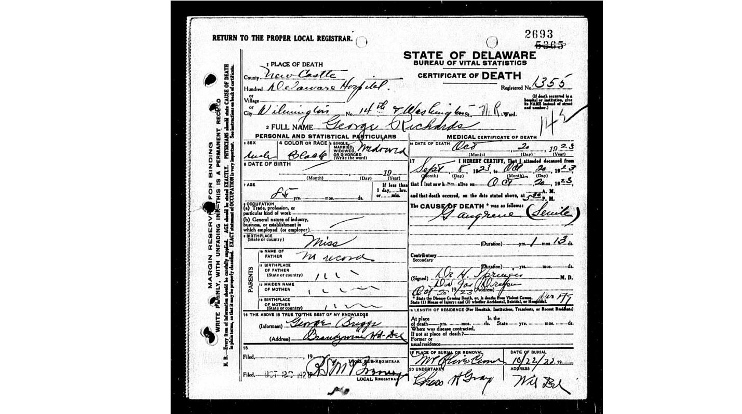

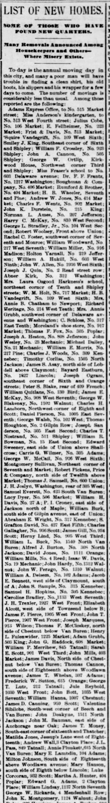 Morning News, 3/25/1885 “Moving Day” in Wilmington, including George W.
