Landren Blannen (probably not an accurate rendering of his name) was a young, African American man who met his untimely death while traveling through Wilmington, Delaware as a “tramp” on the railroad. Very little is known about him other than the circumstances of his death. According to various sources, he was between 20 and 30 years old. He was originally from Marion, North Carolina, and was on his way to find work in Philadelphia by hitching rides on the freight trains. On October 27, 1893, he was gathered in the West Yard with five other tramps, three of whom were white. They had gathered around a fire and an argument broke out. One report says the disagreement was over who had “counted the most railroad ties in their tramp” – who had travelled the furthest. Another version says it was over whether Mr. Blannen had contributed wood for the fire. At any rate, words were exchanged, Blannen turned to leave, and one of the white men – never identified – shot him once in the back with a “self-cocking revolver” or pistol. The other white men then intervened before more shots could be fired.
The police were summoned, and the other tramps dispersed. Mr. Blannen was taken to the Delaware Hospital with what was considered to be a relatively minor injury. The police sent word down the train lines to Newark to be on the lookout for the shooter. Despite a major effort to track him, the police lost him near Stanton, and he was never apprehended or identified. The initial reports indicated that Blannen was expected to recover fully. However, his condition deteriorated over the next several days and he died on November 2, 1893. He was buried in the NCCH/Farnhurst Potter’s Field.\
A coroner’s inquest was held but could only conclude that he was killed by a person unknown to the panel. No trace of a young man named Landren Blannen could be found in either North or South Carolina, both of which have towns called Marion. There was a man named Leander Blandon, but he survived into the 20th century.

News Journal, Oct 28, 1893

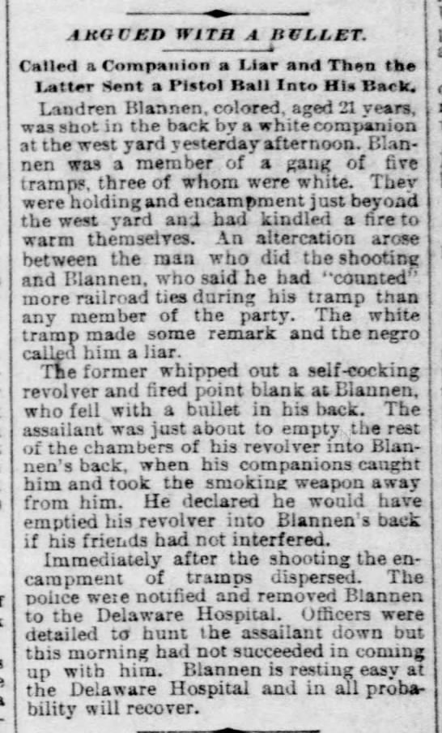

Morning News, Oct 28, 1893

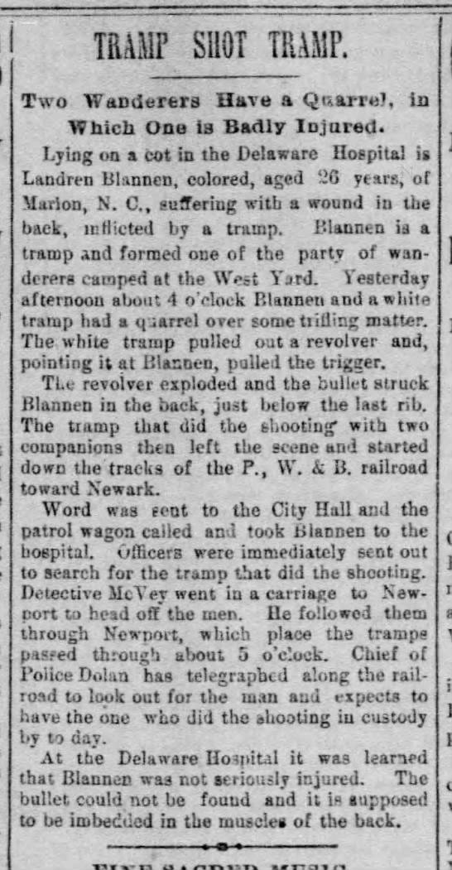

News Journal, Oct 30, 1893

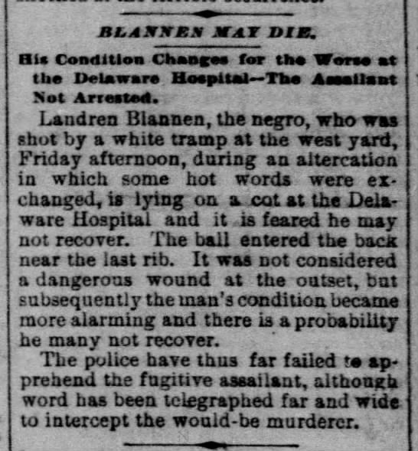

Morning News, Nov 3, 1893

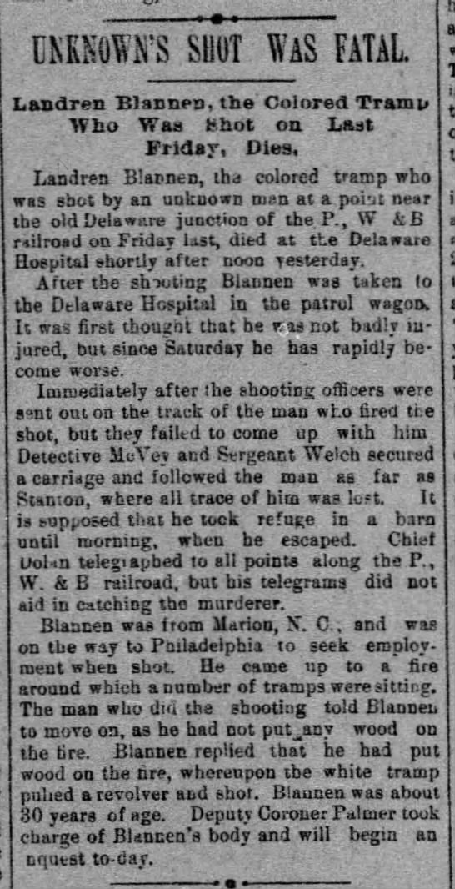

Coroner’s Inquest was not able to identify person who fired the shot from a double-barreled self-cocking revolver.

