[Richard] Moses Brooks (1852-1929)
Moses Brooks was an elderly, poor, single black man, who lived at the New Castle County Hospital/Almshouse for 6 years before dying there on May 3, 1929 of “senile debility.” He was buried under marker #2048 in the New Castle County Hospital/Almshouse Cemetery, in a grave recently vacated by one Robert Burgess, who had died on April 23, 1929 and was relocated to another cemetery.
In many ways, Moses Brooks is an excellent representative of the many elderlies, poor, single black men who spent their last years living at the Almshouse and had no friends or relatives to bury them elsewhere, thus ending up in the NCCH Cemetery. Although we know little of his life, we can piece together a number of interesting tidbits about him and his family, which reach out into various aspects of life in the region during the late 19th and early 20th centuries.
Moses was the son of free blacks, Robert Brooks, a Civil War veteran who died in 1869, and Martha A. Demby Brooks, who survived until 1897. Robert Brooks was born around 1820. He and Martha first appear in the 1850 census as free blacks living in Pencader Hundred, Delaware, ages 35 and 30, respectively, along with their children Eliza, 9, and David, 1. Robert worked as a general laborer. Both Robert and Martha were originally from Maryland.
By the 1860 census, they had moved to the 5th ward of Wilmington, Delaware and had added two more children. We find Robert and Martha (both supposedly now 40 years old) and their children Eliza, 18, David H., 11, Richard Moses, 8 (born in August of 1852), and Elizabeth, 4. We know that Robert enlisted and served in the United States Colored Infantry during the Civil War. He apparently died in 1868 or 1869, as Martha applied for a widow’s pension on January 30, 1869.
In the 1870 census for Wilmington Subdivision No. 1, we find the household consisting of widow Martha, 51, her son David, 21, Richard [Moses] 19, Eliza Brooks Williams, 26, and Eliza’s daughter Emma Williams, one month of age. In 1870, Richard is working as a house servant. In the 1880 census, we find the family living at 833 Walnut Street, where they will reside for many years, with the household now listing Eliza Williams, 35, as the head, along with her daughter Emma, now 10, her mother Martha, 65, and her brothers David H., 28, and Richard, 26, both listed as “laborers.” In 1880, Martha was working as a janitress. The house at 833 Walnut Street no longer exists. Its location is now part of the Louis L. Redding City County Building, or its parking lot, at the corner of 8th St. and North Walnut St.
We know from various city directories and census records that Moses worked most of his adult life as a hotel waiter, at least from the early 1880s through the 1910 census. In the 1883 Wilmington City Directory, he was living at 833 Walnut Street with his mother, and working at the Clayton House Hotel (originally the Indian Queen Hotel, then the Clayton House Hotel, then the Queen Theater, on the corner of Market Street and 5th Street; see photo in Word file). In 1894, he was working as a waiter at the Central Hotel in Wilmington. He continued to live with his mother on Walnut Street as a single adult until her death on August 3, 1897. She was buried in Mt. Zion Cemetery.
In the 1900 census, Moses was living with his brother David and his wife and children in the 6th ward in Wilmington and still working as a hotel waiter. By 1910, he had moved out of his brother’s home and was living as a boarder, still in the 6th ward, and still working as a hotel waiter. He doesn’t seem to appear in the 1920 census.
Moses Brooks made the newspapers only a couple of times, in relationship to his work with St. Matthews Mission, an African American group of the Episcopal Church, organized by Bishop Coleman. Today, the congregation is known as the Episcopal Church of Saints Andrew and Matthew. In 1891, the St. Matthews Mission opened a day nursery to care for the children of African American women who had to go out to work. The Board of Managers for the day nursery included Moses Brooks. The nursery was originally located at 1019 Orange St., and charged $2/year for membership, and $.05 per day per child for care. The following year, Moses Brooks gave a speech at the annual St. Matthews Festival, along side Bishop Coleman and the Reverend H. Ashton Henry, so he must have been highly respected and admired.
On May 23, 1923, Moses Brooks entered the New Castle County Hospital/Almshouse, where he lived until he died of senile debility at the age of 71 on May 3, 1929. As stated above, he was buried in the NCCH Cemetery under marker #2048. His brother David Henry Brooks had died the previous year, on April 16, 1928 of chronic valvular heart disease, and was buried at Mt. Olive Cemetery. David’s COD says his occupation was as a janitor.
Moses’ brother David H. Brooks had married Maria Jane Bailey (from New Jersey) and had several children, including a son named Robert George Washington Brooks, who died at the age of 1 year and 8 months of whooping cough, and was buried at Mt. Zion. They also had daughters named Adaline, Albertha (b. 1884), Jeannette, and George/Georgia Emma, who went by Emma. Emma grew up and married Walter N. Fisher, and gave birth to a stillborn son on March 24, 1924. This baby was the great-nephew of Moses Brooks, and is also buried at the New Castle County Hospital Cemetery, under the listing “Baby Boy Fisher.”
The 1900 census for Wilmington lists David Brooks as the head of the household, and a niece named Lula, age 10 (parents not specified). There is a death certificate for a Lula Brooks who died of typhoid fever on July 19, 1904 in Pittsburgh, Pennsylvania, and whose body was embalmed and prepared for “transit.” This information is provided on a form titled “Undertaker’s affidavit in case of infectious or contagious disease.” The form does not specify where the body was sent, or where it was buried. This doesn’t seem to be the same Lula Brooks, however, as she is recorded as being white, and 25 years of age when she died.

Death certificate of Moses Brooks.

1893 photo of the Clayton House Hotel (built 1871) on Market Street at the corner with 5th, where Moses Brooks worked as a waiter.

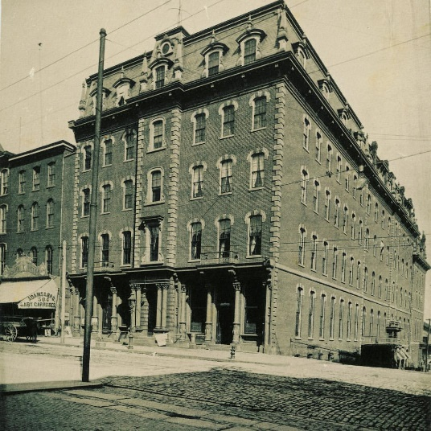

Photo from the Delaware Historical Society, https://www.facebook.com/dehistory/photos/long-before-wilmington-was-home-to-any-major-hotel-chains-the-clayton-house-boas/10153578021305673/

“Long before Wilmington was home to any major hotel chains, the Clayton House boasted the city’s finest lodgings. Built in 1871 at 5th and Market Streets on the site of the old Indian Queen Hotel, the five-story Clayton House had 105 well-appointed rooms, each of which promised “gas, water, and a bell.” In 1876, guests could enjoy all this luxury for roughly $3.00 per day. While prices were likely a bit higher by 1893, when this #tbt photo was taken, they certainly seem like a steal by today’s standards! Following its heyday as a hotel, the Clayton House became a movie theater, was abandoned for several decades, and is now the site of World Cafe Live at The Queen, which is also our neighbor here at the Delaware Historical Society!”

