William Jenkin Harris, Jr. was born in 1871 in Lykens, Pennsylvania and died in 1917 in Delaware. His parents were [William] Jenkin Harris* (1827-1872), originally from Tredegar, Monmouthshire, Wales, and Mary Jane Simmonds Harris, originally from Bitton, Gloucestershire, England (1832-1883). These two towns are about 65 miles apart, not that far for today, but it would be interesting to know how the two young people came to meet one another. They were wed in 1853 in Monmouthshire, Wales, and had four children there before emigrating to the United States in 1863. The elder (William) Jenkin Harris was a coal miner. Coal mining was, of course, the major industry in the valleys of central and northern Wales, and many Welsh citizens emigrated to the coal mining areas of Pennsylvania in the 19th century.
William Jenkin Harris, Jr. was born in 1871, in Lykens, about 41 miles from his later residence in Danville, Pennsylvania, just north of Harrisburg. His father died in 1872, when he was less than 2 years of age, and his mother died in 1883, when he was 12. He was the youngest of their five children. His father died when he fell off a railroad bridge (see newspaper story in Word file), probably while intoxicated.
We don’t know anything more about William’s life until his marriage to Anna Margaret “Maggie” Barr (1876-1949) on March 9, 1894 in Danville. It was the first marriage for both; he was 21 and she was 18. The marriage license points out that her father had given permission for her to marry. William and Maggie’s only child, their daughter Helen Mildred Harris, was born on August 31, 1895.

*Note that “Jenkin Harris” is a not-uncommon name in Wales, and there was another person of this name living in Wilkes-Barre, Pennsylvania the same time that “our” William Jenkin Harris, Jr. and his father Jenkin Harris were living near Danville, Pennsylvania. Also note that there is no “s” on the end of Jenkin. Jenkin, not Jenkins.

We do know that William enlisted in the military and served during the time of the Spanish-American War. His military records indicate that he enlisted on May 9, 1898 in Mt. Gretna, Pennsylvania and was a private in Company D of the 13th Pennsylvania infantry. His unit never saw combat. A great history of the brief and inglorious history of the 13th can be found here: https://www.spanamwar.com/13thpa.htm#:~:text=The%2013th%20Pennsylvania%20Volunteer%20Infantry%20was%20formed%20from%20the%2013th,service%20on%20May%2012%2D13
He was mustered out on March 11, 1899 in Augusta, Georgia.

According to descendants of Helen (his daughter), he abandoned the family, stranding Helen and Anna Margaret Harris in her hometown of Danville, Pennsylvania. One guess from the family is that he didn’t really want to be responsible for any children. It isn’t clear when this happened (what year), but his wife never heard from him again, and after 7 years with signs of him, she had him declared dead. In the 1910 census, Annie described herself as divorced. She then went on to marry Walter Garfield Rishel, age 34, on April 6, 1914. The newspaper announcement of the marriage lists her as Miss Anna M. Barr. Walter Rishel’s obituary reads, in part:

“Walter Garfield Rishel, a well-known young man of this city, died at the residence of David A. Reese, Riverside, following a long illness of a complication of diseases at 10:30 o’clock Friday night. Of Mr. Rishel it might be said that he was as highly esteemed as he was widely known. For many years along with his father, the late Edward Rishel, he had charge of the McCormick Bus Line of this city. Thus he came in close contact not only with our townspeople but also with the traveling public. He was a man of pleasing personality, considerate and accommodating to a degree that is seldom attained by men of his calling. He was never known to refuse a favor, if within his power to grant it. . . . . Mr. Rishel was ill for two years. He put up a determined fight for life but from the first the odds were against him. He bore his suffering uncomplainingly and as far as he was able he mingled with his fellow men with the same good spirits and optimism that characterized him when in health. . . . ”

Walter was only 38 when he died on April 22, 1918. He and Maggie were married for only 4 years, and he was sick for the last 2 years of that time. David A. Reese, at whose home he died, was Helen Mildred Harris’ husband. Mr. Rishel’s Certificate of Death lists the cause of death as “Addison’s Disease,” which is an insufficiency of the adrenal glands, which can lead to a variety of health problems.
On December 17, 1918, Anna Margaret (Barr) Rishel married for the third time, to Robert Elmer St. Clair, who worked on and off at the Danville State (mental) Hospital. Interestingly, Robert St. Clair was born in 1899, so he was 19 years old when he married Anna, who was 42. There’s a story there, but we may never know it. I could not find them in the 1920 census, either!
Anna herself died of a cerebral hemorrhage in 1949, and Robert St. Clair died of a heart attack in 1955 at the Danville State Hospital. Newspaper articles of his death say both that he had been employed as the state hospital for many years, and also that he was a resident there. He may have been a “patient” or he may have been provided living quarters on the grounds of the hospital after his wife had died.
More information about Helen Mildred Harris Reese, William Jenkin Harris’ daughter, and her descendants, is provided below.

So what happened to William Jenkin Harris after he left the military? It isn’t clear when or why he deserted his wife and daughter, or where he was for most of the time between mustering out in 1899 and his death in Delaware in 1917. We know that from 1915 to 1917 he was in and out of the U.S. National Home for Disabled Volunteer Soldiers in Hampton, Virginia. His admission record notes that he lived in Washington, D.C. after his discharge from the military, and that he told the VA hospital he was divorced.
He apparently returned to his hometown of Danville, Pennsylvania in 1906, but not after that, and he did not keep in touch with any family or friends there, including his former wife and daughter. When he died, no one in Delaware seemed to know him, so he was buried in the Farnhurst Potter’s Field. Someone wrote to the Danville postmaster reporting his death, and an obituary was published in the local paper.

Helen Mildred Harris Reese and her descendants

In the 1910 census Annie M. and Helen M. Harris are living in Danville, Montour County, Pennsylvania, Annie’s (Maggie’s) hometown, where her parents, the Barrs, were one of the original settler families. Annie is listed as divorced, age 33, Helen is 14. Annie is doing washing, Helen is working at “pairing” in a silk mill. Annie has only had the one child, who is still alive. The rest of Annie’s story is described above.
In the 1920 census for Berwick, Columbia County, Pennsylvania, we find David A. Reese, 28, wife Helen M., 23, and child David A. Reese, 2.5 (born in 1917). The elder David is the superintendent at the silk mill! He was 21 and she was only 17 when they married. By the 1930 census for the town of Penn in Perry County, Pennsylvania, the household includes David Sr., 39, Helen, 34, and Arthur D. Reese, 12. David Sr. is still working at the silk mill.
In the 1940 census, both males give Arthur as their first name and the family is now living in Columbia, Lancaster County, Pa. Arthur Sr. is 49, Helen is 44, Arthur Jr. is 22. Helen finished two years of high school, and her son finished two years of college. Arthur Sr. only completed the eighth grade. Senior is now the “Superintendent of throwing at the silk mill” and worked 72 hours the previous week. Junior is a salesman for a tobacco company, and also worked 72 hours the previous week. For an explanation of “throwing silk” see https://en.wikipedia.org/wiki/Silk_throwing David A. Reese, Sr. died in 1955.
David Arthur Reese, Jr. served as a captain in the US Army during World War II. In 1949, David Arthur Reese, Jr. married June Isabel Patton, and they had two children. He worked at various executive positions with highway safety organizations, and eventually worked for 3M. He died in 1985. His two children included daughter Melinda Patton Reese-Antsaklis and son David Arthur Reese, III. I have been in contacted with the daughter of Melinda Reese via FB, who kindly contributed family information about William Jenkin Harris. Melinda earned a Ph.D. in Slavic Languages from Brown University and was employed as a faculty member in the department of Modern and Classical Languages at Notre Dame.

Marriage of William J. Harris and Anna Margaret Barr

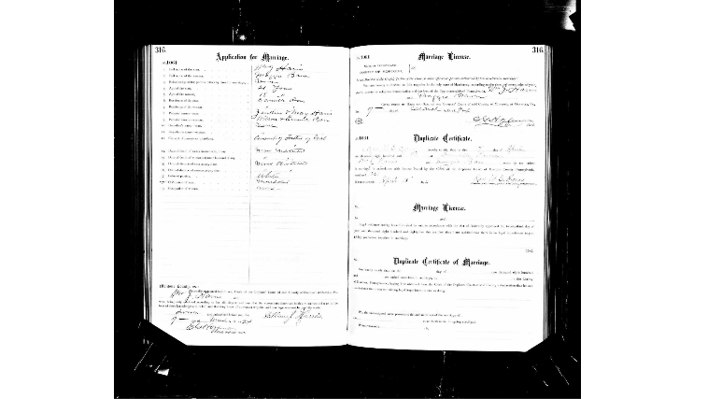

Marriage of D. Arthur Reese, Jr. and June Isabel Patton, Daily News of Huntingdon, Pa., 6/14/1049
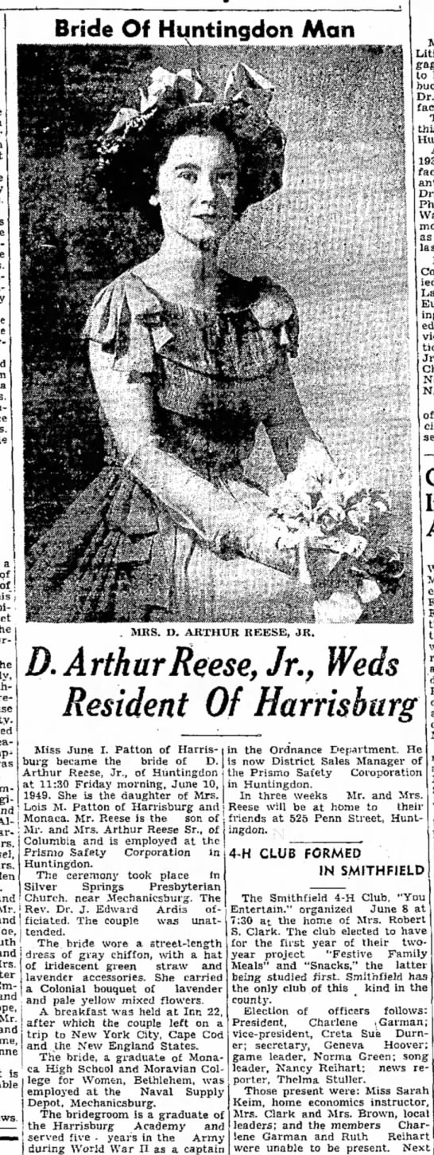
U.S. National Home for Disabled Volunteer Soldiers, 1866-1938

Name: | William J Harris
Admission Age: | 43
Birth Date: | abt 1872
Birth Place: | Lykens, Pennsylvania
Enlistment Date: | 9 May 1898
Enlistment Place: | MT Grelma. PA.
Discharge Date: | 11 Mar 1899
Discharge Place: | Augusta, Georgia
Military Company: | D
Military Regiment: | 13 Pa Infty
Admission Date: | 1915
Residence Date: | 1915
Residence Place: | Hampton, Virginia, USA
Notes: | Roseburg Branch

That’s supposed to be Mt. Gretna, PA [not Mt. Grelma]. It’s about 40 miles from his hometown of Lykens to Mt. Gretna.

Details from the record of the National Homes for Disabled Volunteer Soldiers, 1866-1938 for William J. Harris

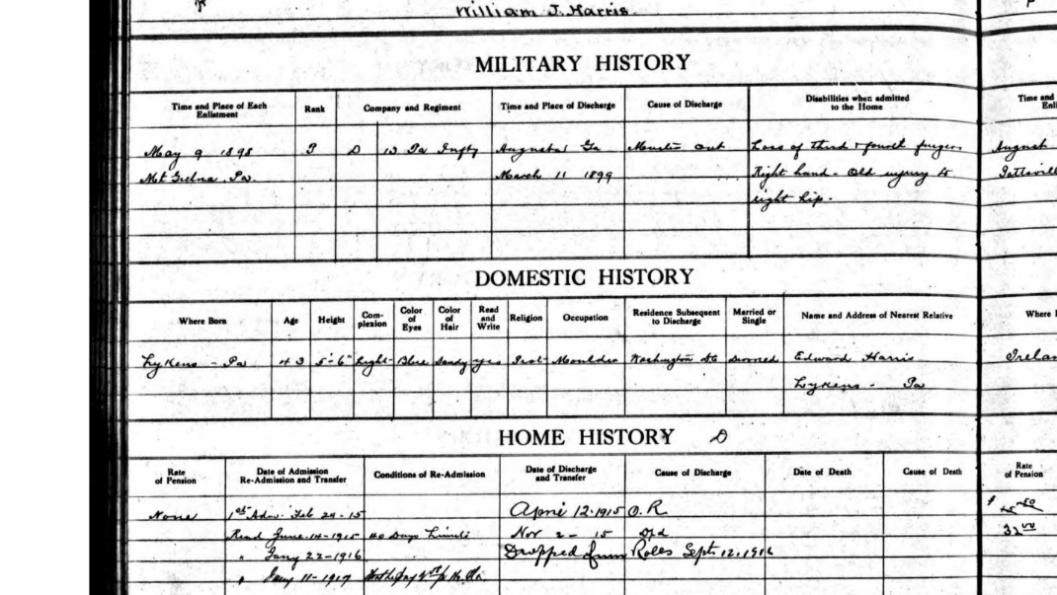

Obituary for William Jenkin Harris, Sr. (he died May 3, 1872), Harrisburg Telegraph, May 6, 1872

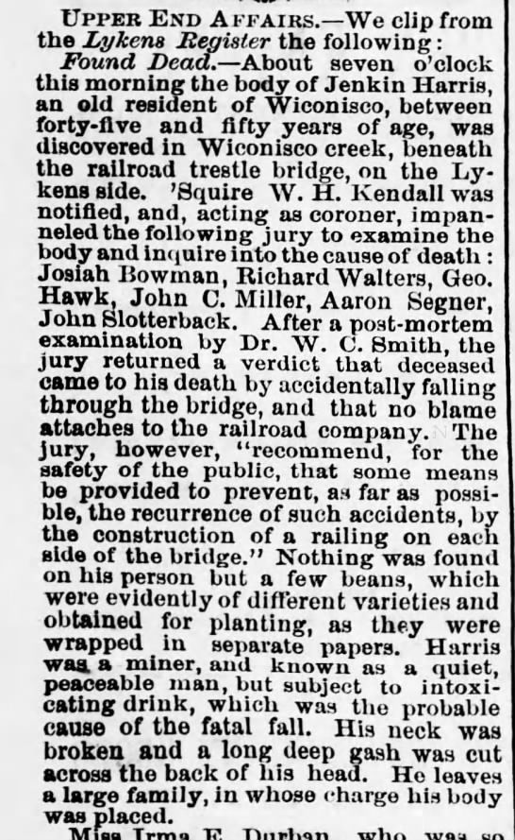

COD and obituary for William Jenkin Harris, Jr.

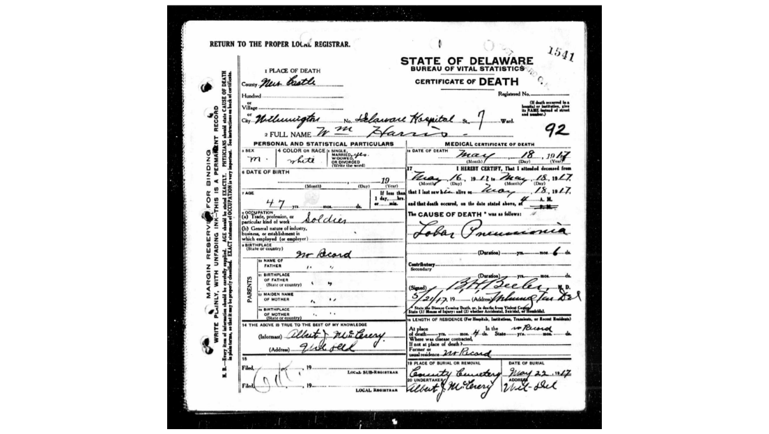
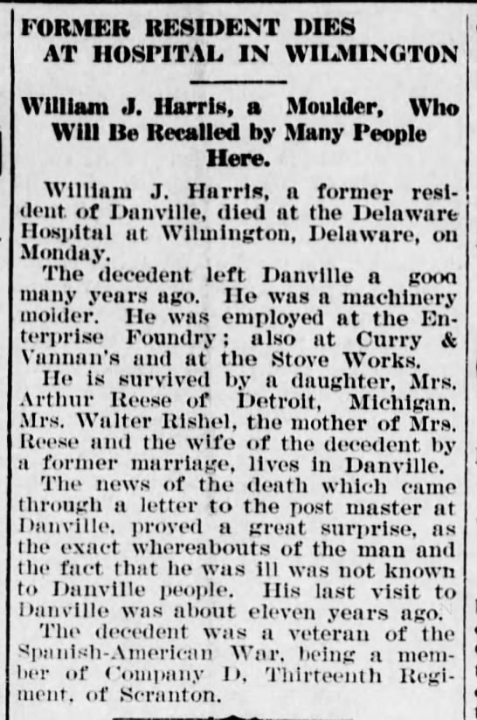 Danville Morning News, May 23, 1917

COD and obituary from 1949 for Anna Margaret “Maggie” Barr Harris Rishel St. Clair
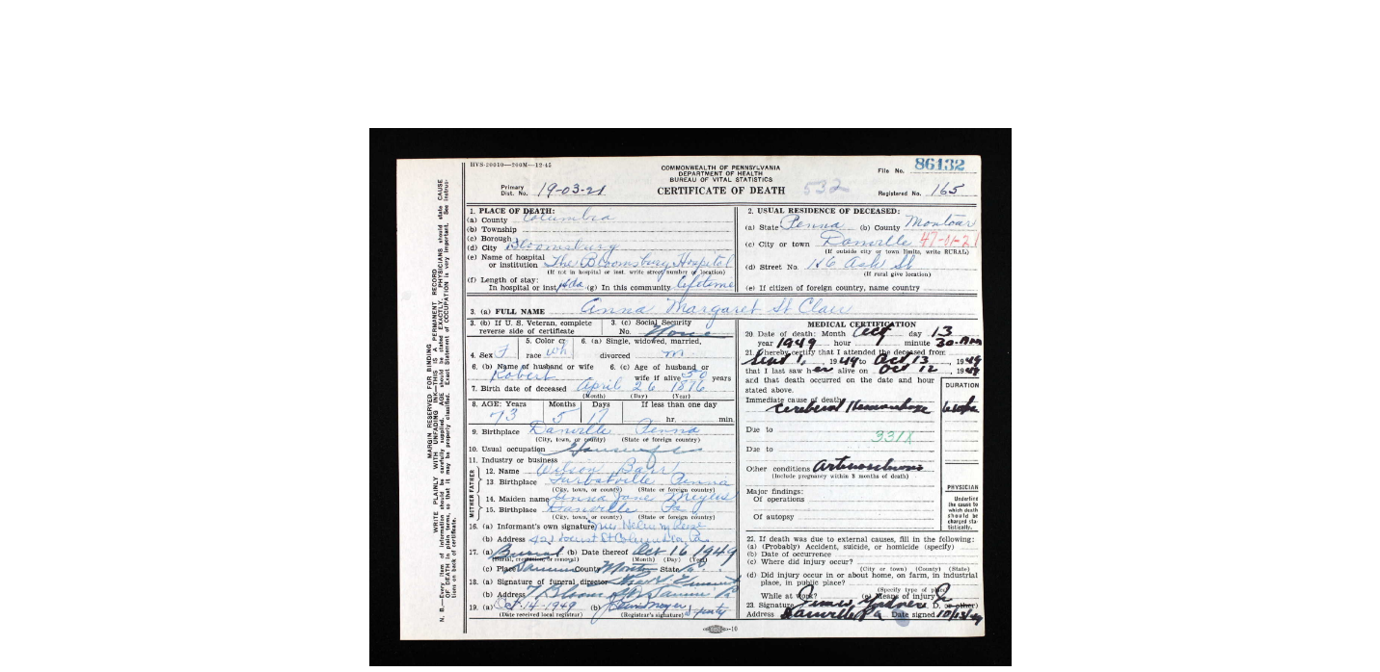

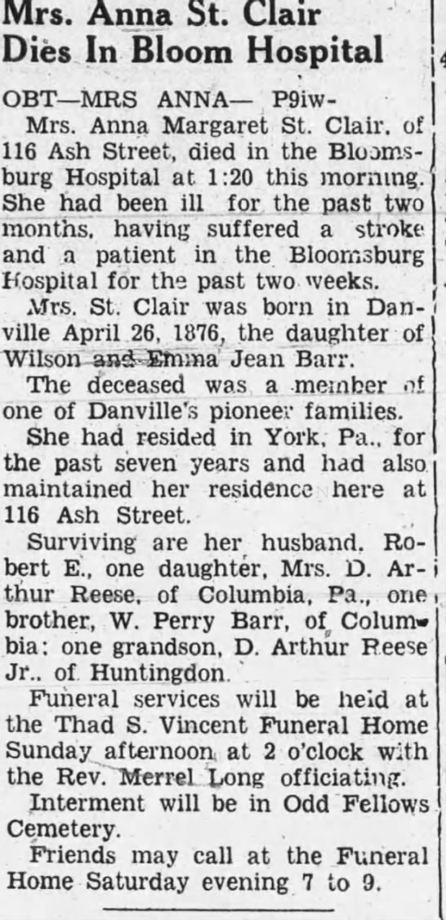 10/13/1949, Danville Morning News

Maggie’s second marriage, Wed 4/6/1914, Danville Morning News published notice 4/15/1914

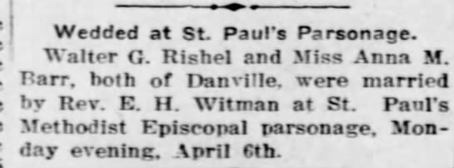

Walter Rishel’s obit Danville Morning News, 4/22/1918

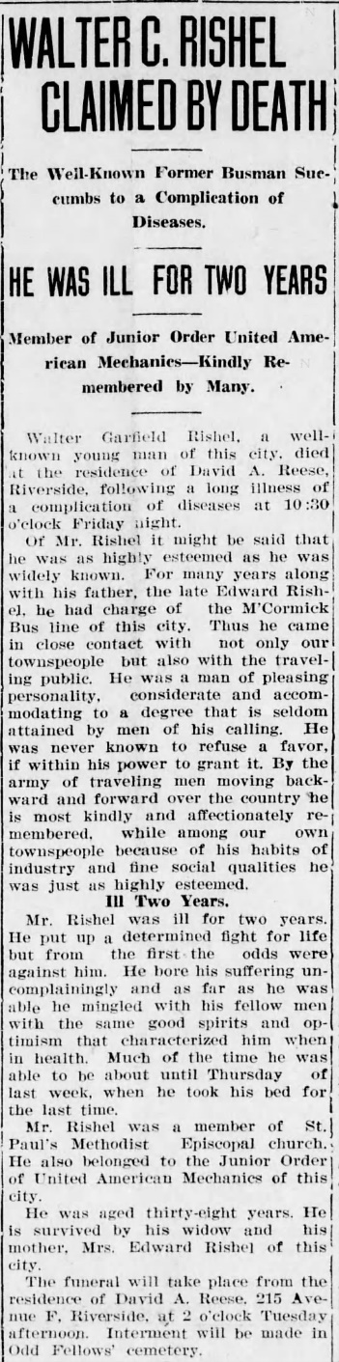 Danville Morning News, 4/22/1918

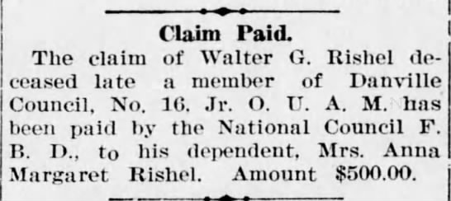

David Arthur Reese, Sr.’s obituary, Berwick Enterprise, 2/19/1955

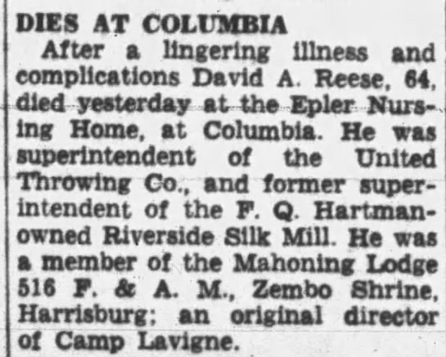

And another obit of Sr. from the Duncannon Record, 2/24/1955

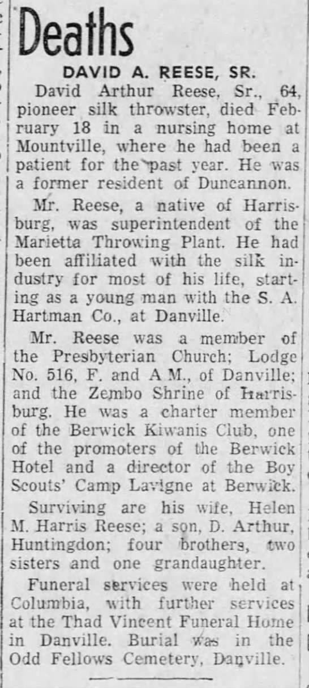

David Arthur Reese, Jr.’s obituary

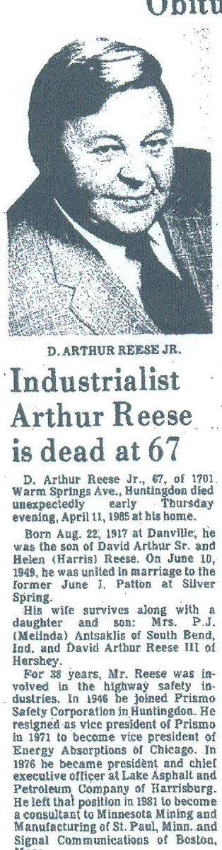 Obituary from ancestry.com family tree, profile image, no citation

Marriage of David Arthur Reese, Jr. and June Isabel Patton, 1949

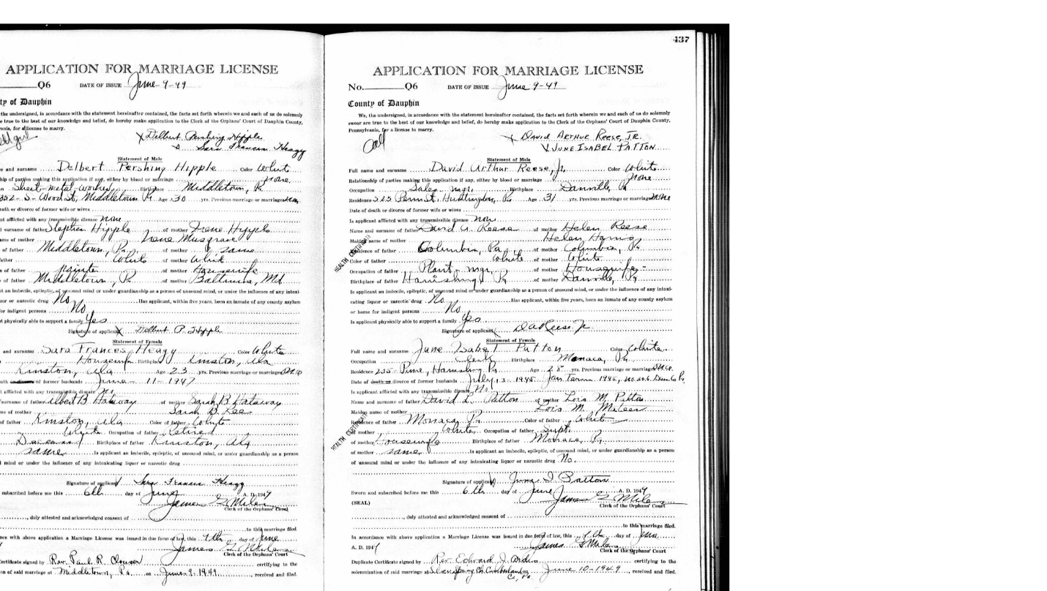

Obituary for Robert Elmer St. Clair, Danville Morning News, 8/29/1955

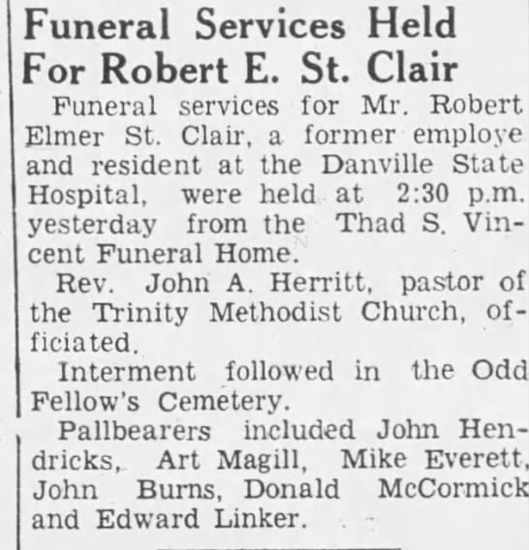
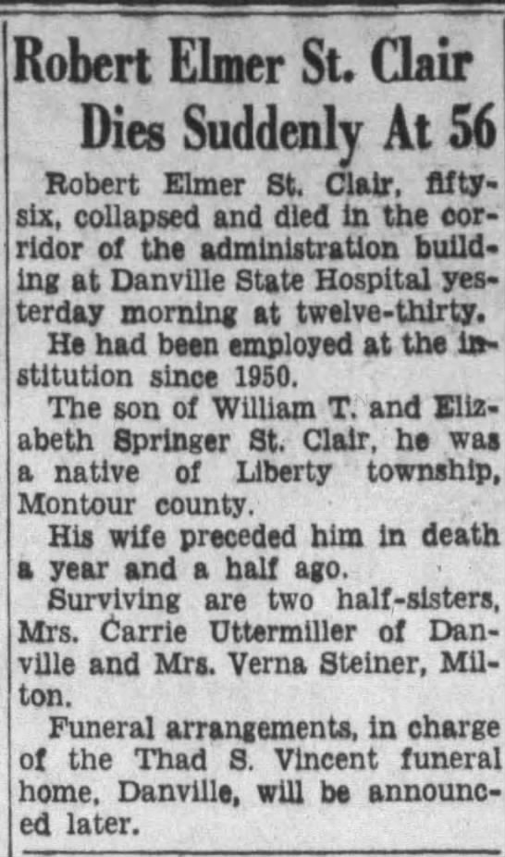 The Morning Press, 8/26/1955

